H446 OCR Programming Project

*Eshan Fadi*

*Upton Court Grammar School*

*Centre Number: 51427*

*Candidate Number: 8052*

Abrupt Animus

Table of Contents

Project Ideas 8

Engine and Language Evaluations 8

Unity – C# 9

Unreal Engine – C++ 9

Godot Engine – GDScript 9

Python (using Pygame) 10

RPG in a Box – Bauxite 10

Chosen Idea and Justification 11

Analysis 11

Problem Identification 11

Computational Methods 11

Stakeholders 15

SillyAustralian ® - Henry Masters (Founder and CEO) 15

DrunkDriving ™ - Amarveer Flora (CEO) 15

Research 16

Titanfall 2 (AKA TF|2) 16

Half Life (and other Source Engine games) 18

Omori 20

Conclusion 21

Interview 22

Essential Features 26

Movement 26

Walking/Strafing 26

Sprinting 26

Jumping 26

Crouching (both toggle and hold) 26

Sliding 26

Wallrunning 27

Grappling 27

Double Jump 27

Boosting 27

Combat 27

Fire 27

Zoom 27

Swap weapon 28

Quick melee 28

Pick up weapon 28

Reload 28

Sound Effects 29

Saving 29

Multiple Levels 29

Glitch 29

Scoring System 30

Merit 30

Dialogue System 31

Death Screens 31

Graphical User Interface (GUI) 31

Limitations 32

Solution Requirements 33

Hardware and Software Requirements 34

Success Criteria 35

Design 36

Decomposition 36

Combat 36

Weaponry 36

Swapping 36

Guns 36

Melee 37

Grenades 37

Player 37

Movement 37

Horizontal 37

Vertical 37

Wallrunning 37

Entities 37

Drones 38

Soldiers 38

Tanks 38

Civilians 38

Environment 38

Ground 38

Walls 38

Pickups 38

Interacts 39

UI 39

HUD 39

Menu 39

Title screen 39

Options 39

Pause 39

Pre-level inventory 39

Save menu 39

Checkpoints 39

Load game 40

Dialogue 40

Interpreter 40

Actors 40

Managers 40

Structure Definition 40

Algorithms 41

Movement 41

Enemy Entities 46

Weapon and its Interaction 50

Dialogue 53

Save System 58

Usability 60

Game Design 60

First Designs: 61

Main Menu: 61

Save Slot Menu: 62

Game HUD: 62

Choice 65

Subtitles: 65

Pause Menu: 66

2nd: 66

Main Menu: 66

Save Slot Menu: 67

Pause Menu: 68

3rd: 68

Main Menu: 68

Save Slot Menu: 69

Final Agreed Designs: 69

Main Menu: 70

Save Slot Menu: 70

Game HUD: 71

Choice: 71

Subtitles: 72

Pause Menu: 72

Variables and Data Structures 72

Enumerators 77

PlayerMovementState: 77

DerivativeType: 77

MemberState: 78

Databases 78

Dialogue: 78

SceneInfo: 78

Naming Conventions 78

Class Diagrams 80

Entities 80

Weapons 81

Iterative Tests 81

Strafing 82

Looking 83

Boosting 83

Jumping 84

Crouching 84

Different crouch keys 84

Looking and strafing combined tests 85

Post Tests 86

Development 86

Prototype 1 86

Input Detection 86

Movement 87

Miscellaneous 115

End of prototype tests 116

Strafing 116

Looking 117

Boosting 118

Jumping 118

Crouching 119

Different crouch keys 119

Looking and strafing combined tests 120

Interview 121

Prototype 2 121

Interacting with weapons 121

Entities (Damage) 123

End of prototype tests 123

Interview 123

Prototype 3 123

Saving and Loading System 123

Menus 127

Miscellaneous 128

Referencing the Game Manager 128

End of prototype tests 130

Interview 130

Prototype 4 130

Audio 130

Movement 130

Dialogue 130

End of prototype tests 135

Interview 136

Evaluation 136

Evaluative Testing 136

Usability Tests 136

Success Criteria 136

Usability Features 136

Limitations 136

Maintenance 136

Bibliography 137

# Project Ideas

|  |  |  |  |  |
| --- | --- | --- | --- | --- |
| Idea | Short Explanation | Complexity | Language | Computational Methods |
| Movement first-person-shooter game | A game where the player must simultaneously manage their momentum and there aim | Medium - ample use of math and GUI. Movement must be fine-tuned along with movement-based bug fixes. Player physics, and bullet physics, enemy AI, and modular interconnected components, OOP, libraries | C#, C++, GDScript, Python, easier with engines | OOP, database, modular design, abstraction for the GUI, reusability for functions |
| Game engine | An application designed to help and aid someone in the creation of game or another app | Difficult - lots of math, OOP, GUI, implementing a physics engine, along with functionality for any component, must include compilers and built in libraries to assist in building the game | C#, C++ | OOP, decomposition of functions |
| Programming Language | Writing a language and run it either being compiled, or to interpreted | Easy - filled with trees and if statements, and exception raising, must have built in functions, handle memory and add basic data structures | C#, C++, CPython | Selection, trees, decomposition, and modular design for various parts of the compiler |

## Engine and Language Evaluations

The purpose of an engine within software development is to speed up the development speed. Usually, these contain tools that manage and automate significant background processes, such as the script execution order, a built-in physics engine, and a lighting pipeline. Many modern engines feature a modular design for their workflow, with there being objects which you can attach components to, to add further functionality to the object. Some of these may be colliders, materials, or even scripts.

### Unity – C#

Released in 2005, Unity is an extremely useful engine that has great capabilities for both 3D and 2D, with powerful tools to assist in the creation of apps (mostly games) and experiences. It has a huge community surrounding it, making it incredibly easy to learn, with a wide variety of plugins to aid in the development of certain aspects of the process. The currently supported language used within it is C#, part of the C family. The language is quite easy to learn, having aspects like Python and JavaScript. It also simultaneously has the speed and access of C++, as it is a compiled language. I have some previous experience in using both Unity and C#, but the majority of their functionality is still to be explored. However, Unity recently made some economic decisions that have severely damaged the reputation of the company and software. As such, if I wish to continue the project afterwards, I may end up having to completely transfer the entire project to another piece of software, so this may not be the best long-term solution.

### Unreal Engine – C++

All the way from 1998, this engine is well known for boasting incredible visuals without much effort required from the developer. It is comparatively easier to optimise the application to run faster, as certain mesh optimizations exist natively to Unreal Engine 5 (namely Nanite). Proven its ability repeatedly, the Unity scandal has brought more eyes upon this amazing piece of software. However, due to its fabulous visual capabilities by default, making lightweight applications and games is far tougher, as many layers must be stripped away. Furthermore, it is well known that Unreal Engine is not built for the 2D experience, limiting the type of content that it can create. The language of choice for UE5 is C++, a language notorious for being extremely difficult to learn with low-level concepts such as pointers mixed in with high-level abstractions such as object-oriented programming. I have little-to-none prior experience programming with C++, so the learning curve to use UE5 is far greater than the other options.

### Godot Engine – GDScript

Godot is the game engine equivalent to Blender 3D in the 3D modelling world - a completely free and open-source alternative, which is only getting better and better every update, and will most likely become the industry standard within a decade. It uses a node-based system to construct the world and all objects which is similar to the systems that other game engines use. This intuitive system allows for more flexibility, greatly helping in the learning process. Godot mainly uses GDScript, a custom language which the engine supports completely for all platforms. It also supports C# and C++, but C# is not currently available to be compiled for the web in Godot 4.2 (the latest version of Godot at the time of writing). Godot can also support any other language using extensions to the engine. The worthwhile option would be GDScript, which is similar in syntax to JavaScript and Python, and has many built in functions such as is_on_floor() to handle common and simple checks automatically. The number of tutorials that the community and the Godot team themselves have made is vast and is only increasing, as many people flock from Unity to Godot, making it so that learning the engine and its language would be far easier than before.

### Python (using Pygame)

Python and Pygame together allow anyone to easily pick up and create anything and everything that they want. Unlike the other entries on this list, this is not an engine, which means that the creator must program in every feature, from collision handling and response, to manually testing individual locations for objects, instead of placing them in a visual scene and moving them easily. This significantly slows down the development of the application and can be extremely tedious as everything must be done by the developer, reducing the amount of creativity and passion that can be put into the project. While the language itself is extremely easy to learn, the underlying concepts behind game development such as matrix transformations and quaternions are extremely difficult to understand and waste one’s time when implementing them in such a small timescale. Such a project would be better suited to one with a far longer time frame to work within.

### RPG in a Box – Bauxite

Made using Godot, RPG in a Box is a game engine that has everything built within it for you: a voxel editor, fully working dialogue system, a sound effects generator, and even a visual scripting language. While many of the other engines on this list also have visual scripting as part of their arsenal, none use it or recommend it as much as RPG in a Box. It also has a secondary fully working scripting language called Bauxite, which is extremely similar to Lua, a famous programming language that has been used to make amazing games such as Hades. The engine is designed to be as friendly to a normal person as possible, such that no prior experience is required to even begin making something within this engine, but this also happens to be its downfall. Since so many features are required to use the built in system to have full functionality, it becomes harder to implement higher level concepts without effectively writing your own engine.

## Chosen Idea and Justification

The game engine is far too complex and time consuming for the constraint of time, while also requiring more learning than either of the other options. The programming language on the other hand, is simpler and would not allow me to easily incorporate as many computational methods. The movement first-person-shooter game is a great medium between the complexity of the two other options, while also allowing me to incorporate a great deal of creativity and interesting implementations of the course content. Furthermore, I will be using Unity to implement this since I have prior experience using the engine and C# as well, so I can spend more time focusing on constructing the project than learning how to use the program itself. I also get the benefit of using an engine which allows me to focus on unique ideas, rather than implementing standard algorithms and techniques.

# Analysis

## Problem Identification

An up-and-coming group of the gaming community is a collection of speedrunners, craving for fast movement and fluidity to beat the games faster and faster. To satiate this need, I have decided to construct a fast-paced movement first-person-shooter game, demanding both an understanding of momentum and precise aim, to hit a selection of enemies and reach the end of the level as fast as possible. The game will also have a secondary genre of a role-playing game, allowing players to progress and unlock more movement abilities and upgrade already existing ones to navigate the game at faster rates. Applying restrictions to the upgrades players can apply at one time will force them to strategically use their available abilities wisely and changing their style of play based upon the current scenario. For example, puzzle-based sections may better be played using a set of upgrades (typically called a build) that benefits movement and its control. On the other hand, while in combat it could be better to use a build that increases one’s health and damage dealt.

## Computational Methods

|  |  |  |
| --- | --- | --- |
| Method | Why | How |
| Thinking abstractly | Referring to the process of separating ideas from reality, it can be understood in two separate ways: abstraction for the developer, and abstraction for the player. For the developer, abstraction refers to the difference between the code and the hardware, and hence creating a model that will make the best use of the hardware. For the player, abstraction is the difference between the information given to them (such as the GUI, colours of effects) and the actual code and logic behind it all. | Only the bare minimum information is provided to the player, making sure that they only know what the developer wants them to know. Workings of certain mechanics could be summarised within a paragraph or shown through cutscene tutorials. Information on weapon states can be shown with images instead of text. As much as possible should follow the show-not-tell principle and detail does not need to reach that of realism. |
| Thinking procedurally | Otherwise known as decomposition, this is the process of breaking a large problem into sub-problems, making the overall task much simpler. Without the ability to decompose, designing and creating a game would be completely impossible. People already decompose problems to solve them. By splitting a huge problem into extremely simple ones, it makes the entire task far easier and reduces the time wasted in trying to solve a complicated problem. All the saved time will create a better product in the end. | The task of creating a game can be split into the many parts of game development, such as programming, art design, and other things. Within programming, it can be used to split the game into separate modules, classes, and functions. Grouping together related functions with importable modules will reduce the amount of code one needs to write and is better to maintain and debug. It is also far easier to create a function that does only one job and have a separate function call all the pieces when they are required, avoiding code duplication and errors that might occur when doing so. |
| Thinking ahead | When designing programs, rewriting the same code or similar code over and over again can be boring, inefficient, and a pain to debug, while also reducing the readability and increasing how error-prone it becomes. It also becomes far faster to program if all the steps have been planned out beforehand, such as inputs and outputs. Identifying spots where one can cache data to improve data access speeds and reducing memory usage will also allow the game to run faster, while leaving more resources for other parts of the program. Thinking ahead also references planning out the timing of when to implement features and how long it should take to do so. | One can simplify repeatable code by extracting them into functions and their respective calls. Taking this a level up means using classes (and hence Object Oriented Programming) to reduce code duplication as much as possible. This fits in with using Unity and C# since it uses objects as the framework, and so programming using OOP will be far easier and better supported. When multiple objects may access the same data, this data will be cached in a static section of the class, increasing memory efficiency. Techniques like polymorphism and abstract classes will further reduce the need to rewrite code. |
| Performance modelling | In games where skilfully timing and predicting trajectories is the aim, having any source of freezing or lag (when there is a significant difference between the player’s inputs and the outputs displayed on the screen) will result in a sub-par, even rage-inducing experience, due to issues out of the player’s control. While this is the intention for some games, it is not the intention for mine, and as such, code should be written efficiently to improve the player’s experience. Performance modelling will help in analysing inefficiencies and hence places that could be rewritten, resulting in an overall all better game. | While doing the programming can be more enjoyable than other parts of the development process, wasting time testing inefficient and longwinded solutions can be a massive bane that may end up costing you the project. Being able to evaluate the performance of a function or script before it is rigorously tested by modelling it and quantitative analysis will help identify weak points in algorithms and potential places to improve the efficiency, reducing the lag a player might experience. One useful tool to quickly measure a function’s efficiency is Big O Notation, showing how effective the algorithm is as the input size increases. |
| Thinking concurrently | Not every process in a game can run sequentially. Sometimes things must run simultaneously to run properly, such as physics calculations alongside GUI rendering, and especially input sensing, which must be handled concurrently with other inputs, such as moving and firing. Also, waiting for other tasks to finish or acquire data can block the CPU, which is more wasted time, so allowing the CPU to switch to another task while it waits is efficient use of its cycles. | The Unity Engine already manages a multitude of processes concurrently by assigning them to separate threads, which can then be picked up by separate cores. Other tasks such as highly parallelisable numerical tasks and graphical tasks can be offloaded to the GPU, which performs the same code on many different data (SIMD architecture) in a huge array of parallel cores. |
| Thinking logically | Without the ability for the program to change what it performs based upon the inputs, many projects and pieces of software would be virtually impossible to create. The ability to loop code also significantly reduces repetition of code, reducing the error rates from poorly duplicated code, and making it easier to debug. | Making different functions run when different input keys are pressed is the entire backbone of games, and as such, having the ability to change control flow is incredibly important. Not only that, but having code run on certain conditions being fulfilled makes sure that only necessary code is run, and avoids potential crashes. For example, if a raycast (shooting an imaginary ray and checking if it hit any object) hits an object, the pickup animation might be different for different weapons if the object hit was even a weapon in the first place. In certain situations however, using a switch statement is more efficient that using many if statements, since in a compiled language, the compiler simplifies switch statements into a switch table, which is a table of all the relevant memory locations for the different parts of code, and a hashing function is used to map the match to the memory location. This ability is more efficient than evaluating many if statements. Just as integral is the ability to have all the game code, or at least the relevant sections, be rerun at the start of the next frame, allowing for an interactive experience and to make sure that the game can be actually be played. Looping can be used elsewhere within movement calculations and predictions or for iterating through lists and arrays. |
| Backtracking | When programming, it is not always sure beforehand whether a solution will work, or if is worth implementing a certain way. As such, you may have to backtrack to previous working solutions and try a different approach to settle upon a far better solution. Over time, this maintains or improves the code, will also keeping the development enjoyable, and motivation high. | Sometimes, potential optimisations may be more hassle than the old solution and one’s time could be better spent elsewhere. If at the time such a solution does not present itself, you can leave it for the time being and come back to it at a later date, when your brain as refreshed and other parts of the code may be completed. This allows you to come up with fixes that you may not have thought of before, since you can leverage the other code, and a fresh mindset. |

## Stakeholders

A stakeholder is a person/organisation that is interested in a project, in this case, my game. These people have the power to change significant parts of the documents as they are the ones who the developers must consult when implementing certain features and how those features will work. For example, these people might be users of the program, such as the players of a game, or they could be producers and publishers wishing to make money from selling the program.

### SillyAustralian ® - Henry Masters (Founder and CEO)

My main stakeholder is the founder and CEO of the amazing game development company, SillyAustralian ®, Henry Masters. Masters is a huge fan of precision platformers with lots of challenge, as they prioritise a skilful experience that one can get better at, constantly keeping them within the flow state. Some examples are Celeste and Super Meat Boy, both being loved by players of the precision platformer genre. However, they also like role-playing games (RPGs), such as the hit 2015 indie game, Undertale from the brilliant mind of Toby Fox, and The Legend of Zelda: Breath of the Wild from well-known console and game production company, Nintendo Co., Ltd.

Recently, the company is wishing to start adding a secondary part to their business by publishing other small games under big names and help with the marketing of the experience to allow the developer to reach a larger audience than they may have gotten without going through the publisher. As such, they are willing to provide feedback on the actual code of the game, making sure it is optimised for various devices which may or may not have the greatest hardware, preferring efficient solutions as well. This leads to them requiring a game that runs fast and smoothly as their top priority, since the game should be accessible to as many people as possible, and they are willing to have compromises on the visual clarity of the game and the background story of the game as this does not contribute to the gameplay experience. They would also very much all the code to be easily maintainable, as they wish to continue developing the game after with their own software team. This means that I have to use many easy-to-read notations and naming styles.

### DrunkDriving ™ - Amarveer Flora (CEO)

My secondary stakeholder, handling the playtesting of the game and complexity of the playstyle is Amarveer Flora, the CEO of DrunkDriving ™, along with a small selection of his employees. Also a fan of difficult combat in games such as Elden Ring and Dark Souls, they have experience with massively multiplayer online role-playing games (MMORPG) such as Hypixel Skyblock and Black Desert Online. Similarly to these games, they also like the simple but logical gameplay that comes with automation games like Beltmatic and the Minecraft modpack, Techopolis 2. Importantly, they have great experience with shooter games like Overwatch 2, Fortnite, and Call of Duty, while having great reaction times. This makes them a great stakeholder to test the game for bugs while being able to play at the recommended difficulty of the game. They similarly prioritise the player’s gameplay experience, but they are more focused on the bugs and the instability of the game. Having many bugs in common gameplay will lead to an unfair and dissatisfactory play, so their priority is fixing as many of the bugs as possible, such that a player does not ever experience a frustrating playthrough. They are also willing to get rid of certain features such that the core gameplay elements are kept, and so they will be secondarily overseeing the features added to make sure priority is given to the features the player will interact the most.

## Research

### Titanfall 2 (AKA TF|2)

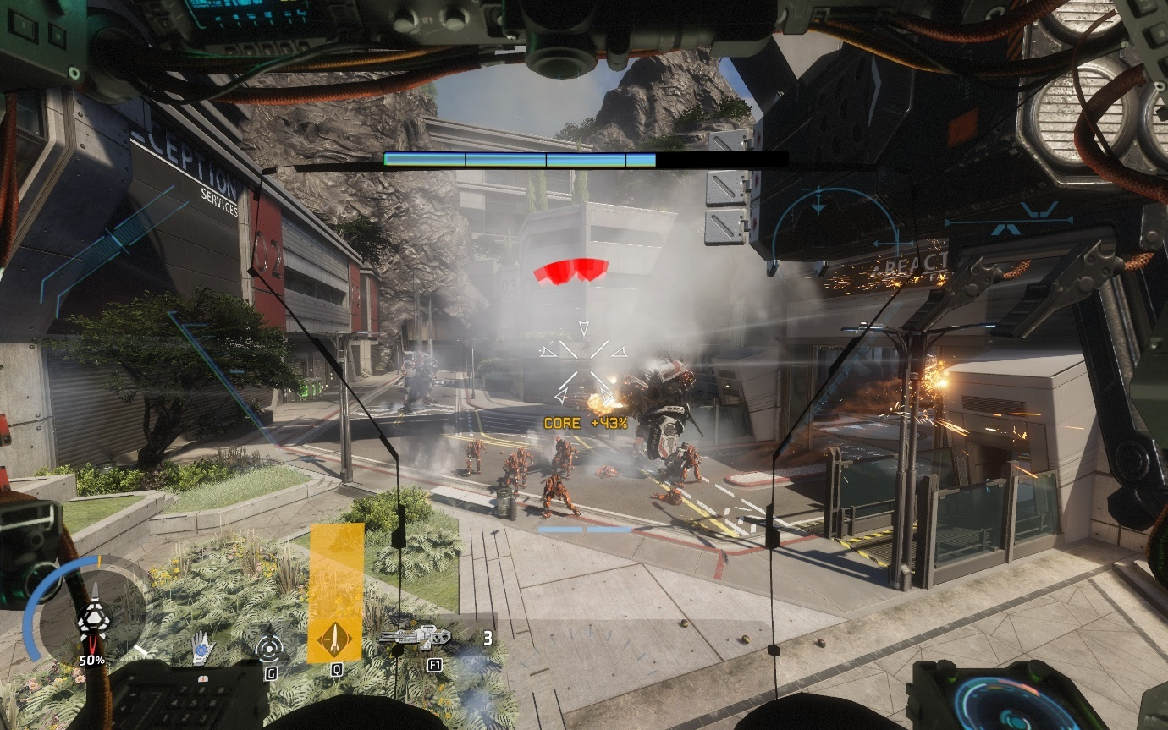

*(Fighting as a titan in Effect and Cause)*

Released on 28th October 2016 by Respawn Entertainment and published by Electronic Arts, Titanfall 2 is movement shooter, where the player swaps between moving around as a human character called a pilot and playing within a Titan, where the style of play completely changes. As a human, the player has access to wallrunnning, sliding, double jumping, and other abilities depending on the level. As a Titan, the player is able to gain great combat abilities, specific to the kit that they choose to apply to the Titan, all of which overpowers a human in every aspect. However, the movement capabilities of the Titan are reduced, leading to the only shared ability between all Titan kits to be the ability to move around. Some kits can fly, others can dash, but most of them have no extra movement capabilities. The 20-foot-tall war machines also struggle to get in some places, and as such the player will need to frequently exit them to reach other places or remove large volumes of health from enemy Titans via hijacking. This excellently illustrates the design philosophy for each of the levels in TF|2 – ‘211’: two parts pilot combat, one part pilot movement/puzzle solving, and one part Titan combat.

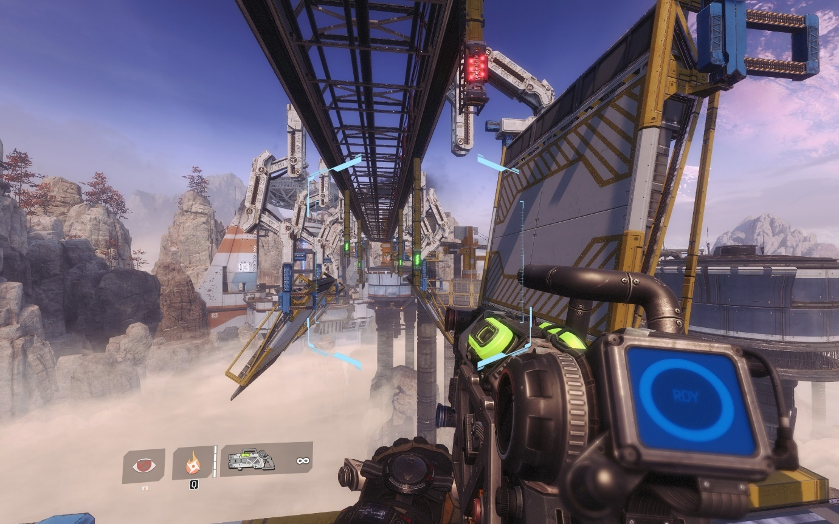

*(A time-based puzzle in The Beacon where the player must activate the platforms correctly using this level’s special feature, the Arc Tool)*

When designing levels, the team at Respawn Entertainment made each of them based upon on a different feature. For example, in the level Cause and Effect, the player swaps between the past and the present, managing enemies in both timelines, and using the changes between the two to help in accessing different areas. This planning technique is something that would be wise to follow, but since levels are designed to be completed in speed (and making long levels can be difficult) it might instead be smarter to split a theme across multiple levels, which are typically called zones. It should not be overdone however, as the feeling of ‘wanting more’ is always better than the feeling of boredom.

### Half Life (and other Source Engine games)

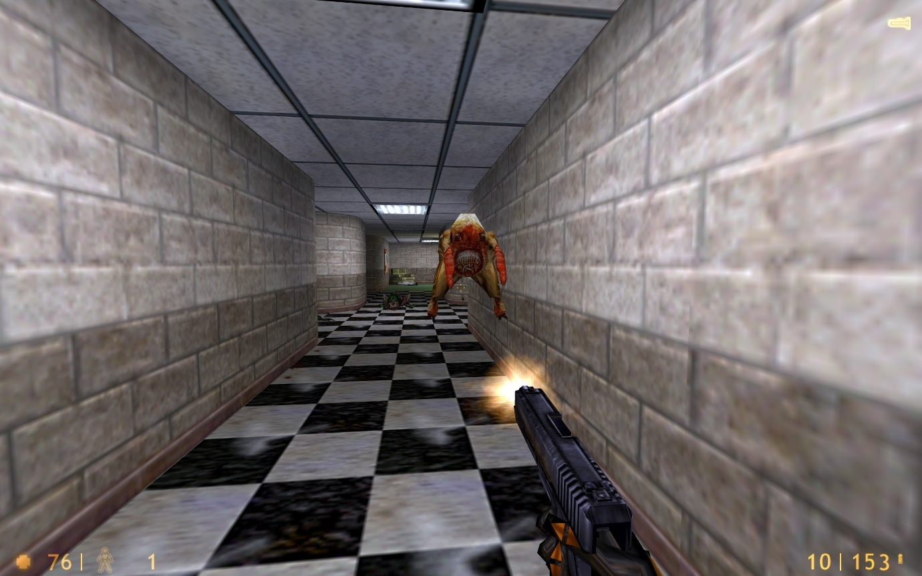

*(Freeman fighting against a headcrab in Office Complex)*

Half Life was the inspiration for many of Titanfall 2’s puzzle design, where there is a minimum amount of momentum required to traverse and solve the puzzles. Released in 1998 as Valve Corporation’s first game after 2 years of work, Half Life set the standard for what an amazing story-based first-person shooter game should be. It carefully and cleverly introduced the player to all its mechanics, and showing the depth that they could be used. Across the 19 chapters, and approximately 12 hours of immersive gameplay, Valve crafted an experience that tells the story of the creation of a dystopia, and Gordan Freeman (a young scientist) along with his attempts to stop it.

Valve built their debut game on GoldSrc – an extremely modified version of the Quake Engine and the Quake II Engine from id Software (the developers estimate that the resulting code is over 75% their own). The Quake Engine had a feature within its movement calculation code called ‘air acceleration’, which as its name suggests, allows the player to accelerate in midair. Normally, this wouldn’t matter, since the drag from moving forward and the deceleration that you experience when touching the floor is enough to cancel all speed increase. However, with a special movement technique called air strafing and bunnyhopping, it’s possible to gain speed, essentially to as fast as you want. Valve later modified and upgraded this to make the Source Engine which debuted alongside Half Life 2 and Counter-Strike: Source, and later on the Source 2 Engine with Half Life: Alyx. Since all the later engines were based of the previous engines, they all contain the same similar movement code and hence speedrunning techniques, which is incredibly useful for speedrunners since they can reuse their own skills.

The Half Life franchise is also well known for its incredibly realistic AI, which is especially well demonstrated with the Overwatch Soldiers from Half Life 2 and the following games in the series. The soldiers are capable of replicating and enforcing blitzkrieg-style military tactics against the player and making smart decisions in the usage of their weapons. There is also a clear hierarchy present within each team, and the behaviours of the different soldiers are cleverly explained behind the story of the game.

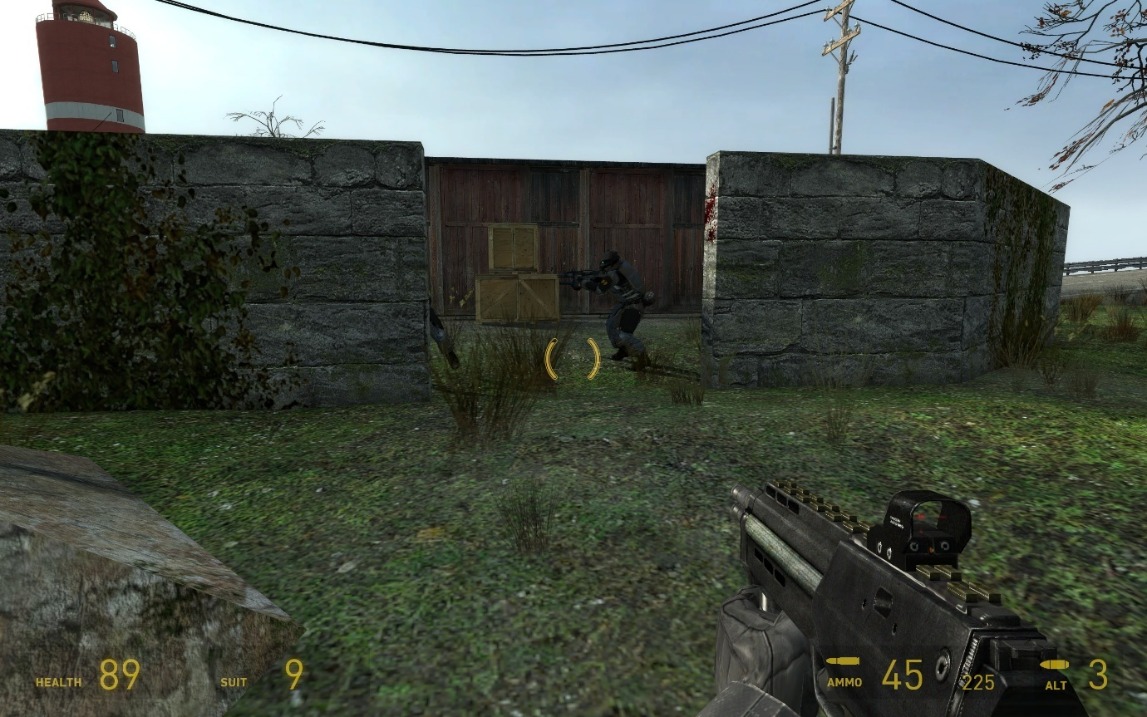

*(The Combine AI has decided to seek cover with its teammate, and reload under cover)*

The Combine AI functions as a multi-part system, with each enemy following a set of logical steps, then reporting back to a manager system, which assigns the respective enemies the appropriate roles based on the number of targets. Each soldier will then maintain that slot until their schedule finishes, which is a set of tasks assigned to it, such as finding cover, or firing at the player. This complex system allows for the tactics that the enemies should enact, while also keeping the situation manageable for the player, since the system will not allow more than 2 enemies to attack the same target simultaneously, which makes it a brilliant basis to design the enemy AI for my game as well.

### Omori

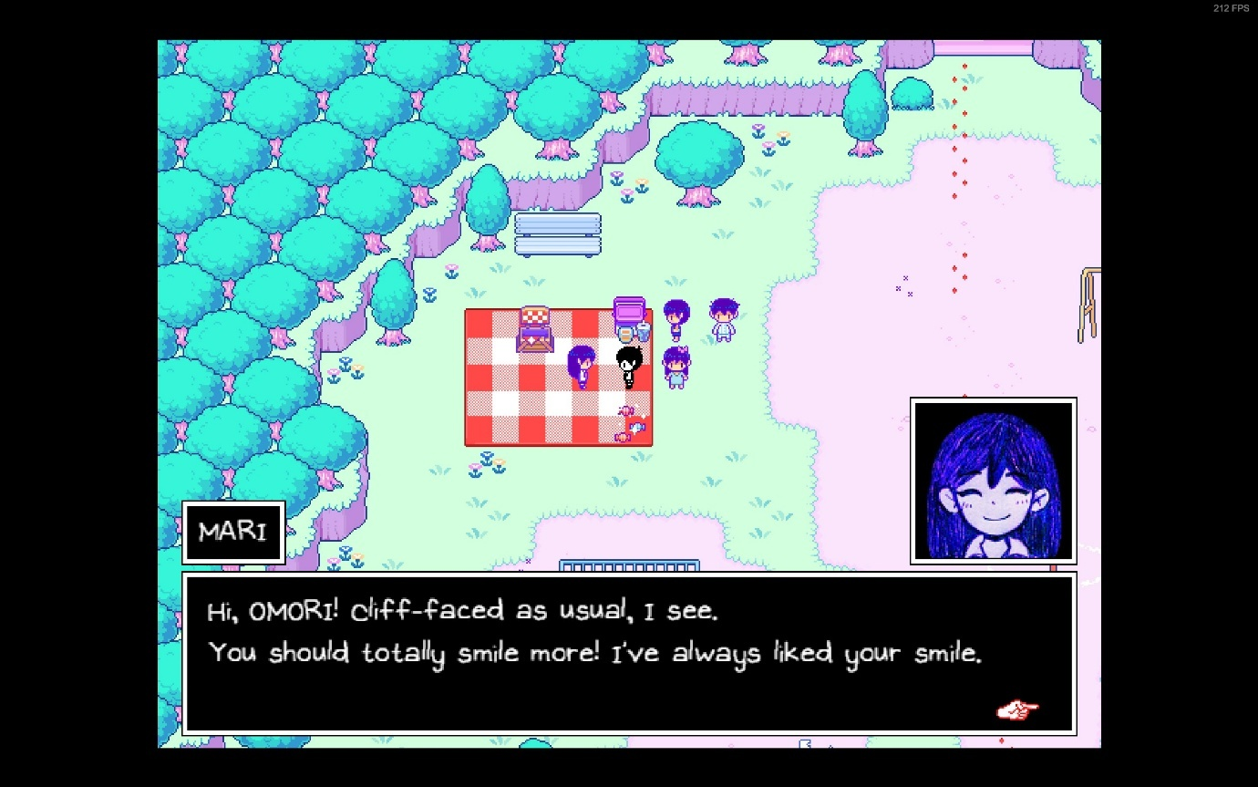

*(Mari talking to her brother, Omori, who is also the player)*

An absolutely phenomenal role-playing game (RPG) by OMOCAT using RPG Maker MV, Omori tells two interconnected stories of two connected teenage boys, dealing with both friendship and guilt. The bulk of the game is spent interacting with characters in both the storylines and completing quests for all of them. Dialogue systems in games can be incredibly complex and important, giving one an insight into how the characters of the game are feeling, and the possible options can change based on what the player has done. If the player has completed a quest, the system must be able to detect the change to the relative variables and change accordingly.

The importance of dialogue in a game comes not from the words, but the feelings they invoke and pass on to the player. After all, if the only things a character says is just describing the current situation, better world design or even a signpost is what you need to have ‘dialogue’, instead of implementing such a complicated system. However, the inverse is not true – a signpost can not represent emotion as well as a set of characters, no matter whether they display the emotion or not.

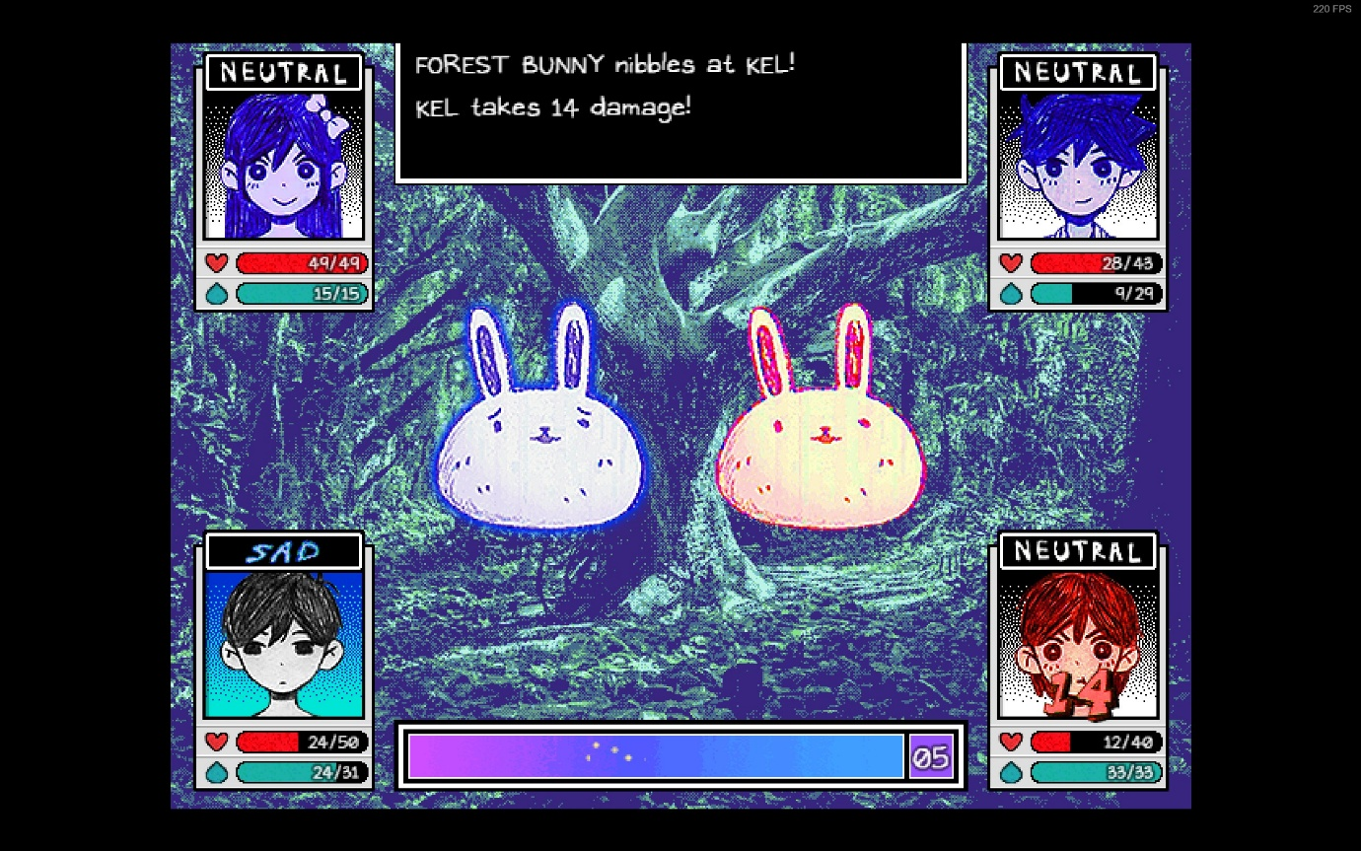

*(Kel takes damage from a forest bunny, one of the enemies the player is currently fighting)*

Omori’s system links together facial emotions and text effects to further accentuate the feelings of the characters. I, on the other hand, do not need to invoke emotions through facial expressions, nor do I need such extravagant text effects such as shaking and waving. However, applying colour, italicising and bolding text is useful in pointing out the most important things to the player while they are skimming through the text, while also helping them retain those specific pieces of information. In the game that I am making, the player will be under a lot of stress, so being able to skim dialogue quickly is important.

### Conclusion

From my research into these different games, I have decided on different elements of these games that would fit well into this game. From Titanfall 2, the main inspiration for this game, the way it splits the game into long chapters will be utilised. The ability to run along walls will also be used. However, the majority of the movement will be taken from Half Life and the various other source games since this is the basis for even TF|2’s own movement. I will also be utilizing part of the design philosophy (211), splitting part of the levels into both combat and the parkour section where the player has to get around to different locations.

From Half Life 2, I will be utilising part of the enemy’s AI system, although it will not be implemented to that extent. Rather, the manager AI will only exist to alert other enemies’ part of the same group of the player’s existence. This is necessary to keep the project within a reasonable timeframe.

Omori will be the inspiration for the dialogue system, although only text will be on it: no images or animated faces since the dialogue is only a secondary aspect of the game, not meant to detract from the main shooter aspect of the game, since the RPG aspect is just a sub-genre.

### Interview

For this interview, I needed to gain an insight into the exact features that the stakeholders wanted, and as such I convened with both. First, I prepared some questions, spread across different categories:

* Movement
  + What should be the basic movement options?
  + Any special movement options?
  + Should movement be location specific?
* Combat
  + What should the basic combat abilities be?
  + Should the player have multiple weapons, and if so, how many?
* Audio
  + Should there be sound effects?
  + Should there be a soundtrack?
* Systems
  + Dialogue
    - What should the system be capable of?
    - Should there be quests?
  + Saving
    - Is this system needed?
    - Should it be slot-based?
  + Currency
    - Will the game have any currency?
    - What should the currency be used for?
    - Is this a necessary system?
  + Any extra systems?
* World
  + Should the game be split into levels?
  + Should enemies be placed in predetermined locations in the world?
  + Should the world be modelled, or just prototype models?
* UI
  + Should there be a main menu?
  + Should there be a pause menu?
  + Should there be a HUD?

Upon asking these questions, I was able to obtain the following responses from both my stakeholders:

What should be the basic movement options?

The player should be able to move both slowly and quickly in all directions on the floor. They should also be able to jump off the floor. They should also be able to crouch, both as a hold key and a toggle, where the held version should take priority.

Any special movement options?

Special movement options should be the ability to run along walls, an ability to grapple to any surface in the world, an ability to slide when the player is running fast enough. A slide should provide a speed boost for the first second of entering it. Being able to jump in mid-air and multiplicatively increase their speed is also useful.

Should movement be location specific?

No, the movement should be useable anywhere, with only the ability to run along walls being specific to walls only and not the ceiling.

What should the basic combat abilities be?

The player should be able to fire bullets from a gun, and be able to reload the gun, if infinite ammunition is not an option. Zooming in would also be useful so the player can have higher precision when firing. The player needs to also be able to swap their current weapons with the ones on the ground or dropped from enemies if possible. Finally, an optional add-on is the ability to quickly perform a melee upon any enemy using the current weapon in hand.

Should the player have multiple weapons, and if so, how many?

The player should have access to hold onto multiple weapons but should only be able to use 1 at any given moment. A nice middle ground between too many and too few is 4 weapons. This should work well with the fact that weapons should be of 3 types: blades, explosives, and bullets.

Should there be sound effects?

Yes, the game needs to have sound effects to indicate if an action has taken place. However, you don’t need to design the effects, just put in the systems to add them in place.

Should there be a soundtrack?

No, the game does not need to have a soundtrack, it should just use the same system as the sound effects, but you need not implement it.

What should the dialogue system be capable of?

It should be able to display text on the screen at a minimum and have easy syntax so that we can have people writing the dialogue with no other knowledge of how the rest of the game works. Optionally, it can include things like choices for the player and animation keys for characters to face other characters.

Should there be quests?

No, a quest system is not needed and is also optional in combination with the dialogue system’s choices.

Is the saving system needed?

Saving is integral for any player in any game and should be one of the higher priority systems that would be implemented.

Should it be slot-based?

Many games do use a slot-based system where you can only have a limited number of saves at a time. We are not a fan of this system however and would like the player to be able to make an infinite number of slots, with its own data.

Will the game have any currency?

The game should have the capability for currency, granted to the player upon killing enemies, and performing other important actions.

What should the currency be used for?

The currency should be used to buy upgrades to the player, such as more health, and more health regeneration.

Is this a necessary system?

No, it need not be implemented at all and is completely optional. This system should be implemented last

Any extra systems?

It would be interesting to have a system to challenge the player into getting through a level as fast as possible or perhaps deciding to survive as a pacifist. This could be a scoring system. It would be interesting to make the game dynamically make itself harder as the player plays as a pacifist more and more: this could tie into some story behind the game, such as calling it a glitch meter and making the player a robot.

Should the game be split into levels?

The game should be split into multiple different levels and have the capability to set up more levels as much as possible.

Should enemies be placed in predetermined locations in the world?

This is both yes and no. For replayabilty, the enemies should have partly random spawn locations, but these should all be within predetermined locations, so that speedrunners can enjoy speedrunning the game more, while still having a level of difficulty to the run.

Should the world be modelled, or just prototype models?

Leave everything as simple objects, and we shall replace them with our own models once you pass the project to us (SillyAustralian). This covers all graphical elements; they need only be placeholders.

Should there be a main menu?

Yes, the player needs somewhere to start the game and decide which save to play, along with managing settings or quitting the game.

Should there be a pause menu?

The player should be able to pause the game, stopping all actions including the game’s physics and enemy attacks. This menu should allow the player to manually save and load, if implemented, and allow them to change their settings and finally quit to the main menu or quit the game.

Should there be a Heads-Up-Display?

Absolutely! The HUD is very important for the player to see some information about data about themselves that they need to keep track of. This can include the player’s health and their currently equipped weapons, along with information related ot that weapon.

## Essential Features

### Movement

#### Walking/Strafing

Walking is the basic movement action that the player can enact and will need this to start of many other actions. Comparatively to other ground-based movement, the speed of this will be situated in the middle of the rest.

#### Sprinting

While walking can be all one might need, getting to places faster is important to avoid getting hit in combat, or complete certain puzzles within the required timeframe. Sprinting will increase the ground acceleration that is enacted, and the player will also have a higher top speed compared to walking.

#### Jumping

Another staple of the movement actions, jumping allows the player to easily gain vertical momentum, and it can be developed by allowing the player to jump while in the air, or jumping off walls.

#### Crouching (both toggle and hold)

Crouching will shrink the player’s hitbox vertically, granting access to smaller passageways, and providing a potential advantage in combat, since the area that enemies can attack the player in is far smaller. To balance this out, crouching will force the player to move much more slowly and will be the slowest ground-based movement option.

#### Sliding

When above a certain speed, using the crouch button will instead lock the player into a sliding state. Sliding should first increase, then decrease the player’s speed, encouraging you to leave your slide earlier to gain speed. The target direction will be the current direction of movement, but input will only allow slight nudges in direction, rather than a controlling factor, allowing the bare minimum control. Friction while in a sliding state will also be a lot lower than other states.

#### Wallrunning

A much more advanced movement option, this makes the player stick to walls and allow them to move along it. This opens the possibilities of combat terrains and puzzles and is usually included in movement-shooter games. The player can also jump off these walls, which may lead to a variety of solutions to different situations the player may encounter.

#### Grappling

While not as common in other games, grappling is still fun to use, but is also far harder to control, since this requires one to plan trajectories. It is also much harder to implement but is still well enjoyed by many players in the game’s it shows up in, such as the multiplayer mode of Titanfall 2, or as a basic movement option of Ghostrunner.

#### Double Jump

This is a far more common ability, where while in air, the player can press the jump button again to gain an extra boost vertically, akin to a jump on the ground. Without this, the player is only permitted to jump while touching the ground.

#### Boosting

Like a dash that might appear in other games, a boost is a multiplicative increase to the player’s speed and will allow them to gain speed much faster than attainable through other methods. Due to the potential of exponential speed, both a maximum limit for boosting must be set, while also implementing a heavy cooldown for using it.

### Combat

#### Fire

On the combat side, firing is an essential action. Without this, it would not be called a movement-shooter. Firing will be a catch-all term for using weaponry, such as slicing with a blade, shooting a weapon, or throwing a grenade.

#### Zoom

While a player may not use this as much when they are moving around a lot, it is still a staple of the shooter genre to include some sort of zoom capability on weaponry or on your visuals to be able to see long distance clearer. This may have a side effect of encouraging a stealthy and cautious playstyle instead, but this could be negated by having more difficult sections later in the game.

#### Swap weapon

From the beginning of first-person shooters, the usefulness of having multiple weapons and the strategy that appears from doing so was always an incredible lure into the games of the past. This inherent feature stuck through the generations and remains as an expected feature in a shooter. However, starting from Halo, the number of weapons one could carry could be limited, due to the limitations of the controller at the time. As such, another trend of having a limited number of weapons that the player could equip at one time rose in popularity. It’s an incredibly easy way of bringing depth into any shooter, by making the player have to choose which weapons, they want to use, and by having a limited ammunition capacity, also making the player choose if they can wait to get ammunition, or if they need to change weapons now.

#### Quick melee

While unlikely that the player might repeatedly get within close range of any of the enemies, there must be a close, high damage option for the player to enact. The melee is a powerful move, that depending on game-to-game, can be one of the highest damage options available. This ability allows the player to use any weapon to inflict a strike onto an enemy, no matter the usual use of the weapon.

#### Pick up weapon

Since the player can run out of ammunition, it is likely that they will end up without any weapons with ammunition in them, other than blades. As such, it is possible for the player to pick up weapons dropped by enemies or placed in boxes throughout the level to counteract this difficulty.

#### Reload

Guns do not have a limitless capacity of ammunition, and to help players to immerse better with the game, the player can reload the magazine in the currently active weapon if applicable to do so. This can add a further layer of strategy to the game, as a player can decide to reload in the middle of a magazine before entering a gunfight, or not do so if they fear they will get hit in a moment.

### Sound Effects

The brain is very good at linking different senses together for the same piece of information. Having different sound effects (sfx) link to different actions will act as either a confirmation that the action has been processed, or it may warn the player of danger.

### Saving

Saving is needed for longer games, since players can get incredibly frustrated with losing progress every single time they close the game. As such, saving has been implemented in many major games as a basic feature. Different games do the system slightly differently, usually splitting into 3 different types. The first is where the player has many slots and can save the game into any of these save slots and have multiple different places they can pick up from. This can also be used to have entirely different playthroughs existing at the same time. The second method has only one save slot but saves progressively by making a new save every single time. This only allows for one playthrough, but many checkpoints that the player can load back into. The third method is the one that I shall implement, where a mix of the other two types is used. Specifically, the player will have multiple slots, where each slot denotes a playthrough. Each slot will have multiple versions based on manual saves or automatic ones based on checkpoint.

### Multiple Levels

Having many different levels will increase the playtime of the game and introduce variety, so that the player doesn’t get bored with repeating the same level with no differences. These levels will be split into zones/chapters where levels in the same zones/chapters will have the same thematic style and mechanics.

### Glitch

The glitch meter is a measure of how aligned to the default programming the player is. Pacifism goes against the original programming: this decreases the glitch meter. Killing follows the original programming: this increases glitch meter. Secrets decrease the glitch meter, as they reveal the true nature of things. A lower glitch meter would represent the player character questioning the morality of what they have always been taught and programmed to do. It will cause:

* Decrease in health regeneration speed.
* Increase in damage taken.
* Player will see hallucinations.
  + Grants the ability to attack friendlies.
  + Enemy civilians may be on your side.
  + Characters in names and signs may move around.
  + Relates to PTSD type event at the beginning of the game – the only cutscene of the game.

A higher glitch meter represents the player character believes what they have been taught and programmed is the right thing, leading to:

* Increase in health regeneration speed.
* Decrease in damage taken.

This works with the moral of the game - doing the right thing is almost always harder than doing the wrong thing, and sometimes prejudice will perpetuate persecution.

### Scoring System

Each level is scored based on:

* Time to complete.
* Enemies killed.
* Secrets collected.
* Inverse of death count.

Further point bonuses will be granted for:

* Using less weapons (melee only)
* No deaths
* Pacifist (only applied on the final level if the player has killed zero enemies across the whole save)

This should encourage players to return to the level and get a higher score, potentially seeing the flower planting system. The score will be displayed in a room, and the player can interact with each of the elements to show the score for each category.

### Merit

The currency of the game is called merit. It can be obtained by picking it up from within the level (such as the bodies of friendly soldiers) and from the score at the end of the level. Killing increasingly difficult enemies will lead to more merit, although to stop merit-farming tactics, it will be limited to this equation:

$No. minimum enemies*base merit multiplier*base merit value of enemies$.

Merit will allow the player to buy upgrades for their player character and unlock more weaponry/ammunition types to use in the pre-level inventory setup. However, ability unlocks will be based upon the level progress, since it will be tied to the story.

### Dialogue System

While it should not be used extensively as it may break the flow of the game, this system should be complex enough to handle all dialogue requirements it needs.

It must:

* Allow for one to easily add multiple languages
* Allow for timing cues
* Allow for branching options
* Allow for quest completions
* Allow for different dialogue based on external events
* Allowed to change variables
* Prompting characters to face different characters
* Allow for changing text colour (this should allow for accessibility changes)

### Death Screens

To encourage the player to use healing items and use better movement to avoid taking damage, too much damage will result in the player’s death, and a screen will need to pop up allowing the player to load the most recent save, and potentially showing a useful tip on the screen to avoid death the next time. The screen could also give other statistics such as how many the enemies had killed.

### Graphical User Interface (GUI)

Many users are not exceptional at navigating and using command-line interfaces, and the human brain can process images faster than it can process words, and using the mouse is more accessible than using text arguments. As such, I will be implementing both a GUI for menu navigation, and a Heads-up Display (HUD), which will communicate information to the player while playing the game. Some elements of the HUD may be in text and numbers, while other will be in graphical solutions such as bars and images.

## Limitations

Within every project, there are limitations that one must consider, since not everything that one would like to do can be accomplished. Sometimes, trying to implement everything you want will in fact ruin the final project. Instead of trying to break all the constraints, one must instead make considerations and work around these considerations. If possible, some of the limitations could be considered challenges and you should work to break it down and produce a better product, but the costs of doing so must be accurately estimated and the reasons must be weighted accurately against the problems it may cause.

|  |  |
| --- | --- |
| Limitation | Why? |
| Time | Time is the most obvious limitation – the never-changing constraint that will limit how far I can progress with the game. With infinite time, everything in the game could get infinitely refined, and many features could be added to the game. However, infinite time is not something we have the luxury to. In fact, the entire project must be done within the space of 8 months. Therefore, there will be features that would be desirable but can’t be implemented and some features which will not be as refined as preferable. |
| Budget | The budget for this entire project is nothing. This is a severe limitation meaning that nothing can be outsourced, and while usually you could hire better programmer, and an entire sound design team, nothing of the sorts can be done here. This will have repercussions for the software limitation as well and means that if there are any textures or models I want to use, they must be free or made by myself. |
| Hardware | Maintaining the performance of the game is very important because not everyone has access to top-notch hardware, and the game must run extremely well since speedrunners wish to have zero-latency from sending their actions to receiving feedback on the screen. Therefore, the game must be made as simply as possible, with as much optimisation as well. However, I am also unable to test on different types of hardware, and so the best I can do is testing on Windows on my own system. Furthermore, the game will be only for the PC, since I do not own a console, nor can I get the game files onto a console if I owned one. |
| Software | Software is also a constraint since I can’t acquire all the professional applications, and some applications I can’t run due to my own hardware. Since the budget is zero, all software and third-party resources must all be free, or hand made. |
| Proficiency | While I have used Unity and C# in the past, they were all for basic projects that were copied from tutorials, and as such I will need to learn more of the quirks of the engine and its language, which will take even more of my time to build the game. |

## Solution Requirements

While it would be ideal to have all of the essential features included in the game, not every single one needs to be implemented to the same level of usability as others. Based on the limitations, some features may need to be cut from the game, as is typical within the industry.

|  |  |
| --- | --- |
| Requirement | Justification |
| Movement and Combat | Both movement and combat are single-handedly the most important requirements to exist for this NEA, since they define the primary genre of the game. Without either of these features, it would be incorrect to call the game a movement-shooter. |
| Saving | Every single modern game that is released nowadays has saving since no player is ever expected to finish an entire game in one sitting. To maintain the player’s retention, they must be able to return to most of their progress still available to access. |
| Multiple Levels | For such a fast-paced experience, the game would be unsatisfying and not an adequate experience if not for multiple levels. This will extend the playtime of the game and allow the player to better integrate with and learn the mechanics of the game better. |
| GUI | A GUI is integral for the user to be able to interact with the game, since many engines do not allow the player direct access to a console/terminal for a command-line-interface. A CLI is also far more difficult to use and is less accessible to the average gamer, making this a requirement of the final project solution. |
| Death Screen | This also includes the player being able to die, and this is incredibly important for gameplay. Death is the risk factor, and it is what the player is intending to avoid as they are rushing around and firing at the other enemies. With no risk, there is no need for the player to attempt to play the game as intended. Once death has been achieved, it is important that the player is able to go back to their previous save or restart the level to continue playing. Any hints on how to avoid death are an optional extra to add to the death screen. |

### Hardware and Software Requirements

|  |  |
| --- | --- |
| Requirement | Justification |
| Computer Hardware | The game is intended to run quickly, with as minimal delay/lag as possible, therefore the GPU requirement is only the need for integrated graphics, or a simple graphics card such that one can have an enjoyable experience, while the CPU requirement is for a chip that can adequately support its GPU. On the side of system memory, the game will require a minimum of 2GB of RAM, so the system would be recommended to have 8GB of RAM, so as not to cause disk thrashing with other programs that the user may have loaded in, which only less that 2.5% of people who play games do not have access to nowadays. |
| Peripherals | The game will have support for both a mouse and keyboard combination (kb/m), or a controller as an input device, but nothing else, as it would be difficult to port all of the controls that would be needed to play the game to another appropriate input system, such as touch controls. The kb/m and controller input schemes are also the most commonly used ones, as evidenced by all the games in my research having support for both of them. |
| Operating System | My project will only be available upon a 64-bit Windows system since that is the most widely used type of system for playing games, coming in at 96.78% of all gamers on the Steam platform according to the Steam Hardware Survey of August 2024. |
| Storage | One would need as much storage as is required to contain all the files of the game and have at least a few gigabytes leftover for a swapfile/pagefile, in case the computer needs to use virtual storage. |
| Software | Many games use the same set of C++ Redistributables and depending on the individual’s proficiency in playing games, they may or may not already have the relevant packages installed. This also includes .Net 4.0, the appropriate drivers for their device and the XNA Framework Redistributable. Furthermore, if the user wishes to use a controller, they will need the right software to connect the controller to their computer, which is usually Microsoft’s XInput, but may also be DInput (an older version for support for more buttons). The appropriate software and drivers are dependent on the user’s own controller. |

## Success Criteria

|  |  |
| --- | --- |
| Criterion | Justification |
| Strafing Movement | Strafing is the barebones required option for moving, allowing access to 2 dimensions, and even the third dimension when slopes are introduced. |
| Jump | While strafing can allow the player to move vertically, it is dependent on the level geometry, and it would instead be a better option to allow the player the ability to jump while on the ground, and maybe even a double jump while in midair. |
| Crouching | To avoid the enemy gunfire or to enter certain sections of puzzles in the game, crouching is a criterion as it allows the player to decrease the surface area that is exposed. |
| Firing weapons | As mentioned, the player must be able to fire weapons to retaliate and survive for longer against their enemies. It is also part of the genre’s title and would be fraud to use the genre ‘movement-shooter’ without the ability to shoot. |
| Can take damage | While the player can damage others, in turn, they too must be able to take damage, allowing an even playing field and forcing the player to take better and safer movement routes, or prioritise more dangerous enemies. |
| Ability to go back to a save on death | Once the player’s health reaches below 0, the only logical option is for the player to die, which reinforces the risk with taking damage. The player must then be able to continue playing which in a singleplayer campaign, is usually done by reloading a previous save. The death screen will contain a button to do so, by selecting between a variety of saves. |
| Saving | This allows the player to retain their current progress for later, such as when they close the game, or if they suspect that they might be in a tricky situation. |
| Loading | Conversely, one must be able to load the save that they made to bring meaning to the saving feature and re-enter the state that they were in when making the save. |
| Menu with buttons | The GUI is the most accessible method of navigating through menus and interacting with the game. Out of all of these, the button is the most intuitive and useful of selecting options, instead of a scrollable menu. |

# Design

## Decomposition

### Combat

#### Weaponry

##### Swapping

Being able to swap out your weaponry on the fly is what encourages players to try new things in the game. This swaps the currently selected weapon with the weapon that the player is looking at.

##### Guns

1 of the 3 types of weaponry is guns that allow the player to deal damage from range, firing bullets that damage upon clicking the button via a raycast.

##### Melee

The second type is melee weaponry which deals high damage from close range, like bats and blades, requiring a collision check instead.

##### Grenades

The last type is grenades, which are lobbed, following a physical arc and dealing explosive damage based on its range.

#### Player

##### Movement

###### Horizontal

All movement that uses the basic strafing keys are handled similarly within the same function, moving the player in the direction of the keys relative to the current facing angle in the horizontal plane. This will all be held in one function, that references other functions to access the relevant acceleration values for the different movement types and the speed limits.

###### Vertical

This encompasses jumping, gravity and the lack of control the player should have when moving in air. While the player is not on the ground, gravity will constantly accelerate them downwards. Jumping allows one to get over an obstacle by adding vertical velocity, but it is also possible to ramp off slopes and get far more verticality that way. Due to this, one will have lower control of the character once in the air, needing them to plan their original trajectory. Ramping will be automatically handled by the physics system that is built into Unity 3D, while both jumping and gravity will be separate functions. Jumping will be triggered upon the input being pressed, while gravity will be triggered every frame.

###### Wallrunning

Wallrunning is a special case of movement since the plane of movement then becomes that of the wall you are running on, and the player can only move forward on this wall, fall off or jump off. This allows them to stick to the wall and is an entirely separate movement option than the others.

#### Entities

All entity types are shared between allies (friendlies) and enemies, bar the civilians which are only on the enemy side, as is in line with the setting of the game.

##### Drones

An enemy that flies around and maintains a height-advantage on the player where possible. Depending on their type, they may act differently, such as shooting from afar for ranged drones, or moving towards the player for explosive and melee drones.

##### Soldiers

An enemy that moves around only on the ground and will drop weapons and ammunition when killed. Will stay away from the player but will attempt to maintain line of sight.

##### Tanks

Large and slow ground-based vehicles that deal heavy explosive damage occasionally. Have exceptional range compared to any other type of troop.

##### Civilians

Cannot deal damage and will run away from enemies.

### Environment

#### Ground

Allows for all basic movement and disables gravity while the player is stood upon it. It also prevents the player from falling out of the bounds of the level. Moving up a slope will convert some of your horizontal velocity to vertical velocity as per the physics dictate.

#### Walls

The player can wallrun upon them but loses all other types of movement except jumping. Also disables gravity and prevents access to certain places.

#### Pickups

Items will be scattered around the level, such as coins or weapons that the player can pick up and use, encouraging exploration and challenge.

#### Interacts

Objectives for the level can be anything and are interacted with. Other things like doors and upgrades can also be interacted with.

### UI

#### HUD

The heads-up display shows important information to the player, such as their health, what the active weapon is, how much ammunition that weapon has, and outlines for enemies for clarity. It cannot be interacted with but is a necessary part of gameplay.

#### Menu

##### Title screen

Loads on startup, allowing access to the options menu and save menu, along with exiting the game. Displays the name of the game

##### Options

Changes settings such as game volume and mouse sensitivity.

##### Pause

Pauses the game and allows the player to return to the main menu. Does not save the current state of the game.

##### Pre-level inventory

Provides a GUI for the player to assign upgrades appropriately and select the contents of their weapon slots.

##### Save menu

Displays all the save slots, each displaying 4 things: the slot number, the save history menu, the time spent in the save, and the name of the level.

##### Checkpoints

Will automatically save the progress of the player in the game at these points, creating an autosave.

###### Load game

Once a save has been selected, it will load the attributes into memory and load the level

### Dialogue

#### Interpreter

Reads the .dlg file and translates the instructions to instructions/lines for the manager to assign.

#### Actors

Will look towards appropriate actors according to the interaction and message sent by the manager.

#### Managers

Handles the receiving of instructions from the interpreter and assigning the appropriate actors their roles, or sending the subtitles/choices to the subtitles text box

## Structure Definition

## Algorithms

### Movement

procedure SetPlayerDimensions(height)

playerCollider.height = height

endprocedure

This changes the dimensions of the player which will be shaped like a capsule (a cylinder with hemispheres at either end) to be set to the parameter of height, allowing for the scaling of the player character and crouching.

function CrouchControlState()

holdCrouch = playerInputs.Player.HoldCrouch.inProgress

if playerInputs.Player.toggleCrouch.triggered then

if toggleCrouch == true then

toggleCrouch = false

else

toggleCrouch = true

endif

endif

if holdCrouch == true then

lastHoldCrouchState = true

return true

else

if lastHoldCrouchState == true then

toggleCrouch = false

endif

lastHoldCrouchState = false

return toggleCrouch

endif

endfunction

Since the stakeholder requested both the ability to toggle crouch and a crouch that must be held using two separate keys (mentioned in the first interview), this function decides what the appropriate crouch state is, based upon the values of the keys pressed and their previous values.

procedure Gravity()

if NOT isGrounded then

movement = movement – gravity * Time.deltaTime

endif

endprocedure

So long as the player does not have contact with the ground, they feel a constant acceleration of gravity downwards - a necessary factor of a movement-shooter game where the intuitive physics is key.

procedure Crouch()

if lastMovementState != movementState then

if movementState == PlayerMovementState.crouching OR movementState == PlayerMovementState.sliding then

SetPlayerDimensions(crouchingHeight, playerRadius)

else

SetPlayerDimensions(standingHeight, playerRadius)

endif

endif

endprocedure

When the player has just changed their movement state, and that state is from standing to crouching, or vice versa, it calls the relevant function with the correct dimensions. Having this be a simple function reduces the chances for any bugs which fulfils the primary requirement for Amarveer Flora, and also makes it highly maintainable, simultaneously participating to the needs of Henry Masters.

procedure Movement()

inputDirection = playerInputs.Player.Movement.ReadValue<Vector2>().normalized

if inputDirection.magnitude != 0

if movementState != PlayerMovementState.boosting

movementState = PlayerMovementState.walking

endif

float speedMultiplier = CalculateAccelerationMultiplier()

Vector3 multipliedVelocity = new Vector2(inputDirection.x, inputDirection.y) * movementAcceleration * speedMultiplier * Time.deltaTime

Vector3 directedVelocity = new Vector2(inputDirection.x, inputDirection.y) * movementAcceleration * 20 * Time.deltaTime

float alignment = Vector3.Dot(player.velocity.normalized, directedVelocity.normalized)

Vector3 lerpedVelocity = Vector3.Slerp(directedVelocity, multipliedVelocity, alignment)

player.AddForce(new Vector3(inputDirection.x, 0, inputDirection.y) * movementAcceleration * speedMultiplier * Time.deltaTime, ForceMode.Impulse)

endif

endprocedure

This is the main movement code, where it slowly attempts to align the player’s velocity with the current movement being slowly aligned to face towards the direction that the player intends to move towards. It only does this if the player wishes to move, otherwise it can skip out on all the processing and let the friction reduce the player’s speed naturally. This way, all the movement, both horizontal and vertical is all applied simultaneously and only when necessary and does not cause any errors with the physics system that Unity uses which contributes to Amarveer Flora’s primary need of as little bugs as possible.

procedure Jump()

direction = Vector3.up * jumpForce

if velocity.y < 0 then

direction.y = direction.y - velocity.y

endif

if isGrounded == true then

movement = movement + direction

else if airJumpsLeft > 0 then

movement = movement + direction

airJumpsLeft = airJumpsLeft - 1

endif

endprocedure

One of the other primary movement options that the stakeholders requested was jumping, which is also vital in a game centred around movement. This code also handles the ability to double jump, and any potential amount of jumps the player could have by having 2 variables – airJumpsLeft tracks how many more times the player is allowed to jump in the air before they must touch the landscape of the level. Once they do collide with the level geometry, then airJumpsTotal resets airJumpsLeft to the appropriate value so that the player can restart jumping in mid-air. This is handled by the following code:

procedure CollisionDetected(collision)

if collision.contacts.Length > 0 then

for i = 0 to collision.contacts.Length - 1

slopeAngle = Vector3.Angle(contact.normal, Vector3.up)

airJumpsLeft = airJumpsTotal

if slopeAngle > maxSlope then

wallNormal = contact.normal

Wallrun()

else

isGrounded = true

groundNormal = contact.normal

endif

next i

else

isGrounded = false

groundNormal = Vector3.up

endif

endprocedure

This handles all responses to collisions, such as deciding if the surface touched is a wall or walkable floor and setting isGrounded to true for the gravity calculations. This is better than this other algorithm (see below), which has to make an extra check on the physics system, rather than leveraging the automatic function calls it makes. It also only checks if one is on the floor, rather than doing 2 jobs with the same checks.

function GroundCheck()

return Physics.CheckSphere(new Vector3(player.transform.position.x, player.transform.position.y - groundDistance + (0.99f * player.transform.localScale.x * playerCollider.radius) - (player.transform.localScale.y * playerCollider.height)/2, player.transform.position.z), player.transform.localScale.x * playerCollider.radius * 0.99f, playerLayer)

endfunction

This function creates a sphere that has the same radius as the player and is positioned at the player’s feet, checking if there is anything intersecting that sphere. This is more expensive than the above solution, and so will not be used.

procedure Boost()

movementState = movementState.boosting

inputDirection = playerInputs.Player.Movement.ReadValue()

boostMovement = player.rotation * inputDirection * groundVelocity.magnitude * (boostMultiplier - 1)

movement = movement + boostMovement

endprocedure

An optional feature that the founder of SillyAustralian wanted included, boost takes the current player’s velocity and multiplies it by a factor, another potentially upgradeable value for the player. It then adds this value onto the player’s current velocity, meaning it could be used by a player to instantly turn around and move in the other direction.

procedure Look()

lookMotion = lookAction.ReadValue<Vector2> * mouseSensitivity / 20

playerBody.rotation = playerBody.rotation * Quaternion.Euler(Vector3.up * lookMotion.x)

// Apply the vertical rotation to the camera

verticalRotation = verticalRotation - lookMotion.movementY

verticalRotation = Mathf.Clamp(verticalRotation, -90, 90)

transform.localRotation = Quaternion.Euler(verticalRotation, 0, 0)

endprocedure

The final movement algorithm is the one that handles the player’s ability to look around in 3-dimensions. It converts the player’s horizontal mouse movement to a horizontal rotation and their vertical movement into an up-down looking motion.

### Enemy Entities

procedure EnemyLoop()

velocity = rigidbody.linearVelocity

if state != enemyState.None then

if target != null then

RotateToTarget(target.transform)

endif

if state == enemyState.Combat then

movementTarget = target.transform.position - (target.transform.position - rigidbody.transform.position).normalized * midRange

ApplyMovement(movementState)

Combat()

else if state == enemyState.Searching then

if (searchingTarget - rigidbody.transform.position).magnitude < 1 || NOT searchTargetSet then

SelectTarget()

searchTargetSet = true

ApplyMovement(searchingTarget)

Searching()

endif

endif

lastPosition = rigidbody.transform.position

endprocedure

This controls the enemies next actions, depending on the state of the enemy. The enemy shall have 3 states that it references within its code: None, Searching, and Combat. None is the state that shall be used to deactivate the enemy’s AI when it is not in use, such as before a combat scenario, while Searching is for when the AI is active, and looking for enemies. Finally, Combat is for the time once an enemy has been discovered, and hence the AI should fight it.

function PIDUpdate(timeStep, currentValue, targetValue, lastPosition:byRef, lastError: byRef, storedIntegral:byRef)

error = targetValue - currentValue

force = proportionalGain * error

derivative = 0

if derivativeType == DerivativeType.Error then

if error - lastError != 0 then

derivative = (error - lastError) / timeStep

endif

else

if currentValue - lastPosition != 0 then

derivative = (currentValue - lastPosition) / timeStep

endif

endif

derivative = derivativeGain * derivative

storedIntegral = Mathf.Clamp(storedIntegral + error * timeStep, -maxStoredIntegral, maxStoredIntegral)

integral = integralGain * storedIntegral

lastError = error

return force + integral + derivative

endfunction

Positional movement by Non-Player-Characters (NPCs) is controlled by a PID controller. PID, standing for Proportional-Integral-Derivative, aims to get a current value to a target value, while making sure that it does not get stuck in a loop, oscillating around the target value. This is achieved with the derivative term, which resists the change, slowing down the overshoot that would occur, eventually making sure that the target value would be reached. The only situation where this wouldn’t occur would be if the system was experiencing a constant force, such as gravity, in which case it would end up settling around a value that was offset from the target. The integral component will sense this error and slowly accumulate it to push the current value back up to the target.

procedure ApplyMovement(target)

movementX = PIDUpdate(Time.fixedDeltaTime, rigidbody.transform.position.x, target.x, lastPosition.x:byRef, lastError.x:byRef, storedIntegral.x:byRef)

movementY = PIDUpdate(Time.fixedDeltaTime, rigidbody.transform.position.y, target.y, lastPosition.y:byRef, lastError.y:byRef, storedIntegral.y:byRef)

movementZ = PIDUpdate(Time.fixedDeltaTime, rigidbody.transform.position.z, target.z, lastPosition.z:byRef, lastError.z:byRef, storedIntegral.z:byRef)

movementTotal = new Vector3(movementX, movementY, movementZ)

if movementTotal.magnitude > maxMoveSpeed then

movementTotal = movementTotal * (maxMoveSpeed/movementTotal.magnitude)

endif

rigidbody.AddForce(movementTotal)

endprocedure

Since PIDUpdate only works on a single value, it is repeated 3 times for each of the respective dimensions with the appropriate values, and then the magnitude of the final vector is clamped to the maxMoveSpeed so that the entity does not move extremely fast.

procedure Searching()

for i = 0 to rayCount - 1

hitInfo = new hitInfo()

rayDirection = Quaternion.AngleAxis(-45f + rayAngle * i, Vector3.up) * Vector3.forward

rayDirection = rigidbody.transform.position * rayDirection

if Physics.Raycast(rigidbody.transform.position, rayDirection, hitInfo:byRef, DetectionRange, playerLayer) then

state = enemyState.Combat

UpdateManager(enemyState.Combat)

target = hitInfo.collider.gameObject

break

endif

next i

The enemy searches via shooting multiple rays out from its front within 45 degrees either side of the direction it is facing in. It sees what is a slit of vision and if the player collides with any of the rays, then the player is set as the target, changing the mode to combat.

procedure SelectTarget()

found = false

point = GetClosestPoint(found:byRef)

if NOT found then

searchingTarget.y = rigidbody.transform.position.y - DetectionRange

return

endif

entityToPoint = rigidbody.transform.position - point

if entityToPoint.magnitude > DetectionRange then

searchingTarget = point - entityToPoint.normalized * Random.Random(0, DetectionRange)

return

endif

// Check the enemy can reach the target

accessible = false

while NOT accessible

searchingTarget.x = Random.Range(-DetectionRange, DetectionRange)

searchingTarget.y = Random.Range(-DetectionRange, DetectionRange)

searchingTarget.z = Random.Range(-DetectionRange, DetectionRange)

searchingTarget = searchingTarget + rigidbody.transform.position

hitInfo = new RaycastHit()

if Physics.Raycast(rigidbody.transform.position, (searchingTarget - rigidbody.transform.position).normalized, hitInfo:byRef, DetectionRange) then

if (hitInfo.point - rigidbody.transform.position).magnitude < 1 then

continue

else

searchingTarget = hitInfo.point

endif

endif

accessible = true

endwhile

endprocedure

Selecting an appropriate target for the enemy to move to while it is searching is a difficult procedure. One option is to make the enemy to move along predefined paths, but for better gameplay interaction, the enemy itself chooses a random point that it can see and moves towards this target. The target is confirmed to be within the enemy’s vision by firing a raycast from the enemy to the target and confirming that it does not interact with anything.

procedure RotateToTarget(target)

targetDirection = target.transform.position - rigidbody.transform.position

dirInQuaternion = Quaternion.Euler(targetDirection.normalized)

rigidbody.transform.rotation = Quaternion.Slerp(rigidbody.transform.rotation, dirInQuaternion, RotationSpeed * Time.fixedDeltaTime)

endprocedure

The final algorithm that the enemy needs to use is a method to rotate towards its target, so that it is facing the right way when it needs. This is done by spherically interpolating between the direction towards the target and the current direction of the enemy. This is makes the enemy move in a manor more visually appealing, rather than snapping towards the target.

### Weapon and its Interaction

procedure Fire()

Instantiate(bullet, barrel.transform.position, barrel.rotation)

endprocedure

Arguably the easiest function in the entire game, it fires in a bullet by spawning in a new bullet. Nothing can go wrong here.

procedure BulletCheck()

RaycastHit hitInfo = new RaycastHit()

if Physics.Raycast(

origin: transform.position,

direction: transform.rotation * Vector2.up

hitInfo: hitInfo:byRef

) then

hit = hitInfo.collider.gameObject

entityClass = hit.GetComponent<Entity>()

if entityClass != null then

hit.SendMessage("Damage", damageAmount)

endif

endprocedure

On the other hand, the bullet itself makes sure that it hits a target and that it deals damage to a target. It does so by checking if there is an object that can be damaged in its path, and hence telling it to damage itself with SendMessage().

procedure SwapWeapon(inputType)

if slotsFilled > 0 then

direction = inputType.ReadValue<int>();

CurrentWeapon(activeWeaponSlot).SetActive(false)

CurrentWeapon(activeWeaponSlot).transform.position = weaponStow.position

activeWeaponSlot = Wrap(activeWeaponSlot + direction, weaponSlots)

if SelectFireWeapon() == null then

activeWeaponSlot = Wrap(activeWeaponSlot - direction, weaponSlots)

endif

CurrentWeapon(activeWeaponSlot).transform.position = weaponHold.position

CurrentWeapon(activeWeaponSlot).SetActive(true)

endif

endprocedure

Swapping a weapon requires checking if there are any weapons to swap to in the first place, but once checked, all that must happen is that the current weapon is disabled and moved out of the way, and the new one is moved into the right spot and then enabled. CurrentWeapon() is a function that returns the appropriate weapon based upon the slot. This is because all the weapons are stored as individual variables and referred to via a switch statement.

function GetSwapSlot(wasUsed:byRef)

if slotsFilled < 4 then

wasUsed = false

return activeWeaponSlot + 1

endif

wasUsed = true

return activeWeaponSlot

endfunction

This function attempts to retrieve the slot that the player needs to access to pickup a weapon. If they do not have all their slots filled, then the next one is supplied. Otherwise, the current one is returned so that it can be swapped out and changed for the new weapon.

procedure Interact(inputType)

RaycastHit hit = new RaycastHit()

if Physics.Raycast(

origin: playerHead.transform.position,

direction: playerHead.transform.rotation * Vector3.forward,

hitInfo: out hit

) then

if hit.collider.gameObject.tag == "Weapon" then

AddWeapon(hit.collider.gameObject)

endif

endif

endprocedure

Interact() allows the player to sense and pickup a weapon and is required due to the input system. Sensing is done via a raycast from the centre of the player’s vision. And checking the hit object’s tag.

procedure AddWeapon(hit)

wasUsed = false;

activeWeaponSlot = GetSwapSlot(wasUsed)

if wasUsed then

CurrentWeapon(activeWeaponSlot).transform.SetParent(null, true)

CurrentWeapon(activeWeaponSlot).transform.position = weaponHold.position

CurrentWeapon(activeWeaponSlot).transform.rotation = weaponHold.rotation

else

SetWeapon(Wrap(activeWeaponSlot + 1), hit)

endif

CurrentWeapon(activeWeaponSlot).transform.SetParent(playerHead.transform, true)

CurrentWeapon(activeWeaponSlot).transform.position = weaponHold.position

CurrentWeapon(activeWeaponSlot).transform.rotation = weaponHold.rotation

endprocedure

To pick up a weapon, first, you must check if there is a weapon you must get rid of, which has to be enabled and unparented from the player. The picked-up weapon is parented to the player, and then placed into the holding spot.

### Dialogue

procedure PreprocessSections()

fileLines = dialogueFile.text.Split("\n")

for i=0 to fileLines.Length - 1

line = fileLines[i]

if line.StartsWith("[") AND line.EndsWith("]") then

dialogueSections.Add(line[1..^1], i)

endif

next i

endprocedure

Dialogue will consist of sections which the text can jump to, and these need to be preprocessed before hand by scanning through every single line of the text file and searching for lines that both start and end with “[“ and “]”, which is the markers for the dialogue. These lines are added to a dictionary for fast lookup.

function RequestNext(isDialogue, language, lineID)

connection = isDialogue ? ddm.OpenDialogueDb() : ddm.OpenActorDb()

lineRequest = connection.CreateCommand()

lineRequest.CommandText = $"SELECT {language} FROM {(isDialogue ? "Dialogue" : "Actor")} WHERE id={lineID}"

response = lineRequest.ExecuteReader()

response.Read()

line = response.GetString(0)

connection.Close()

return line

endfunction

Similarly, the object needs to request a new line by requesting the appropriate ID from a database. All the above code are required to send an SQL query to a database.

function ConvertLine(line)

copy = line

firstItalics = true

firstBold = true

for i=0 to line.Length

if line[i] == '\\' then

i++

else if line[i] == '<' then

hexColour = line.Substring(++i, 7)

copy += "<color=" + hexColour + ">"

i += 6

else if (line[i] == '>') then

copy += "</color>"

else if (line[i] == '_') then

if firstItalics then

copy += "<i>"

firstItalics = false

else

copy += "</i>"

firstItalics = true

endif

else if line[i] == '*' then

if firstBold then

copy += "<b>"

firstBold = false

else

copy += "</b>"

firstBold = true

endif

else

copy += line[i]

endif

return copy

endfunction

Parsing the retrieved line from the database is required to put it into a format read by Unity 3D, which uses RichText to display its text in UI elements. It simply runs through every character in the line, and replaces it with the appropriate tag. For tracking whether a piece of text is bolded or italicised, a boolean is used for each individually.

procedure ReadNext(line, lineTree)

while NOT line.EndOfStream

char token = ReadChar(line)

if token == '#' then

ReadID(line, lineTree)

else if token == '@' then

ReadIf(line, lineTree)

else if token == '-' then

ReadJump(line, lineTree)

else if token == '|' then

ReadChoice(line, lineTree)

else if token == ':' then

token = ReadChar(line)

if token == ':' then

ReadSeparator(line, lineTree)

endif

else

throw new System.Exception($"Tokenizer: The starting character '{token}' was not recognised.")

endif

endwhile

endprocedure

ReadNext() is the main bulk of the tokenizer, identifying what the next token should be, and then passing it on to the relevant function to create that token.

procedure ReadID(StreamReader line, TreeNode lineTree)

char character = ReadChar(line)

int id = ReadNumber(line)

TreeNode idNode = new TreeNode()

lineTree.AddChild(idNode)

if character == 'A' then

idNode.AddType("actor")

else if character == 'L' then

idNode.AddType("line")

else

throw new Exception($"Tokenizer: Unable to decide if this is an actor or line reference: {character}")

endif

idNode.value.Add("id", id.ToString())

endprocedure

This is an example of one of the token functions, first reading more characters to make sure that it indeed is a token that it can read, and throwing an error if it cannot read it. It also creates a node with right type for later parts of the interpreter to use, and then adds this to the current tree.

### Save System

procedure Save(data, type, saveSlot)

// Find the appropriate save number

type = new CultureInfo("en-US", false).TextInfo.ToTitleCase(type)

path = Path.Combine(Application.persistentDataPath, "Saves", "Slot" + saveSlot.ToString(), type)

fileMatch = "Slot" + saveSlot.ToString() + type + "*.dat"

array matches[] = Directory.GetFiles(path, fileMatch)

Array.Sort(matches)

fileNum = 1

if matches.Length > 0 then

lastFile = matches[^1]

lastFile = Path.GetFileNameWithoutExtension(lastFile).ToString()

fileNum = Int32.Parse(Regex.Match(lastFile, pattern).ToString()) + 1

endif

path = Path.Combine(path, "Slot" + saveSlot.ToString() + type + fileNum.ToString() + ".dat")

// Save the data as json

stream = new StreamWriter(path)

json = JsonConvert.SerializeObject(data)

stream.Write(json)

stream.Close()

// Correct the save lookup with the newly created file

lookup = GetLookup()

lookup[$"Slot{saveSlot}"] = path

keys = lookup.Keys

values = lookup.Values

lookupWriter = new StreamWriter(Path.Combine(Application.persistentDataPath, "SaveLookup.txt"))

for i=0 to key.Count - 1

lookupWriter.WriteLine(keys[i] + "," + values[i])

next i

lookupWriter.Close()

endprocedure

The most important function for this system is the ability to save, consisting of 3 major steps: finding the appropriate number for the save; saving the data; modifying the lookup. Finding the right number is a difficult task as all we have is the files in the directory. However, since all files are named the same way, and I can decide how these files are named, the easiest solution is to put the save number right at the end of the file’s name. This way, I can use a regular expression to match the last number in the name, then convert this string to an integer and increment it to use as the new file’s name. This also keeps the filename still readable for anyone trying to maintain the game and debug any problems. Next, saving the data is simple by converting the object into JSON, which is a popular format for noting information about objects in a text format. Finally, modifying just requires changing the right value in the dictionary, then writing these changes to the file.

function LoadSave(path)

sr = new StreamReader(path)

data = JsonConvert.DeserializeObject<SaveData>(sr.ReadToEnd())

sr.Close()

return data

endfunction

Loading a save is much simpler in comparison, since the JSON just needs to be converted back into the appropriate format, which can also be done with the built-in function.

function ListAllSlots()

lookupPairs = GetLookup()

if lookupPairs == null then

return new List<SaveSlot>()

endif

if NOT Directory.Exists(path) then

Directory.CreateDirectory(path)

return new List<SaveSlot>()

endif

slotList = new List<SaveSlot>()

for i=0 to directories.Length - 1

directory = directories[i]

folder = directory.Substring(path.Length).TrimStart(Path.DirectorySeparatorChar)

savePath = lookupPairs[folder]

slot = new SaveSlot(savePath)

slotList.Add(slot)

next i

return slotList

endfunction

This will be used for the menu where all the different slots are displayed, by filtering through the lookup and grabbing the most recent files in all of them. This is then used to form temporary containers for the most important information about every save.

## Usability

### Game Design

For the designs of certain sections, these have been created within Adobe Photoshop so as to make the creation of elements as fast as possible, and then recreated within Unity as interactable elements. The designs were verified and improved upon by my primary stakeholder, SillyAustralian. I will be making a few designs:

* Main Menu - A simple opening menu for the player to see when they open the game. There are very few things that they need to click and hence this makes it easy to navigate.
* Save Slot Menu – Displaying all the save slots a player has; the main centrepiece will be each slot and so the player will naturally be attracted to it.
* Game HUD – Containing the most important information that the player needs to always be aware of. This will not have any interactable elements but will make it as easy as possible for the player to find this information.
* Choice – A pop-up menu with only interactable elements displaying the choices the player has to take. The player will be unable to lose their way here as everything will be in a big font.
* Subtitles – Displaying the text and lines that characters will say. This is not an important part of the screen and hence should take as little space as possible, while still being readable. This might hurt usability if it is too small and so this will have to be discussed with my stakeholder.
* Pause Menu – A menu that the player is expected to use constantly, it must be similar to the Main Menu in layout and functionality and hence will also need to be simple to use.

#### First Designs:

##### Main Menu:

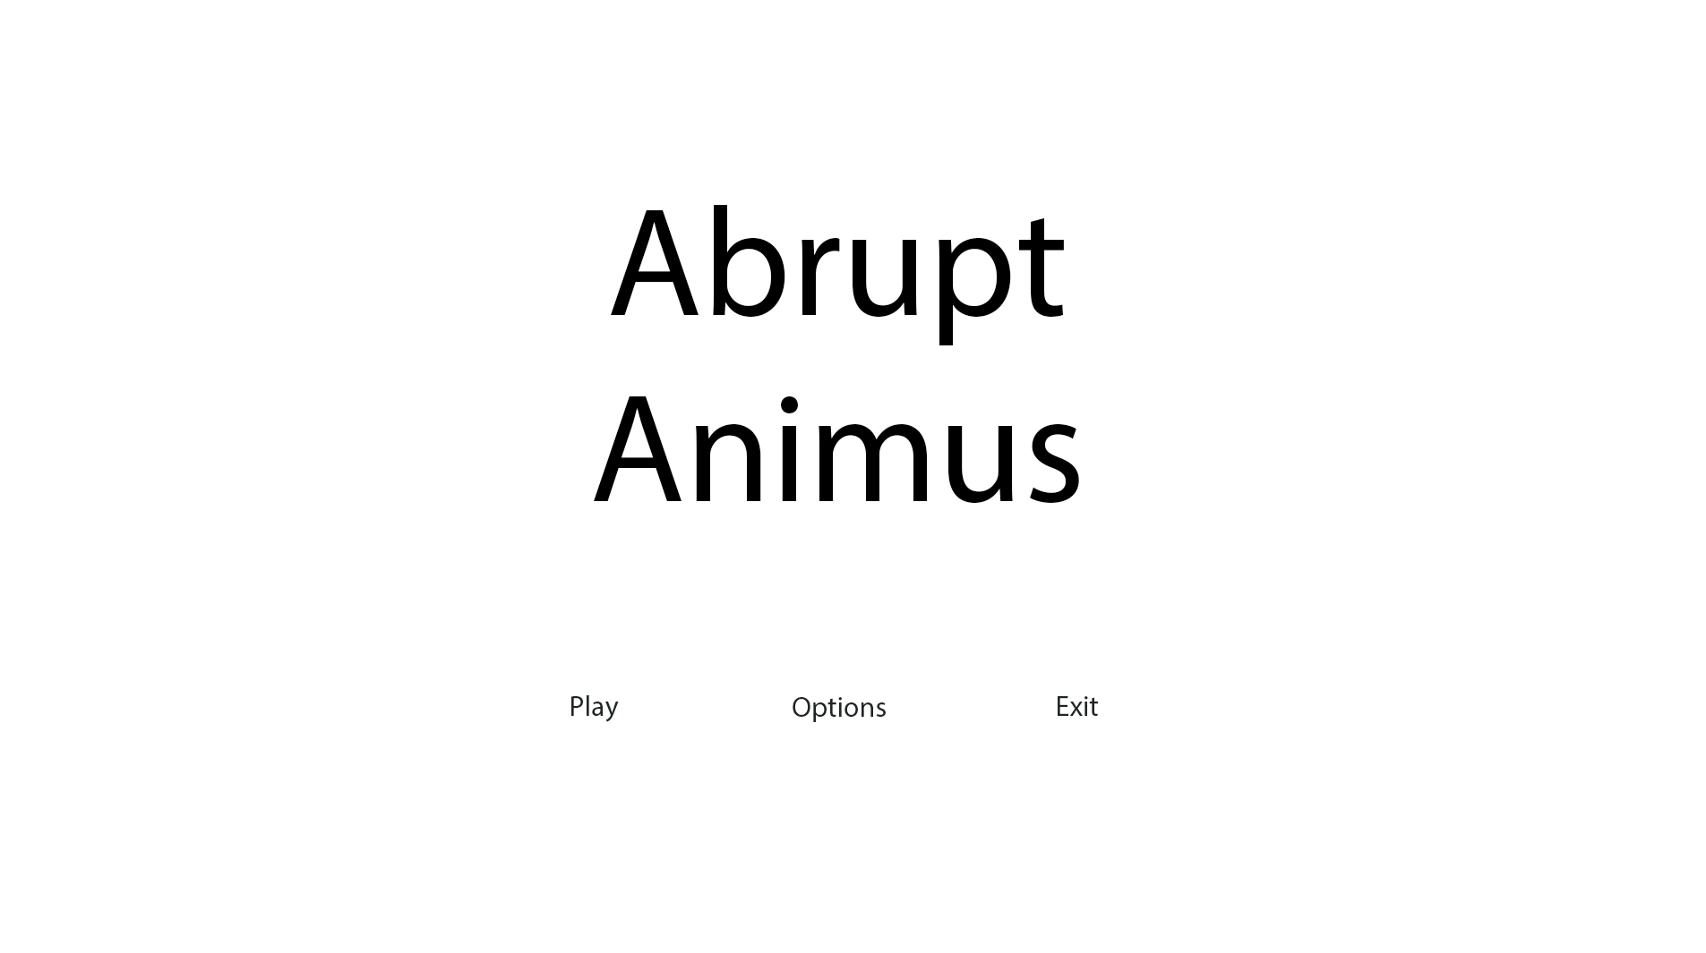

*SillyAustralian*: This design is very simplistic and does not fit the tone of the game. Abrupt Animus is supposed to be a stark and emotionally powerful game, and the use of white for the background does not make sense in this case. Perhaps it would be better to change this to a grey, and then hence the text to white.

##### Save Slot Menu:

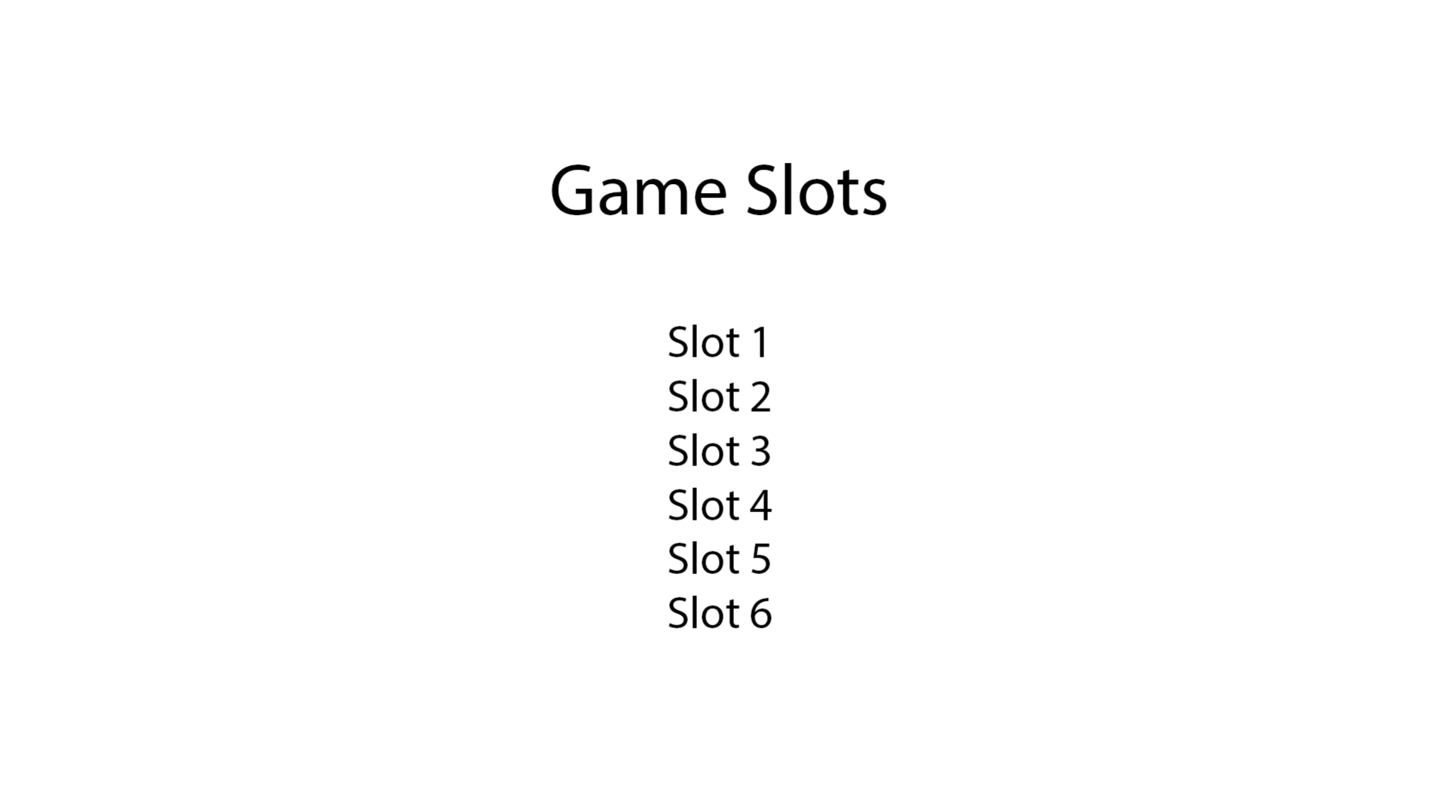

*SillyAustralian*: Similarly with the advice for the Main Menu, the background has to be changed to fit the feel of the game. Other than that, for the save slot menu, we were hoping to implement the slots as a sideways-scrolling menu instead of a list. This way, we could display some more superficial information about each save file so the player can easily recognise which save was the one they wanted. Could you instead make the slots to be black boxes that have the slot number, the current level, and the time spent in that save?

##### Game HUD:

For the Game HUD, since the elements have been placed in many different positions across many different games of the same genre, I decided it would be better to give both my stakeholders the form to complete and pass to some of their top executives. As such, I was able to receive 6 responses in total, which decided the position of these elements. The survey also contained any optional extra elements that could potentially be added.

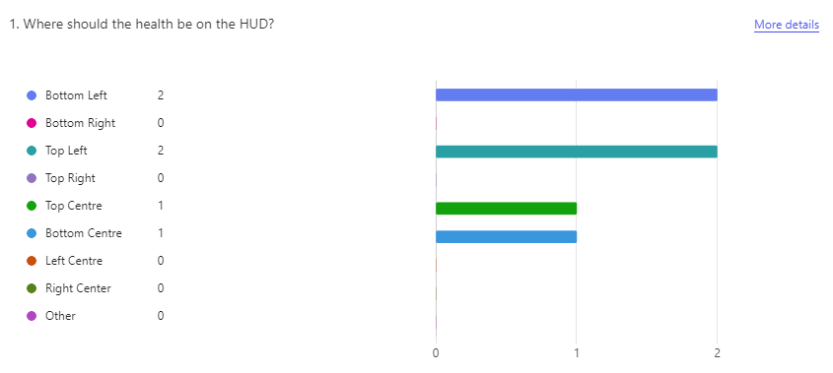

This ended with a tie between bottom left and top left, and I decided that keeping all the elements at the bottom of the screen would leave more space on the top of the screen, encouraging the player to look up and forward, and not at the ground. Hence, the health bar would be placed in the bottom left.

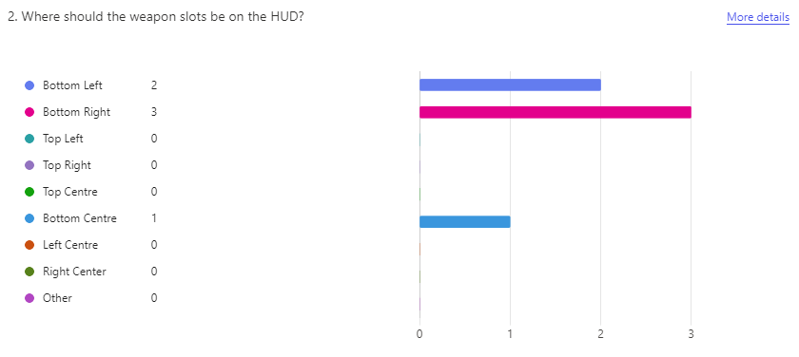

It was a clear winner that the weapon slots, meaning the currently equipped weapon and the next and previous weapons, should be placed in the bottom right, which separated the health bar and the weapon slots. This may be beneficial for the player since it does not confuse them when they need to only look at their health, which is the most important information to the player in the game.

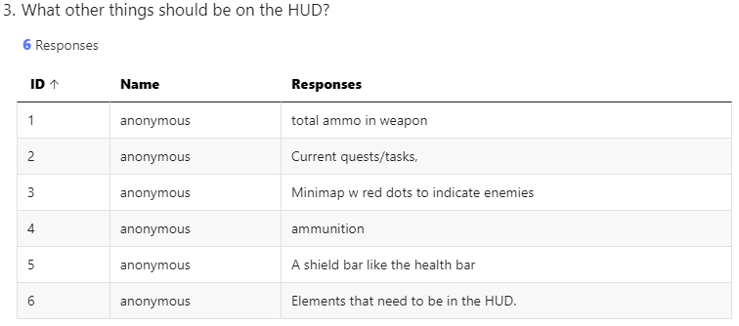

As for extra elements, response 3, 5, and 6 were not helpful, since these options were not in the original request for the game, nor was there time to implement such features. Response 2 had the potential to be useful, if time permits the inclusion of a quest system, but it is highly unlikely that would be the case. Finally, response 1 and 4 both indicated that the ammunition in the weapon should also be displayed on the HUD, and as such, these features would be displayed on the HUD, resulting in the below design:

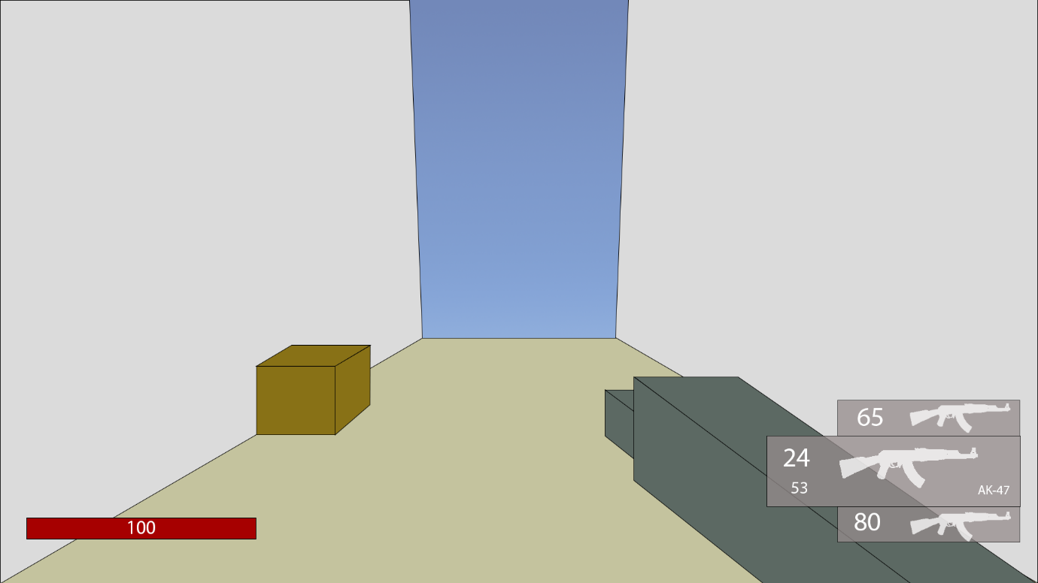

##### Choice

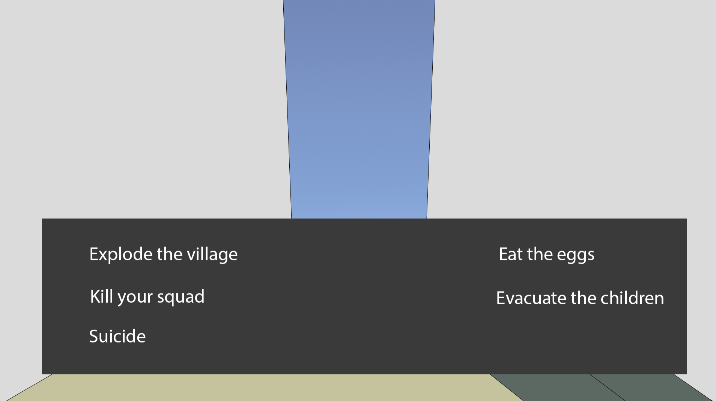

*SillyAustralian*: This design is almost ready right from the start, however, it would be better if it wasn’t completely opaque, so that the player can also plan their next moves once they have finished their choice. There also needs to be a border around the choice box to clearly mark it off from the rest of the screen and make it clear.

##### Subtitles:

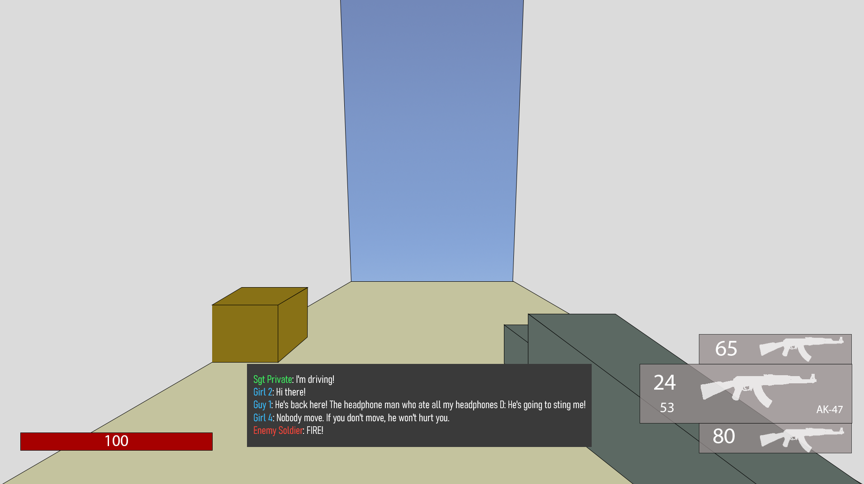

*SillyAustralian*: The subtitles suffer from the same issues as the choice menu, and as such the same changes need to be applied.

##### Pause Menu:

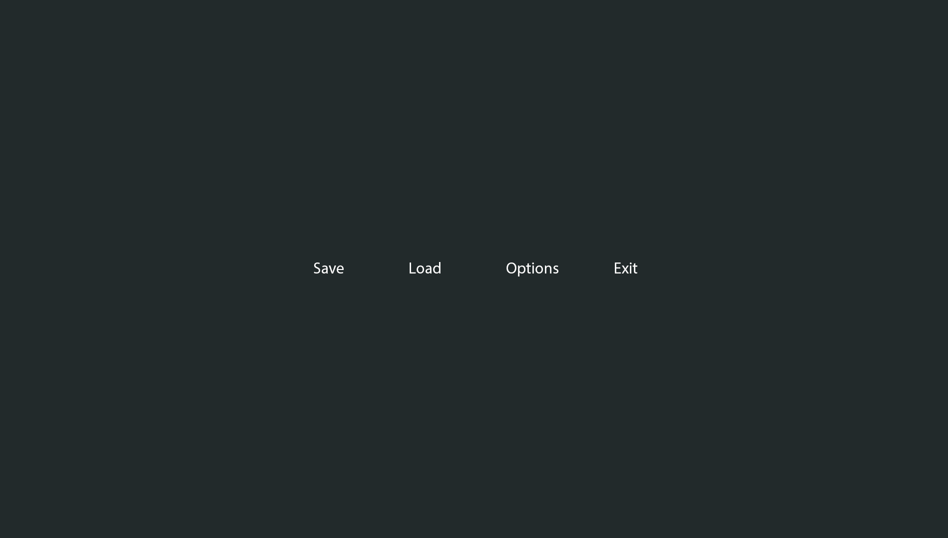

*SillyAustralian*: When in the pause menu, the player should still be able to see some of the game world, so this menu should not be a stark background, but instead it should be slightly transparent. Furthermore, this needs to have the buttons arranged vertically, with the same box background behind them.

#### 2nd:

##### Main Menu:

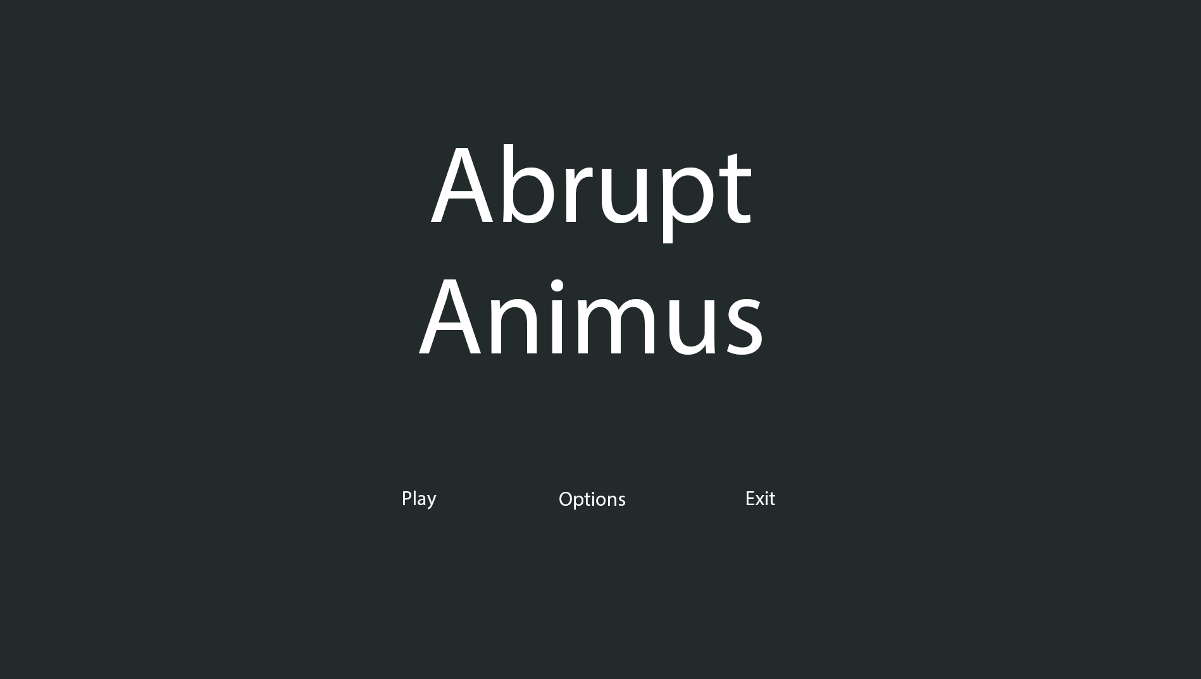

*SillyAustralian*: This is much better than the previous design, however it is now difficult to see where the buttons are. Furthermore, we wish to attract the player to playing the game, not exiting it. Maybe try changing the buttons to be vertical and adding a white background to them.

##### Save Slot Menu:

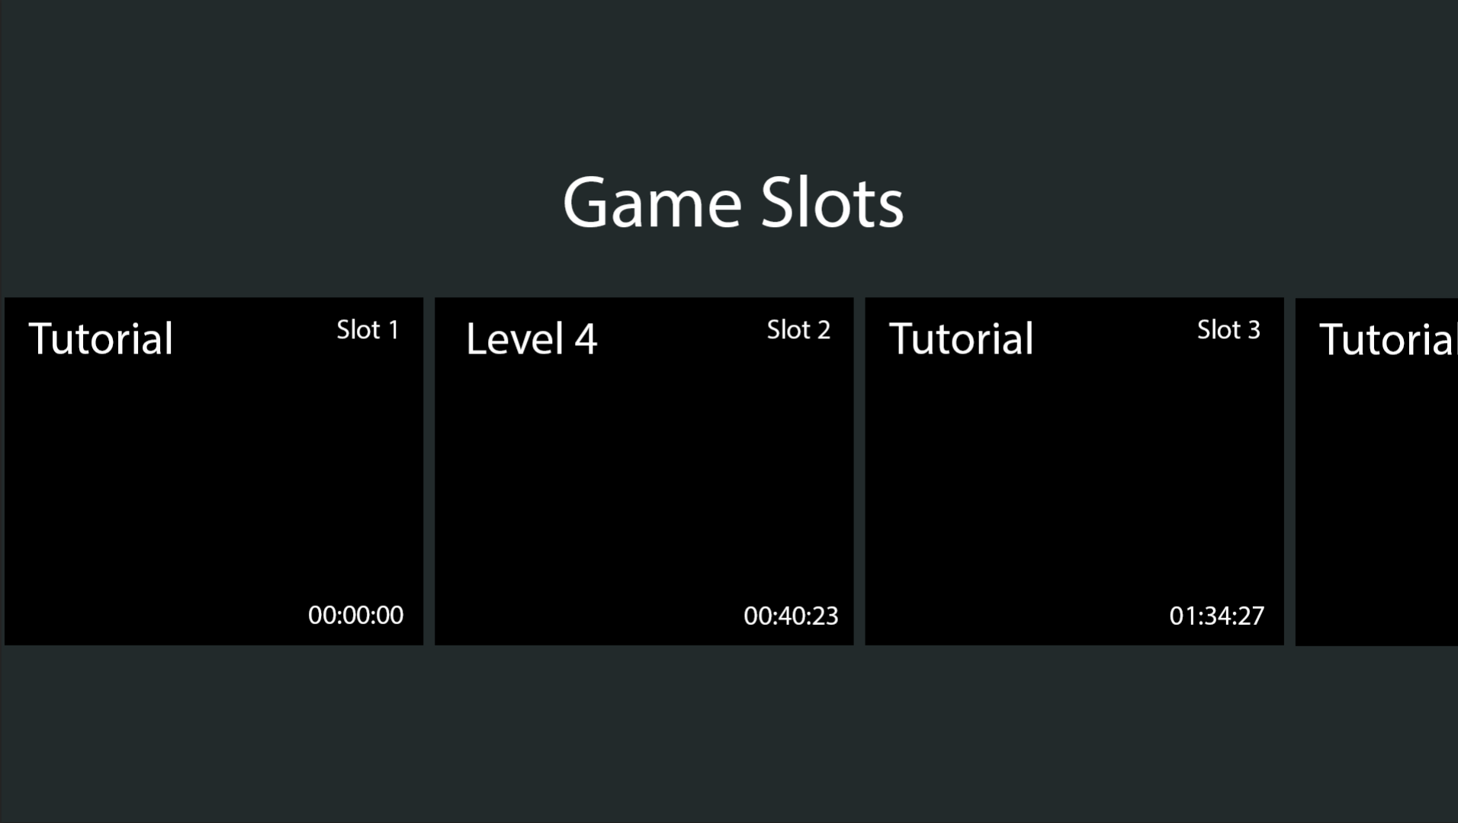

*SillyAustralian*: The text ‘Game Slots’ is far too close to the actual slots, so we would like this moved upwards. Furthermore, it seems that the buttons to make a new save and load the current save are missing, so if you could add that at the bottom of the screen, that would be much better.

##### Pause Menu:

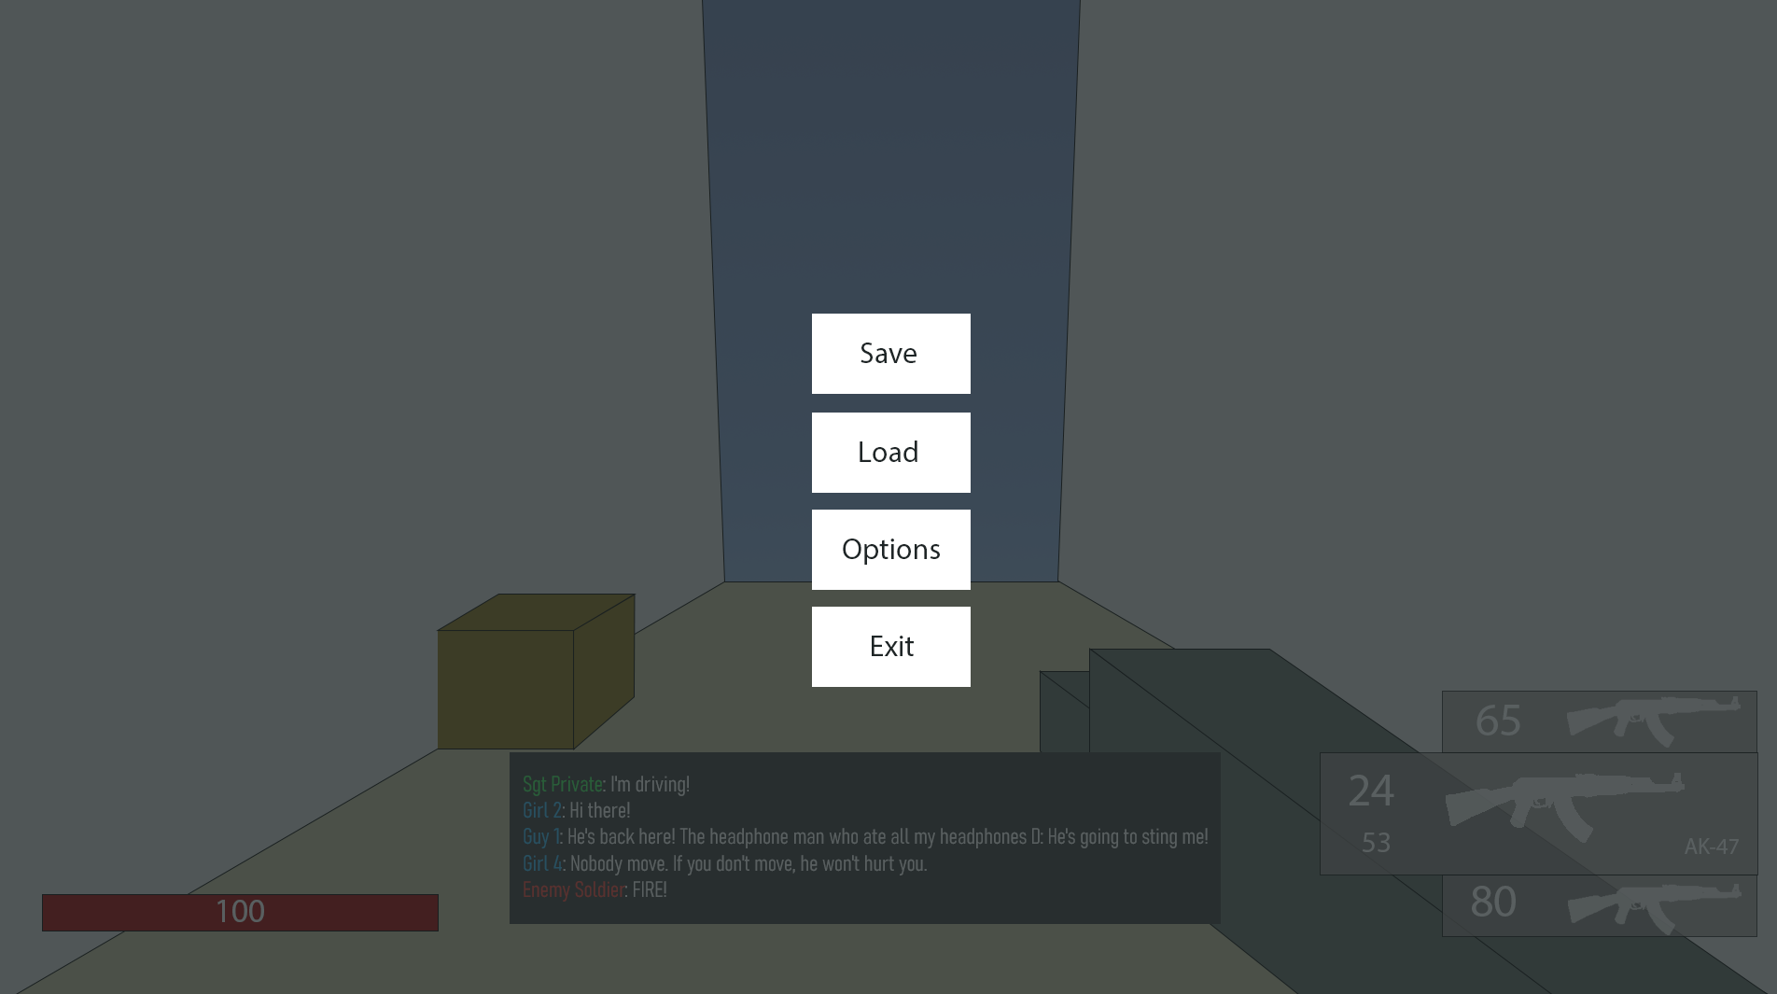

*SillyAustralian*: The only change here that is needed is that the normal game HUD needs to be turned off when the player is in the pause menu, so only the gun and environment needs to remain.

#### 3rd:

##### Main Menu:

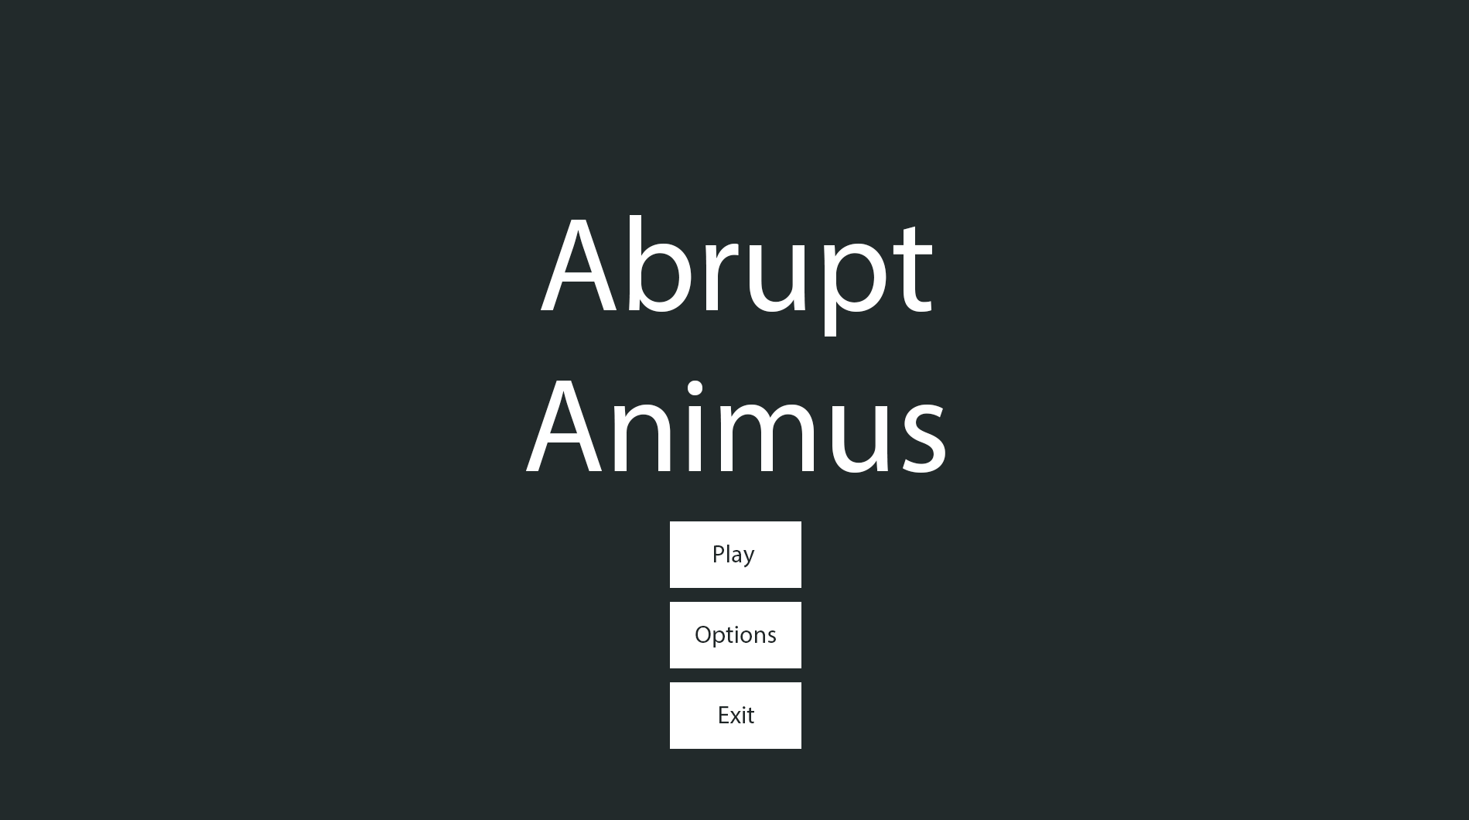

*SillyAustralian*: This is getting closer to what I had imagined in my head! Just two final points from me:

* We, as a company, have decided that we would also like the version number of the game, so could we have this in the bottom left?
* There is too much negative space at the top of the screen, so maybe we can push all the current elements upwards?

##### Save Slot Menu:

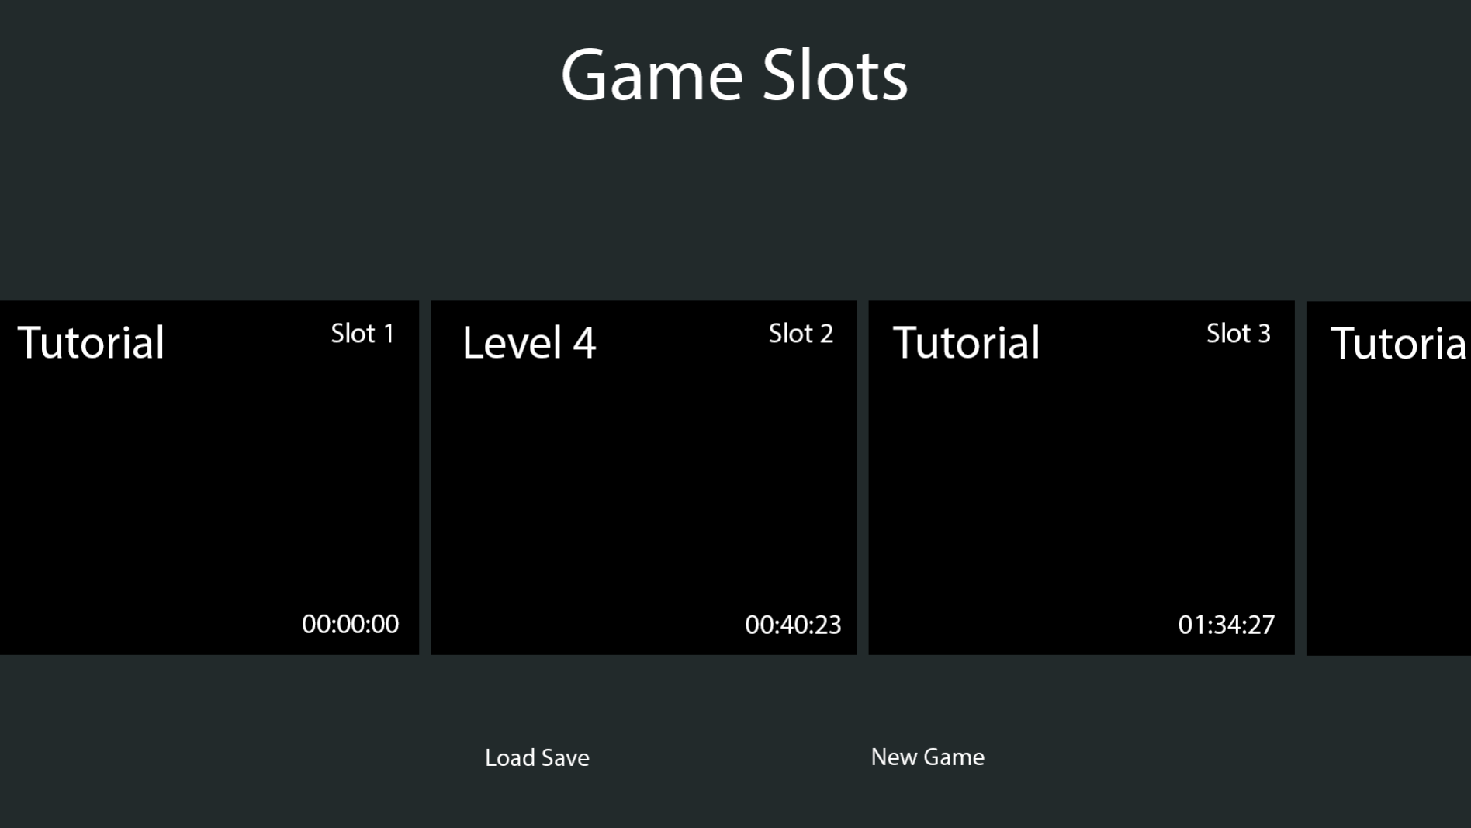

*SillyAustralian*: The buttons for the loading and creating of saves requires a background, just like the ones on the Main Menu design. There also needs to be a backdrop to the slots menu and the button panel at the bottom to make them pop out.

*Me (Eshan Fadi)*: Just thinking from an implementation point of view, I’ve realised that there would also need to be a button for reloading the save slots, so should I add that to the button panel on the left side?  
*SillyAustralian*: Hmm, I see. In that case, you should put the reload button on the right, since the ‘New Game’ button should be in the centre.

#### Final Agreed Designs:

##### Main Menu:

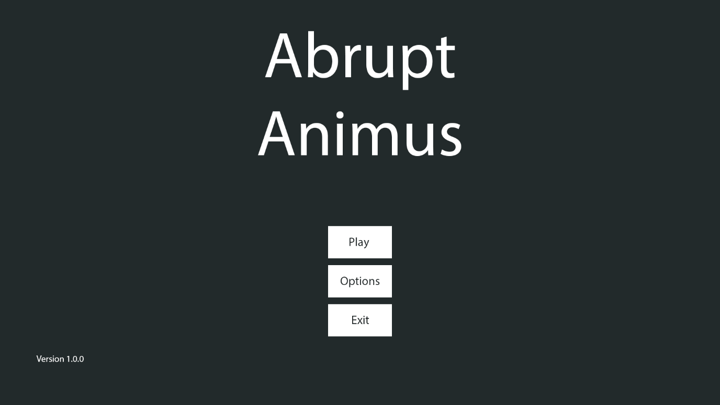

##### Save Slot Menu:

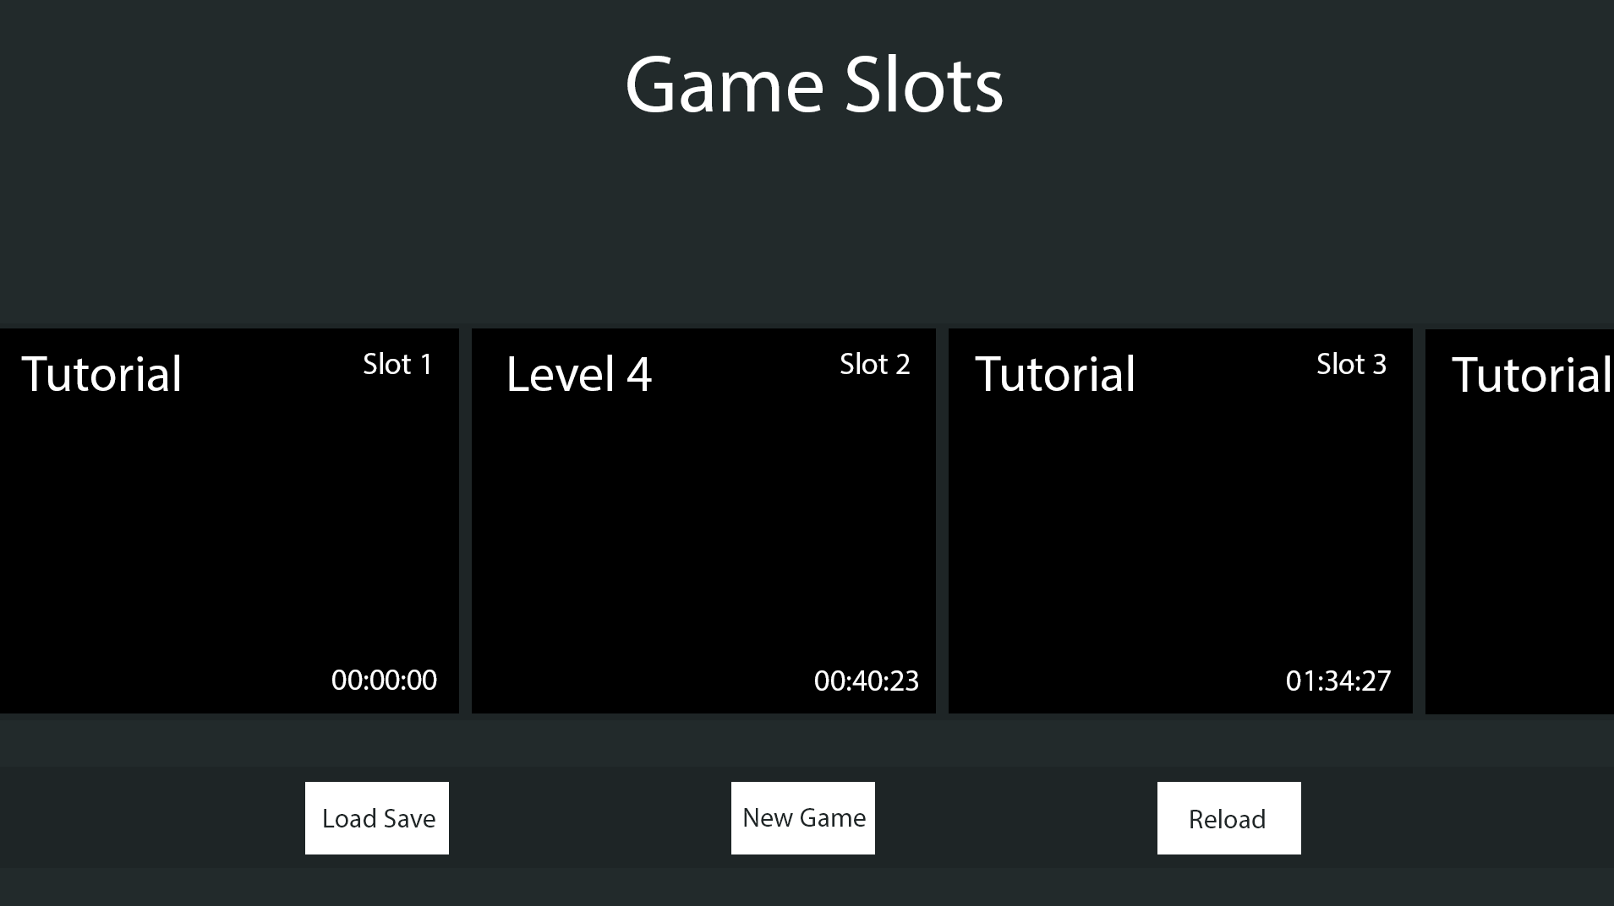

##### Game HUD:



##### Choice:

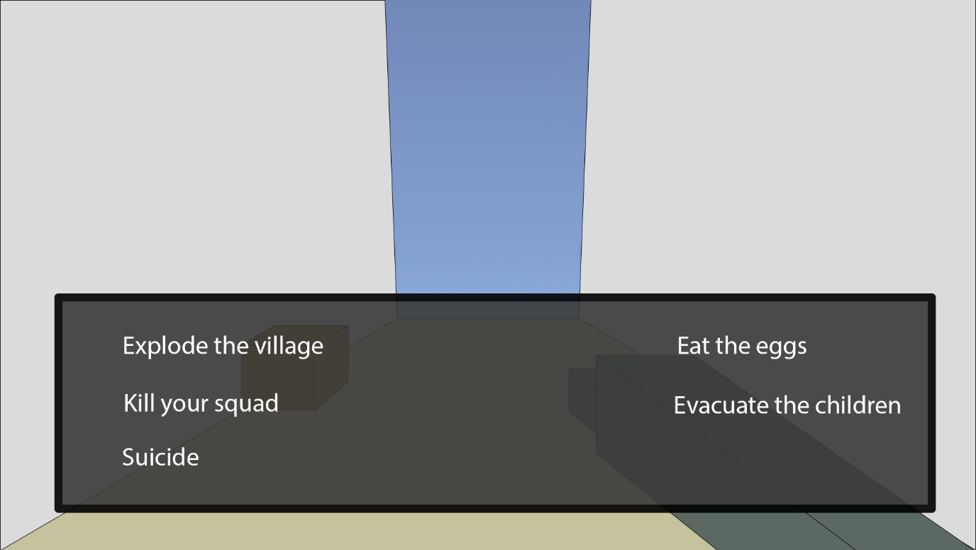

##### Subtitles:

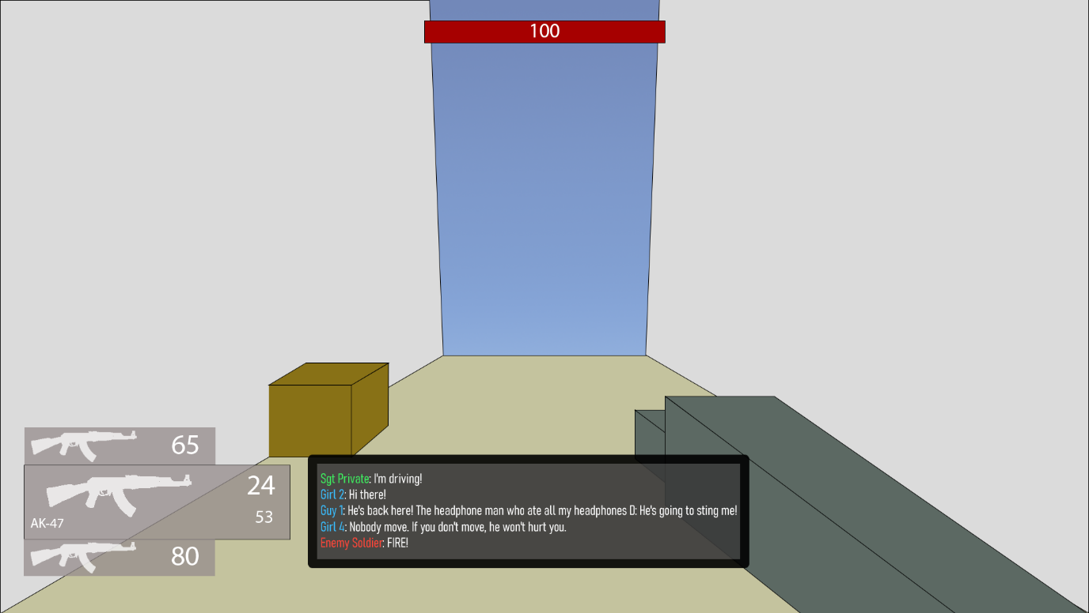

##### Pause Menu:

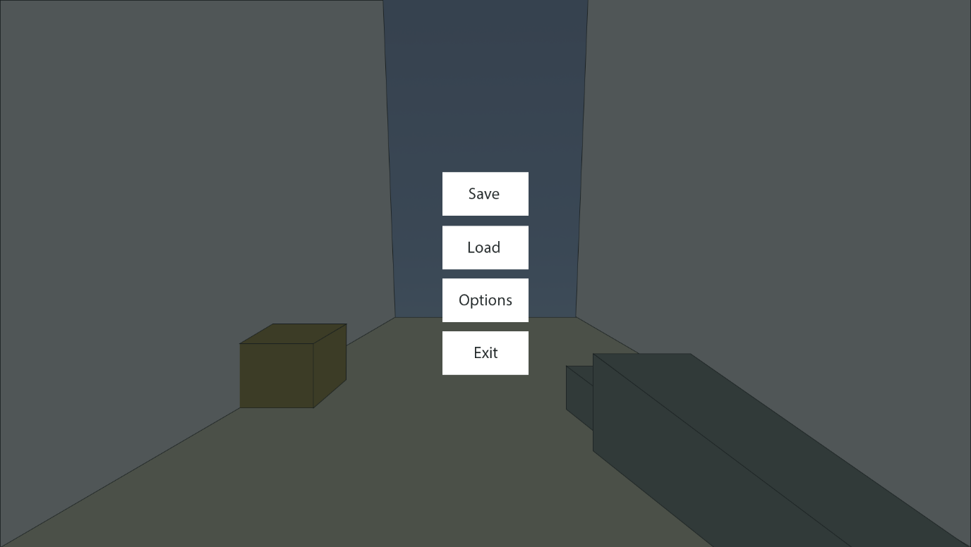

## Variables and Data Structures

|  |  |  |
| --- | --- | --- |
| Type | Name | Justification |
| Movement | | |
| Float | maxSpeed | Limits the player’s speed so that they don’t go too fast and break the game |
| Vector3 | movement | Contains the total movement of all the different movement functions, which is then applied together at once |
| Float | standingHeight | The height of the player when standing |
| Float | crouchingHeight | The height of the player when crouched |
| Bool | isGrounded | Used by the gravity and jump functions to check if the player is touching the ground |
| Float | maxSlope | Used by the collision detection function to partition collisions into floors and walls |
| Float | gravity | How fast the player should accelerate downwards |
| Float | jumpForce | The speed the player leaves the floor when jumping |
| Int | airJumpsTotal | An upgradeable value that makes sure that combined with airJumpLeft, controls the ability to jump in midair |
| Int | airJumpsLeft | Makes sure that the player can’t jump away too far |
| PlayerMovementState | movementState | The current state the player is in such as walking or crouching |
| PlayerMovementState | lastMovementState | Used by the crouching function to check whether the player has changed to crouching from a previous state to then change the player’s dimensions |
| Float | friction | A percentage of the player’s speed that is taken away per frame while on the ground |
| Float | drag | Same as friction but for in the air |
| Bool | holdCrouch | Stores the state of the key responsible for the crouch that must be held |
| Bool | toggleCrouch | Stores the state of the key that can toggle crouching |
| Bool | lastHoldCrouchState | Used to detect a change in the state of holdCrouch |
| Dialogue | | |
| Database | Dialogue | A database is the best way to store similar/linked versions of the same piece of data such as different languages of text and select the right language at the appropriate moment. See below for in depth. |
| Tree | fileTree / lineTree | A tree is the most common method for tracking information for an interpreter, and since this interpreter does not need to track variables and the like, this can be much simpler. |
| Int | choice | Tracks which option the player chose in choices |
| Int | lineNumber | Tracks what line of the file the interpreter is on |
| Dictionary<string, int> | dialogueSections | Stores the appropriate sections and the lines to jump that they start on |
| Save System | | |
| Text File | Save Lookup | This needs to be used to quickly load the last used save on a slot |
| TMP_Text | scene | A reference to the text object on the GUI that is the scene name of the save file. |
| Dictionary<string, string> | lookup | A usable form of Save Lookup for the code to use |
| List<SaveSlot> | slots | Used in the slot displaying system by the GUI after retrieving a list from the SaveSystem |
| Class | SaveSystem | A static class with functions handling saving the player’s data, loading that data into the game, and listing out the saves for external systems. |
| Class | SaveSlot | A temporary container used for the save slot GUI with basic information about a save slot to minimise memory usage. |
| Entities | | |
| Class | Entity | Handles health and damage |
| Class | PlayerEntity | Inherits Entity, allows the player to improve their maximum health |
| Class | EnemyEntity | Inheriting Entity, it implements AI searching, moving, and attacking, along with communicating with a commander. |
| Class | Drone | Inherits EnemyEntity, modifying functions to move in 3 dimensions instead of one the ground. Has far detection range and high speed but weak |
| Class | Soldier | Inherits EnemyEntity, moves on the ground with low detection range and average movement abilities and health |
| Class | Tank | Inherits EnemyEntity, moves on the ground with extremely far detection range and high health but extremely low speed |
| Float | MaxHealth | A property containing the maximum health the entity can reach |
| Float | Health | A property disclosing the current health the entity has |
| Float | DefenseMultiplier | A property that denotes how much less damage the entity takes |
| Float | HealingMultiplier | A property that is used to increase how much healing an entity will experience |
| Vector3 | searchingTarget | A location for the enemy to move towards while it is searching for the player |
| Float | MaxMoveSpeed | A property used as a limit on the PID controller’s output |
| Float | RotationSpeed | A property controlling how fast the entity rotates |
| Float | FarTargetRange | A property that is used in tandem with NearTargetRange to control midrange |
| Float | NearTargetRange | A property that is used in tandem with MaxTargetRange to control midrange |
| Float | DetectionRange | A property used to control how far the enemy can set the target |
| Float | proportionalGain | Used by the PID controller to control how fast the entity reaches the target |
| Float | derivativeGain | Used by the PID controller to control how fast the enemy slows down upon reaching the target |
| Float | integralGain | Used by the PID controller to resist any constant forces (like gravity) |
| Vector3 | lastError | Used by the PID controller to track the error for calculating the derivative |
| Vector3 | lastPosition | Used by the PID controller to track the movement for calculating the derivative |
| Vector3 | storedIntegral | Used by the PID controller to sense any continuous errors over time |
| Float | maxStoredIntegral | Used by the PID controller to limit how much error is stored |
| Weapons | | |
| String | WeaponType | An ID for the weapon, allowing it to be loaded by the save system |
| Int | TotalAmmo | The total number of shots left before more ammunition needs to be picked up |
| Int | AmmoInClip | The total number of shots left before the weapon needs to be reloaded |
| Class | Weapon | An abstract class that mandates a method Fire(), a weapon type, the ammunition left in a weapons clip, and the total ammunition a weapon has |
| Class | Gun | A ranged weapon that fires bullets, dealing damage |
| Class | Blade | A melee weapon using a collider to deal damage |
| Class | Explosive | Deals damage to all entities within its range |

### Enumerators

Enumerators are more human readable way for the states of an object. Instead of having:

if gameState == 0 then

print(“Game has ended”)

else if gameState == 1 then

print(“Game is running”)

. . .

You could instead have an enumerator which names the states and makes it easier to read and remember. It’s far easier to remember if the state is equal to running, instead of remembering that the state is equal to 5, which is running. This is hugely beneficial for maintainability which is what the primary stakeholder required – that the game was easily maintainable and could be improved by other people.

#### PlayerMovementState:

* Idle
* Crouching
* Sliding
* Walking
* Sprinting
* Boosting
* Wallrunning

#### DerivativeType:

* Velocity
* Error

#### MemberState:

* None
* Searching
* Combat
* Dead

### Databases

This project uses a few databases throughout the game to store certain predefined constants. For saving and changing variables, other types of files are used as appropriate to the industry standard, such as level data being stored within the player’s save file instead of a database.

#### Dialogue:

This database contains 2 tables that are not linked to each other through any keys: *Actor* and *Dialogue*. The *Actor* table contains only a primary ID (of type INTEGER) and the respective name of the actor to be used within the subtitles of the system. The *Dialogue* table also contains a primary ID (also of type INTEGER) and the line of dialogue in the next field. However, the field name is the name of the language that you wish to use, allowing SillyAustralian’s company to add support for many other languages if they wish to, and the underlying system will need to have support for this.

#### SceneInfo:

This is a flat file containing information about every scene, such as the start position that the player should be spawned at, whether the player should be allowed to move in this scene, and what the maximum amount of enemies should be, for scoring purposes. Storing the ‘moveability’ of the player is important, as certain scenes may be UI only, and hence the player’s normal game controls should be disabled.

### Naming Conventions

For this project, I will be using the same methodologies for naming parts of the code. This will make the project easy to understand at a glance and will improve the maintainability for when the game is handed over to SillyAustralian.

* Variables / Class attributes – These will be written with camelCase, where the first word is in lowercase, and all subsequent words have the first letter capitalised. Examples include
* Classes / Methods / Functions / Procedures / Class properties – These will use PascalCase, which is also sometimes known as TitleCase with the spaces removed, and this is where all words in the name have the first letter capitalised.

## Class Diagrams

### Entities

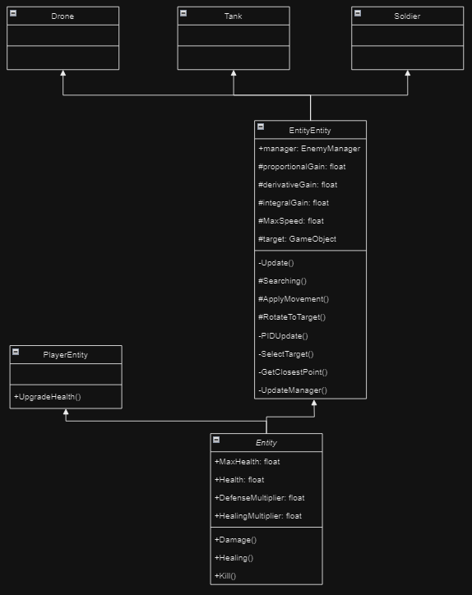

The Entity class system primarily manages the health and damage of the entity it is attached to. However, *Entity* is an abstract class used only as a framework for the PlayerEntity and EnemyEntity. The only extra functionality the player needs is to upgrade their maximum health, while EnemyEntity adds far more functionality to the base class. For enemies, it also provides the functions for its AI and communication systems. While called EnemyEntity, it will also be used for friendly entities, since they have the same use and intent, with only the range of acceptable targets being changed, such as from the Empire to Varsia (the two countries involved in the war).

The main movement the AI will use will be a PID controller, which is used in industrial applications to bring a robot system back to the target without getting stuck in a cycle. It will also be looking for entities opposing it within a cone, limited by its maximum detection range. This tried and tested method is perfect for the enemies.

### Weapons

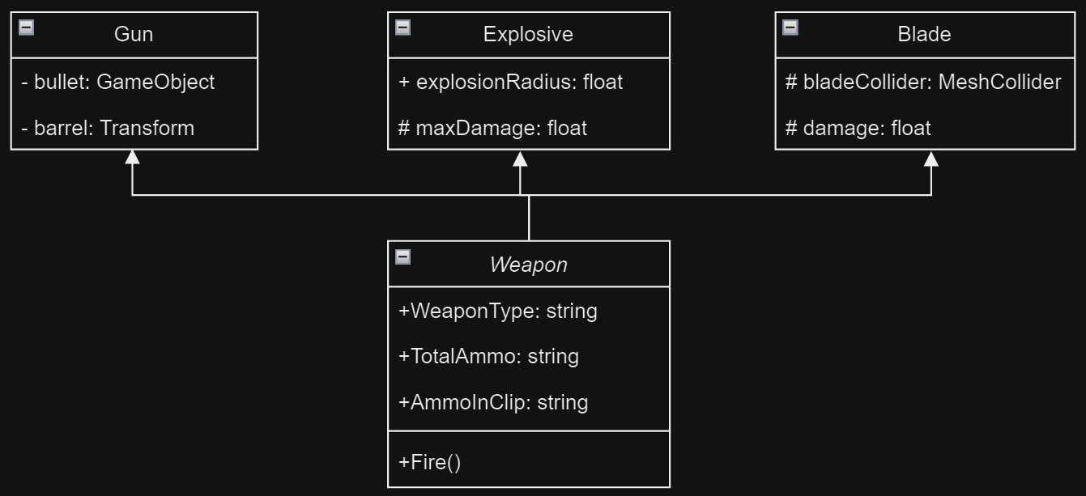

Weapons are how the damage will be dealt to both players and entities in an interactable form. *Weapon* itself is an abstract class that makes sure all following weapons have the correct fields that the save system uses to save their data, while also making sure that weapons have the same public Fire() method that will be used allow scripts that interact with the weapon to use them. This system is also useful for when SillyAustralian wishes to add in more weapons, as OOP makes it easy to add in more weapons, while retaining the previous features, and also combining different weapons for more effects.

## Iterative Tests

These tests will be used constantly during development and will also be updated for whenever new bugs are found and hence test data needs to be created for it. Each test will check for valid, boundary, and erroneous data where applicable. Valid data must pass no matter what, and similarly should boundary data. Meanwhile, erroneous data should not pass through and this may be data that is redundant and should not affect the expected output. All of the 3 tests are important as a game is likely to be pushed to its extremes in all shapes and forms during gameplay, and so to keep the player’s experience as enjoyable as possible, the amount of issues and bugs that slip through must be kept to a minimum.

### Strafing

|  |  |  |  |  |  |
| --- | --- | --- | --- | --- | --- |
| Type | What data fits criteria | Justification | Expected | Actual | Comments |
| Valid | Pressing the W/A/S/D keys alone and in combinations while moving at a wall | These keys allow the player to move in 8 directions once used in the correct combinations and moving at a wall which is required to test the algorithm | The character will accelerate in the direction held until the maximum speed is reached or the direction is released |  |  |
| Boundary | Pressing opposing directions – A and D, S and W | This is possible input that a player might momentarily input as they switch directions, but since it is created from both valid inputs, but results in a different output, it should also be tested. | Combining these keys should result in no movement since they lead to movement in opposing directions |  |  |
| Erroneous | Pressing another key (e.g. M) | Keys not used for movement should not produce any movement | The player will remain still |  |  |

### Looking

|  |  |  |  |  |  |
| --- | --- | --- | --- | --- | --- |
| Type | What data fits criteria | Justification | Expected | Actual | Comments |
| Valid | Moving the mouse up and down | This is the entire input base that the player should be using for looking around | The character will look around normally |  |  |
| Boundary | Moving the mouse really far | This is to check that there is no snapping in the movement and that the system is capable of large movement values | The character will look around really fast |  |  |
| Erroneous | No movement | It is important to check that the system does not continue drifting while the player is not moving the mouse | The camera will be still |  |  |

### Boosting

|  |  |  |  |  |  |
| --- | --- | --- | --- | --- | --- |
| Type | What data fits criteria | Justification | Expected | Actual | Comments |
| Valid | Pressing Q | This should be the only key used for boosting, and hence should respond appropriately | The player’s speed increases by a huge amount |  |  |
| Erroneous | Pressing another key (e.g. M) | Keys not used for boosting should not activate it | The player will remain at their current speed |  |  |

### Jumping

|  |  |  |  |  |  |
| --- | --- | --- | --- | --- | --- |
| Type | What data fits criteria | Justification | Expected | Actual | Comments |
| Valid | Pressing the jump key | As the only input being used to jump, it is important that it works | The character will move upwards, then move back down |  |  |
| Erroneous | Pressing another key (e.g. M) | Since there is only one input, nothing else should cause the player to jump, and if there is, that means something is significantly broken | The player will remain still |  |  |

### Crouching

|  |  |  |  |  |  |
| --- | --- | --- | --- | --- | --- |
| Type | What data fits criteria | Justification | Expected | Actual | Comments |
| Valid | Pressing the crouch key | This is input that the player will use, and hence needs to be tested appropriately | The player’s height will be shrunk |  |  |
| Erroneous | Pressing another key (e.g. M) | An input not related to the test should not affect the test | The player will remain at their standing height |  |  |

### Different crouch keys

|  |  |  |  |  |  |
| --- | --- | --- | --- | --- | --- |
| Type | What data fits criteria | Justification | Expected | Actual | Comments |
| Valid | Pressing the toggle crouch key | Each input must be tested separately to verify that they work | The player will crouch |  |  |
| Valid | Holding the hold crouch key | Each input must be tested separately to verify that they work | The player will crouch for the duration that the key is held |  |  |
| Boundary | Pressing the toggle crouch key and then the hold crouch key, and then releasing it | As was specified in the first interview, the held crouch must take priority over | The player will crouch and then uncrouch when the hold crouch key is released |  |  |
| Erroneous | Pressing another key (e.g. M) | An input not related to the test should not affect the test, and hence checks that the input system is still working as expected | The player will remain at the same height |  |  |

### Looking and strafing combined tests

|  |  |  |  |  |  |
| --- | --- | --- | --- | --- | --- |
| Type | What data fits criteria | Justification | Expected | Actual | Comments |
| Valid | Moving the mouse up and down while moving in a circle | This combines all the looking actions with all the movement options and is also covers the most typical of a player’s movement style | The character will look around and the player will move around relative the current looking direction. |  |  |
| Boundary | Moving the mouse really far while moving in a circle | This is to check that there is no snapping in the movement and that the system is capable of large movement values, while maintaining movement | The character will look around really fast and will move accordingly |  |  |
| Erroneous | No movement | It is important to check that the system does not continue drifting while the player is not moving the mouse | The camera will be still and the player will not move |  |  |

### Fire

|  |  |  |  |  |  |
| --- | --- | --- | --- | --- | --- |
| Type | What data fits criteria | Justification | Expected | Actual | Comments |
| Valid | Pressing the fire button while there is enough ammunition remaining | This is the most common action the weapon will encounter and therefore is suitable as a valid test | The gun will fire 1 bullet |  |  |
| Boundary | Pressing the fire button while there is no ammunition remaining | It is important the system still acts accordingly when there is no ammunition in the clip remaining | The gun will reload |  |  |
| Erroneous | Pressing another key (e.g. M) | Any inputs not related to the system should not affect it | The gun will not fire |  |  |

### Reload

|  |  |  |  |  |  |
| --- | --- | --- | --- | --- | --- |
| Type | What data fits criteria | Justification | Expected | Actual | Comments |
| Valid | Pressing the reload button when there is no ammunition left in the clip, and there is enough ammunition remaining in total | This is the next most common action the weapon will encounter and therefore is suitable as a valid test | The gun will reload back to full |  |  |
| Boundary | Pressing the reload button when there is ammunition left in the clip | It is important the system still acts accordingly when the player reloads before they need to | The gun will reload back to full and only take as much ammo as needed |  |  |
| Erroneous | Pressing another key (e.g. M) | Any inputs not related to the system should not affect it | The gun will not reload |  |  |

### Swap weapon

|  |  |  |  |  |  |
| --- | --- | --- | --- | --- | --- |
| Type | What data fits criteria | Justification | Expected | Actual | Comments |
| Valid | Scrolling the scroll wheel in either direction | The player will want to change the current weapon based on the scenario and therefore this is suitable as a valid test | The selected weapon will change relative to the direction the player scrolled in |  |  |
| Boundary | Scrolling very fast in either direction | It is important the system still acts accordingly when the player may put it under stress | The currently selected weapon should change accordingly |  |  |
| Boundary | Scrolling when all the weapon slots are not filled | It can occur that all the player’s weapons slots are not filled and as such the scrolling should still respond correctly, even though this is a rare case. | The system should continue wrapping with the remaining weapons and change the weapons accordingly. |  |  |
| Erroneous | Pressing another key (e.g. M) | Any inputs not related to the system should not affect it | The current weapon will remain selected |  |  |

### Add weapon

|  |  |  |  |  |  |
| --- | --- | --- | --- | --- | --- |
| Type | What data fits criteria | Justification | Expected | Actual | Comments |
| Valid | Adding a weapon while there is space available | The player will want to change the current weapon based on the scenario and therefore this is suitable as a valid test | The weapon will be added to the list with no other weapon removed, and will swap to that weapon |  |  |
| Valid | Adding a weapon while there is no space available | The player will want to change the current weapon based on the scenario, and this is the more common way to acquire a weapon | The weapon will replace the current weapon |  |  |
| Erroneous | Pressing another key (e.g. M) | Any inputs not related to the system should not affect it | The current weapon will remain selected |  |  |

## Post Tests

While containing similar test data to the iterative tests, these tests will be run at the end of the timeframe and will be used to evaluate how the project has progressed and where it has succeeded and where it has failed.

# Development

## Prototype 1

### Input Detection

To handle the detection of many different actions from many different input sources, I will be using Unity’s built-in Input System package. Within this, I can set up different input maps, such as ‘Player’, and each of these maps have different actions, such as ‘Fire’, and ‘Jump’. I can easily assign to each of these actions multiple different input types that activate them. Actions are a special version of an event, which is a way for functions to be run when something happens. So, when the user presses one the inputs, the related action emits a signal to all the event’s subscribers (the term for functions listening for the event), which all activate simultaneously. This is how the game senses the inputs.

Since multiple input maps can have actions that are enabled with the same inputs, only one input map must be enabled at any time, and the same instance of the input map must be used across all scripts. To follow this criterion, a script called PlayerManager.cs exists, of which one of its functions is to instantiate a new set of inputs and enable the Player input map the moment the game starts. The reference to this map is public, meaning any class wishing to get the inputs of the user needs only reference this variable. Similarly, if the map needs to be changed, such as one used to handle UI, any script can do so, and it will permeate across all, making sure that no unintended actions occur when the player is intending to do something else.

Testing input maps

### Movement

Movement is the most important aspect, and as such, a lot of time has been spent implementing many aspects of the movement. I originally started with a rigidbody method. This works in tandem with the built-in Physics system of Unity where all movement inputs are applied with forces to the player. First, we define many variables that are required, such as the maximum walking speed, the friction, and the current movement state, among others.

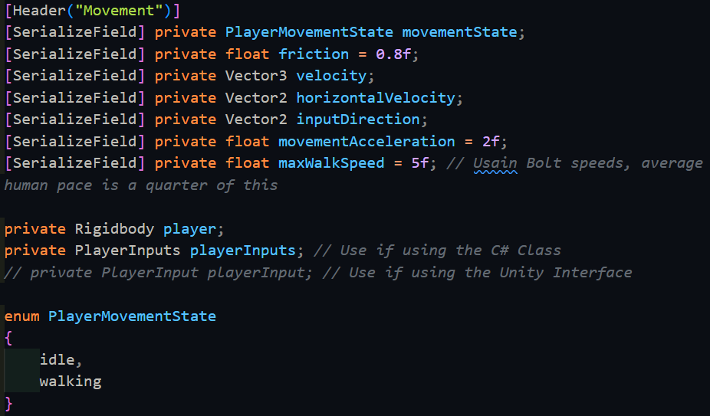

When the object is initialised, we need to fetch the player’s rigidbody, along with enabling the player’s inputs. Also, at the start of the game, since the player is not moving, they are idle and so this must be set as well.

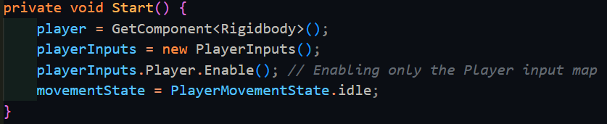

After that, we begin the code for what happens every frame (in Update() ). This includes retrieving the player’s velocity and copying it to an internal variable, along with deciding what the player’s movement state is. Then we need to take the movement inputs, decide the required movement amount, then apply friction. Furthermore, we need to make sure to limit the player’s speed, and then finally send the resulting change to the Physics system.

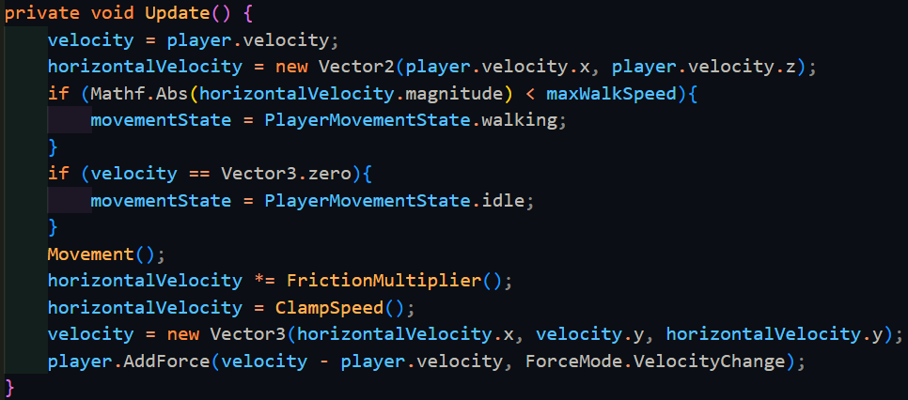

You have to make sure to take the absolute of the ground velocity’s magnitude (horizontalVelocity.magnitude) when comparing it to the maxWalkSpeed. FrictionMultiplier() is a relatively simple function, as it is only an if statement. Multiplying the output to a vector will result in the remaining velocity if friction was applied.

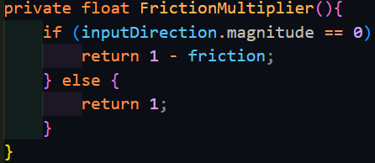

Similarly, ClampSpeed() is also simple, this time being a switch case statement, since all it checks against is the enumerator I made earlier.

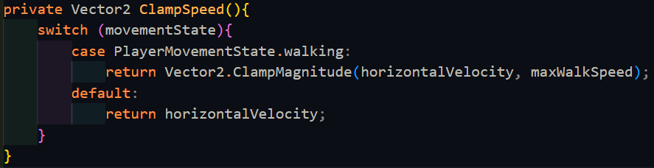

It uses the built-in function Vector2.ClampMagnitude, which scales the first argument (a Vector2) such that if it is higher than the second argument, it makes the vector smaller until it reaches the second argument. In case the state reached is not recognised, by default the vector is returned to not mess with it.

Finally, Movement() is the most complicated function out of all of these. So long as the player’s wants to move, it will calculate how fast they should be accelerated, and the resulting displacement changed in the time of the last frame. However, it may be that the player wants to move in a direction that they are currently not moving in, and as such these 2 directions need to be smoothly interpolated.

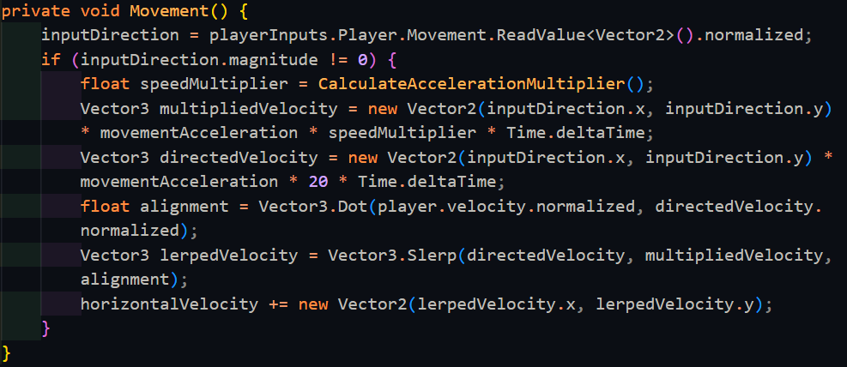

The function internally calls CalculateAccelerationMultiplier() which also uses the enumerator in a switch case statement to return an appropriate acceleration. This also calls a function that is an equation for how much speed should be gained.

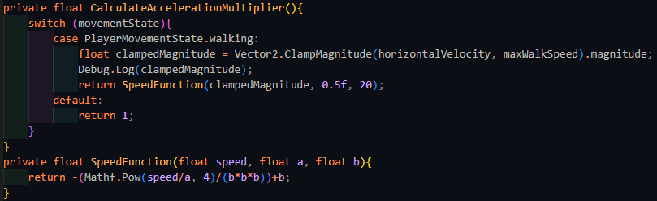

This works completely fine, and there were no bugs with this setup, and as such I attempted to speed this up. This is because Mathf.Pow is an extremely slow function for my needs, due to there being lots of overhead in case it needs to handle non-integer powers. Since I only need to do a predetermined, integer amount of exponentiation, I can rewrite my own quick function to do this with multiplication, which is much faster.

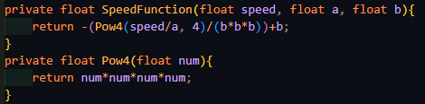

|  |  |  |  |  |  |
| --- | --- | --- | --- | --- | --- |
| Type | What data fits criteria | Justification | Expected | Actual | Comments |
| Valid | Pressing the W/A/S/D keys alone and in combinations | These keys allow the player to move in 8 directions once used in the correct combinations | The character will accelerate in the direction held until the maximum speed is reached or the direction is released | Passed |  |
| Boundary | Pressing opposing directions – A and D, S and W | This is possible input that a player might momentarily input as they switch directions, but since it is created from both valid inputs, but results in a different output, it should also be tested. | Combining these keys should result in no movement since they lead to movement in opposing directions | Passed |  |
| Erroneous | Pressing another key (e.g. M) | Keys not used for movement should not produce any movement | The player will remain still | Passed |  |

At this point, I was ready to move onto Jumping, and hence Gravity. Both of these required knowing about if the player was on the floor or not: one cannot jump if they are in the air (note I am implementing only jumping right now, double jump comes later), and it is faster and a better experience to only apply gravity when the player is not on the ground, otherwise the physics system will have to work overtime trying to make sure you don’t fall through the floor. While rigidbodies in Unity do have a built-in toggle to allow them to have gravity or not, it is better to manually implement gravity with my own constant to better control how the player feels in the game.

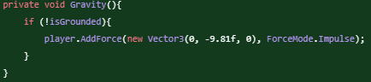

For this to work, however, we need to find out if the player is on the ground or not. Since finding out if the player is on the ground requires interacting with the Physics system, many of the following built-in functions will be from the Physics library, such as the first typical method of using Physics.CheckSphere(). This queries the physics system on whether there is a collision within a specified sphere, defined by radius and centre.

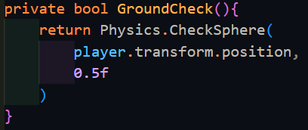

This code seemed to work fine, as when it was run, it did return true when the player was on the ground. To test if it worked when not on the ground, I needed to implement jumping, which should consist of applying a force upwards on the player if they are grounded. With this, we define a new float called jumpForce which we can control in the inspector of Unity.

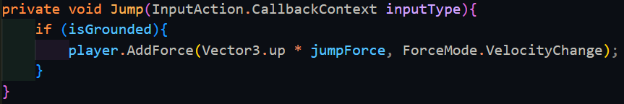

|  |  |  |  |  |  |
| --- | --- | --- | --- | --- | --- |
| Type | What data fits criteria | Justification | Expected | Actual | Comments |
| Valid | Pressing the jump key | As the only input being used to jump, it is important that it works | The character will move upwards, then move back down | Failed: The player continued moving upwards and not coming back down afterwards | The function might be sensing the player all the time instead of ignoring it |
| Erroneous | Pressing another key (e.g. M) | Since there is only one input, nothing else should cause the player to jump, and if there is, that means something is significantly broken | The player will remain still | Passed |  |

Upon binding this function to the Jump action being performed with playerInputs.Player.Jump.performed += Jump, pressing the jump key does indeed cause the player to start rising at a certain speed. Unfortunately, you can still continue jumping infinitely, showing there is indeed a bug with GroundCheck(). Upon closer inspection, the query is sensing that it is inside of the player, and hence that is why it is returning true all the time. Consulting the Unity documentation, CheckSphere() has an overload that takes an optional layer mask, which will exclude objects on those layers from being sensed.

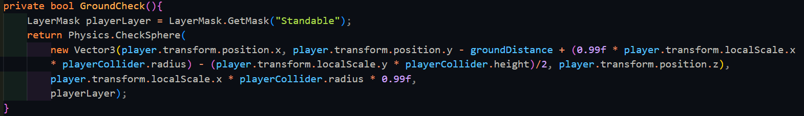

While this is fine, grabbing the layer mask every single time GroundCheck() is run is extremely inefficient and would hurt the player’s performance. Since the value of playerLayer never changes either from scene to scene, it is more efficient to grab the reference once at the start of the game when the script is first run, within the Start() function.

|  |  |  |  |  |  |
| --- | --- | --- | --- | --- | --- |
| Type | What data fits criteria | Justification | Expected | Actual | Comments |
| Valid | Pressing the jump key | As the only input being used to jump, it is important that it works | The character will move upwards, then move back down | Passed |  |
| Erroneous | Pressing another key (e.g. M) | Since there is only one input, nothing else should cause the player to jump, and if there is, that means something is significantly broken | The player will remain still | Passed |  |

The next feature to work on is Boost. This should allow the player to multiplicatively gain speed, so that when they are at higher speeds, they gain a higher boost, encouraging the player to maintain speed. Boost requires that the player’s velocity is simply added back onto itself, with the appropriate multiplication. This new state needs to be added to the PlayerMovementState enum, but it need not be added to the acceleration function, since allowing the player to accelerate at such a high speed will make it difficult to manage their speed effectively. This will also need to be added to the if statement for FrictionMultiplier().

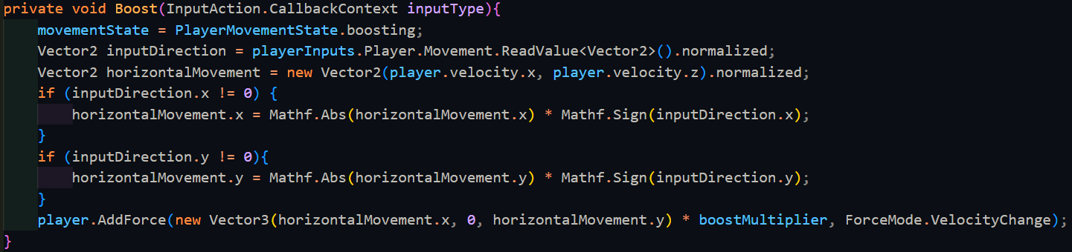

The player’s currently velocity is taken into account and then transformed around to point in the direction that is wanted by the player, so long as that input direction is not 0.

|  |  |  |  |  |  |
| --- | --- | --- | --- | --- | --- |
| Type | What data fits criteria | Justification | Expected | Actual | Comments |
| Valid | Pressing Q | This should be the only key used for boosting, and hence should respond appropriately | The player’s speed increases by a huge amount | Partially | Friction causes boosted speed to be lost far too quickly, or impossible to get past a certain speed. |
| Erroneous | Pressing another key (e.g. M) | Keys not used for boosting should not activate it | The player will remain at their current speed | Passed |  |

While boosting, it typically occurs that the player loses the speed that they gained far too quickly, such that it becomes irrelevant to use past a certain speed. While this could be advantageous, the limit is far too low and not enjoyable to utilise boosting at all. While it is still completely usable, for the player’s experience, I think it would be better to reduce the amount of friction that the player so that they can maintain the speed far easier and for longer. However, I will leave this decision up to the stakeholders:

Stakeholders: Hmm, I do see your point. I think the best solution is indeed your solution, so feel free to change the friction while the player is boosting.

Me: If so, how much should I reduce the friction by?

Stakeholders: Try out a fifth of the friction and I’ll test it out and see how it feels, and then we shall narrow it down from there.

|  |  |
| --- | --- |
| Friction for boost (percentage of normal friction) | Stakeholder comments |
| 20% | This still feels like it is not allowing the player to use the full potential of boost, this needs to go lower. |
| 15% | This feels better than the previous one but it still needs a bit of perfecting. Try going lower. |
| 10% | It feels even better this time! Just to make sure that there isn’t a better one, you should make it just a bit lower and I shall see from there. |
| 5% | Yes, the previous one was the best, this is too little friction, and the player doesn’t noticeably slow down at all. |

Now that I have reached a suitable value for the friction while boosting, I could test it appropriately, since any potential bugs found along the way could potentially be a problem from the specific value of the friction.

|  |  |  |  |  |  |
| --- | --- | --- | --- | --- | --- |
| Type | What data fits criteria | Justification | Expected | Actual | Comments |
| Valid | Pressing Q | This should be the only key used for boosting, and hence should respond appropriately | The player’s speed increases by a huge amount | Failed: the player went through a wall | The game may not be sensing the collision because the player is moving too fast |
| Erroneous | Pressing another key (e.g. M) | Keys not used for boosting should not activate it | The player will remain at their current speed | Passed |  |

The player passing through the wall was one of the most simultaneously difficult and simple issues I have encountered so far. I spent far too long trying to find a solution to this problem, consulting Unity forums and Stack Overflow. As such, I consulted my stakeholder on whether to make the player slower, or to rewrite the movement from the ground up using an alternative I found in my research.

Stakeholder: This is a very drastic solution to the problem. While I absolutely do not want to make the player slower as this is what makes the game fun, this could lose you a lot of time on this project, and as such I will need to cut back on some features.

Me: I have already spent a while trying to fix this and without severely limiting and reducing the player’s experience, I cannot currently see any other way to get around this. The new method will not be as good as the current one, and it may be more difficult to implement, but it is a fix, nonetheless.

Stakeholders: I see. In that case, I’d like to cut back on the weapons and the entities’ AI as these are secondary things that we decided on. Feel free to omit implementing the blades and the explosive weapons, and making the entities be on the player side, or even alert a manager. These are all secondary in face of the movement – the primary genre of this game.

Stakeholder Signature:



[------------------------------------------------------------------------------------------------------------]

The algorithm that I found is a standard in the industry for dealing with an dynamic object colliding with static objects such as wall. It is called Collide and Slide, where its job is in the name – it collides the object with another and slides it across the other’s surface. Certain functions I have already written can be maintained, only needing minor fixes here and there to fit with the controller, that does not use a rigidbody in the same format. Movement() was changed to instead to manually change the velocity off the rigidbody, which is affected by the aforementioned algorithm.

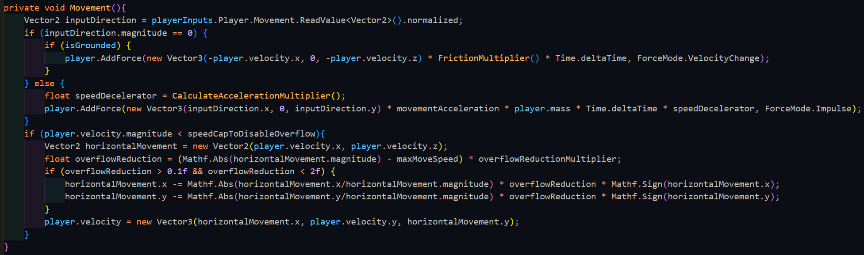

This time, movement handles the player going over the maxSpeed differently: if the player is below a certain speed, it multiplies the overflow speed by an amount which is subtracted from the current speed to slowly reduce the player’s velocity back to the maximum speed. However, if the player is moving above a certain speed cap, the player is deemed as boosting, and the overflow is not reduced. The player also only feels friction once they let go of the movement keys, to make it easier for the player to reach the maximum speed.

|  |  |  |  |  |  |
| --- | --- | --- | --- | --- | --- |
| Type | What data fits criteria | Justification | Expected | Actual | Comments |
| Valid | Pressing the W/A/S/D keys alone and in combinations | These keys allow the player to move in 8 directions once used in the correct combinations | The character will accelerate in the direction held until the maximum speed is reached or the direction is released | Passed |  |
| Boundary | Pressing opposing directions – A and D, S and W | This is possible input that a player might momentarily input as they switch directions, but since it is created from both valid inputs, but results in a different output, it should also be tested. | Combining these keys should result in no movement since they lead to movement in opposing directions | Passed | Importantly, this also leads to the player slowing down, as they should. |
| Erroneous | Pressing another key (e.g. M) | Keys not used for movement should not produce any movement | The player will remain still | Passed |  |

To go hand in hand with this, CollideAndSlide() corrects the player’s velocity as they approach a collider. It predicts where the player will be on the next frame, and if the player will collide with something, it will calculate where the player should end up after colliding with that object.

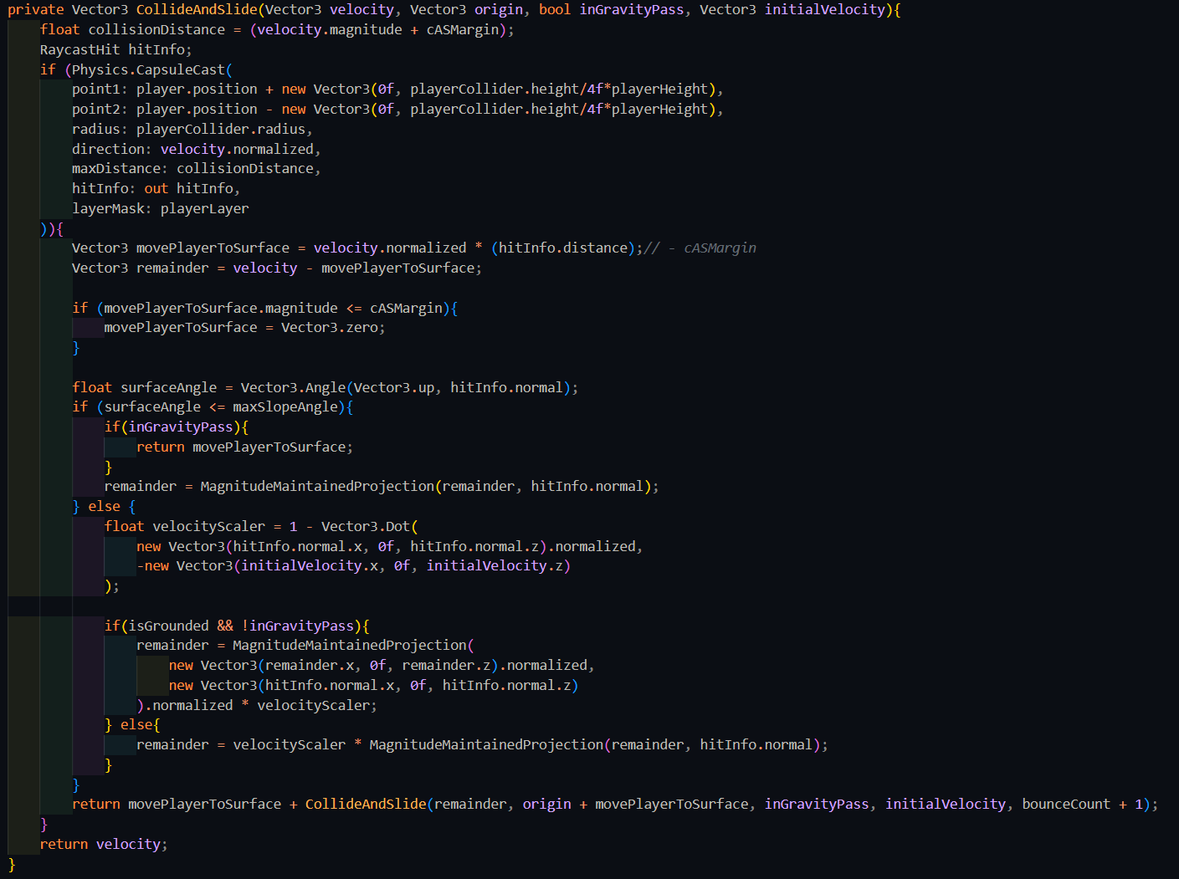

CollideAndSlide() is a recursive algorithm, being called on the remaining velocity every time it collides with something. Collisions are detected with a CapsuleCast, which is similar to a RayCast, except it shoots a capsule instead, which is the same shape as the player. If a collision is detected, the player’s extra velocity is rotated to be parallel with the collider’s normal, of which a percentage is taken away based on how much rotation is required, which is calculated with the dot product. Rotation is done via MagnitudeMaintainedProjection(), which simply stores the magnitude of the vector, then uses Vector3.ProjectOnPlane() to project it and finally sets the magnitude back to the original. The total of the required velocity to move the player to the surface and the speed for any further movements was returned back, via calling the algorithm again. This recursive nature is stopped when there was no collision.

|  |  |  |  |  |  |
| --- | --- | --- | --- | --- | --- |
| Type | What data fits criteria | Justification | Expected | Actual | Comments |
| Valid | Pressing the W/A/S/D keys alone and in combinations while moving at a wall | These keys allow the player to move in 8 directions once used in the correct combinations and moving at a wall which is required to test the algorithm | The character will accelerate in the direction held until the maximum speed is reached or the direction is released | Failed: Unity ran into maximum recursion depth of 100 | Mostly likely comes from there being no maximum bounce count and the algorithm just continuously calling itself as it bounces in a corner |
| Boundary | Pressing opposing directions – A and D, S and W | This is possible input that a player might momentarily input as they switch directions, but since it is created from both valid inputs, but results in a different output, it should also be tested. | Combining these keys should result in no movement since they lead to movement in opposing directions | Passed | Importantly, this also leads to the player slowing down, as they should. |
| Erroneous | Pressing another key (e.g. M) | Keys not used for movement should not produce any movement | The player will remain still | Passed |  |

To counteract the infinite recursion, maxBounceCount was added to the function, along with a tracker for how deep the algorithm has gone so far.



|  |  |  |  |  |  |
| --- | --- | --- | --- | --- | --- |
| Type | What data fits criteria | Justification | Expected | Actual | Comments |
| Valid | Pressing the W/A/S/D keys alone and in combinations while moving at a wall | These keys allow the player to move in 8 directions once used in the correct combinations and moving at a wall which is required to test the algorithm | The character will accelerate in the direction held until the maximum speed is reached or the direction is released | Failed: The player slowed down as they approached the wall instead of continuing along the path at the correct speed | Could be caused by the percentage loss being incorrectly applied or there being errors between using normalised and unnormalized vectors |

While the error of the stack overflowing was solved, the player now slows down as they approach the wall, which is completely unintended behaviour. However, while scouring the code for what could be causing this, I discovered that rigidbodies had a setting that changed how they detect collisions.



This setting was what I needed to solve the original problem, and which would cause the first code to work correctly when the player was moving at high speeds. This setting has 4 different options:

* Discrete – The least computationally intensive option, but also the least accurate, shown well as it was causing the error the first version of this script was experiencing
* Continuous – This sweeps the object from the location at the start of the frame to the end position and detects if there are any collisions with static objects (e.g. walls) in the sweep, and deals with it appropriately. Does not work with objects that move or rotate
* Continuous Dynamic – Works similarly to continuous except it also queries the other moving entities to see if there is a collision with them as well. Does not work with objects that rotate themselves
* Continuous Speculative – Works differently to the other continuous collision detection methods, thereby making it faster but less accurate. It increases an object’s AABB (axis-aligned minimum bounding box) to include the start and end position, then detecting any collisions within that zone. Well known to occasionally detect false collisions and cause havoc. Does work with objects that have rotated themselves.

Out of all these options, the one that I need to use is Continuous Dynamic collision detection, which also allows me to use the original code.

Me: I’ve discovered a method for me that would allow me to fix and use the original code, which so far has less errors and issues than the current implementation. Is it fine for me to use that instead?

Stakeholder: Yes, in that case, go back to the old code, such that we can save time that way. However, is it possible for you to make the original movement feel less slippery while the player is not boosting? I noticed it was not the most responsive due to it, which is hurting the player’s experience.

Stakeholder Signature:



[------------------------------------------------------------------------------------------------------------]

Now that I have returned to the original code, I need to improve the movement function. Furthermore, this movement does not necessarily allow for multiple movement states such as crouching and sprinting. Due to this, the code was edited to instead use a target which is the player’s intended direction and to then work out how much extra speed the player needs to reach that speed. This speed is then projected onto the surface that the player is currently on, with its magnitude maintained. This movement then has a certain acceleration applied, and then friction is applied appropriately. The advantage of doing things like this means that all movement works the exact same way, and the only thing that needs to be changed is the current state’s max speed in the switch statement within MaxSpeed(), and the acceleration multiplier which is handled in a similar way with CalculateAccelerationMultiplier(). In this way, the things that change between states are handled externally to the function and hence the function’s core can stay the same way with as little if statements as possible to slow the program down.

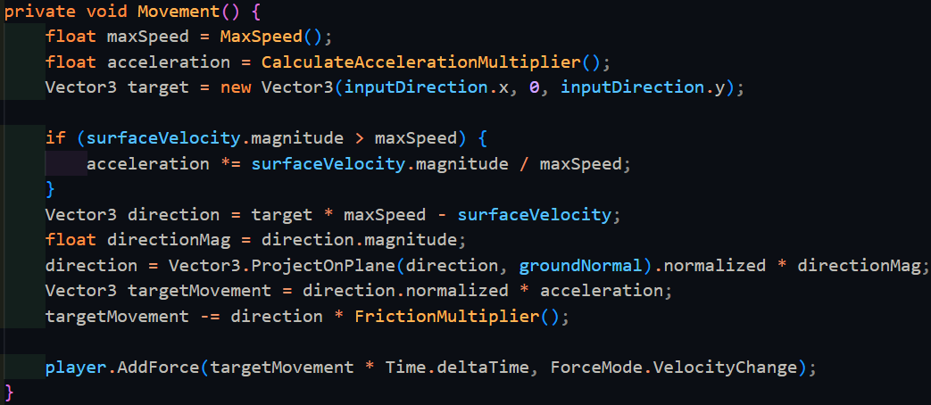

|  |  |  |  |  |  |
| --- | --- | --- | --- | --- | --- |
| Type | What data fits criteria | Justification | Expected | Actual | Comments |
| Valid | Pressing the W/A/S/D keys alone and in combinations while moving at a wall | These keys allow the player to move in 8 directions once used in the correct combinations and moving at a wall which is required to test the algorithm | The character will accelerate in the direction held until the maximum speed is reached or the direction is released | Passed |  |
| Boundary | Pressing opposing directions – A and D, S and W | This is possible input that a player might momentarily input as they switch directions, but since it is created from both valid inputs, but results in a different output, it should also be tested. | Combining these keys should result in no movement since they lead to movement in opposing directions | Passed |  |
| Erroneous | Pressing another key (e.g. M) | Keys not used for movement should not produce any movement | The player will remain still | Passed |  |

With the original movement problem solved, I could now move onto looking as this is equally integral to the player’s movement set, and therefore this might break other sections of the code. Different parts of looking need to interact with different objects. Looking side-to-side can be done by rotating the player’s body on the y-axis (vertical axis) as one would do similarly in reality, however, looking up and down is done by moving your head which is separate from the body. Similarly, the whole body should not rotate when looking up and down, and only the camera should move up and down.

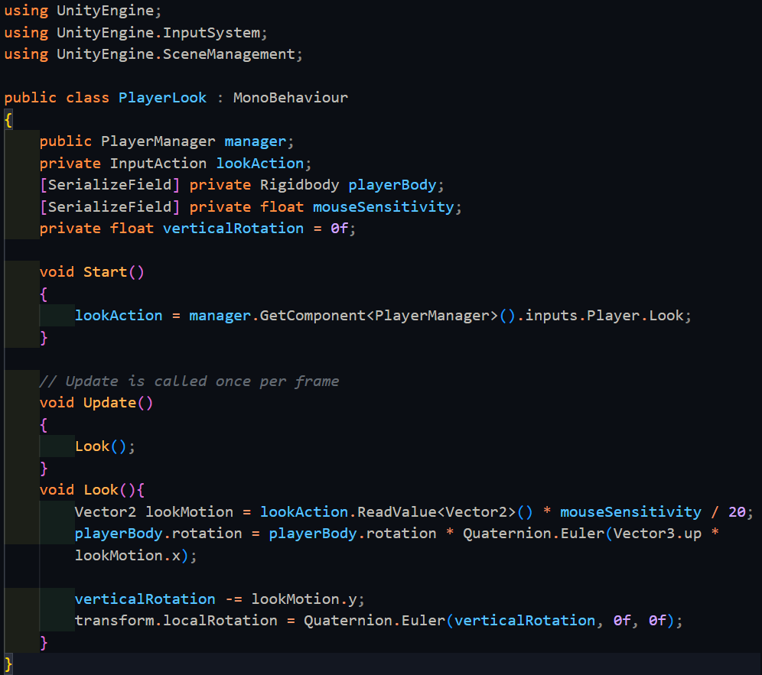

The only purpose of Start() is to retrieve the look action from the manager. The rest of the looking code exists within Update, since it needs to be updated every frame. The look action is a 2D Vector, containing the change horizontally and vertically. The horizontal direction is mapped directly to the vertical rotation of the body, while the vertical direction does not already have a value storing its rotation, so we need to add this in manually. Since this script is placed onto the camera object, transform.localRotation is used instead of referencing the camera directly to save on memory.

|  |  |  |  |  |  |
| --- | --- | --- | --- | --- | --- |
| Type | What data fits criteria | Justification | Expected | Actual | Comments |
| Valid | Moving the mouse up and down | This is the entire input base that the player should be using for looking around | The character will look around normally | Failed: the mouse went off the screen | The cursor needs to be locked to the game window |
| Boundary | Moving the mouse really far | This is to check that there is no snapping in the movement and that the system is capable of large movement values | The character will look around really fast | Failed: the player was able to look upside down, which can disorient them | This might be caused by not stopping the angle from going past 90 degrees up and down |
| Erroneous | No movement | It is important to check that the system does not continue drifting while the player is not moving the mouse | The camera will be still | Passed |  |

There was an unforeseen error where the player was able to look past the top and bottom and continue looking upside down. This is most likely caused by the fact that the vertical rotation was not clamped between -90 and 90 degrees. This can be fixed via this line below:

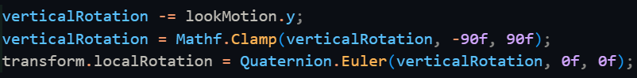

Now, this is clamped between -90˚ and 90˚ to make sure that the player does not continue looking and end up backwards, theoretically breaking their neck.

|  |  |  |  |  |  |
| --- | --- | --- | --- | --- | --- |
| Valid | Moving the mouse up and down | This is the entire input base that the player should be using for looking around | The character will look around normally | Passed |  |

The next error now needs to be solved: the player’s mouse continues to move off the screen since it is not constrained within the window. This is a distraction and inconvenient when the player clicks, so Cursor.lockState is set to Locked.

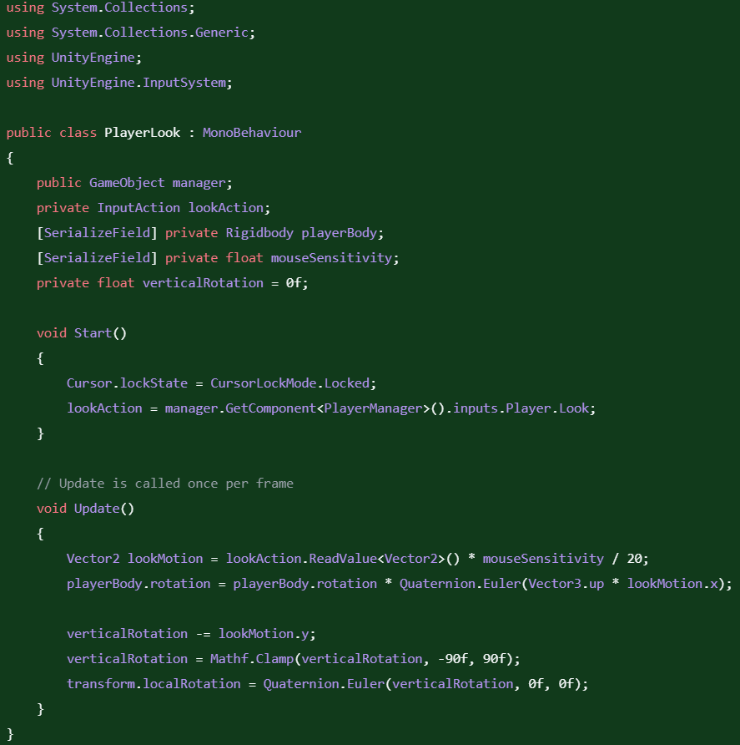

|  |  |  |  |  |  |
| --- | --- | --- | --- | --- | --- |
| Boundary | Moving the mouse really far | This is to check that there is no snapping in the movement and that the system is capable of large movement values | The character will look around really fast | Passed |  |

Now that the system is finished, I tested it again with all the tests again, to make sure none of the fixes broke anything.

|  |  |  |  |  |  |
| --- | --- | --- | --- | --- | --- |
| Type | What data fits criteria | Justification | Expected | Actual | Comments |
| Valid | Moving the mouse up and down and side to side | This is the entire input base that the player should be using for looking around | The character will look around normally | Passed |  |
| Boundary | Moving the mouse really far in any direction | This is to check that there is no snapping in the movement and that the system is capable of large movement values | The character will look around really fast | Passed |  |
| Erroneous | No movement | It is important to check that the system does not continue drifting while the player is not moving the mouse | The camera will be still | Passed |  |

Looking alone worked fine, and now I needed to test it with movement together.

|  |  |  |  |  |  |
| --- | --- | --- | --- | --- | --- |
| Type | What data fits criteria | Justification | Expected | Actual | Comments |
| Valid | Moving the mouse up and down while moving in a circle | This combines all the looking actions with all the movement options and is also covers the most typical of a player’s movement style | The character will look around and the player will move around relative the current looking direction. | Failed: the player moved around independent of their facing angle. | Most likely caused by the movement script writing global direction instead of local directions. |
| Boundary | Moving the mouse really far while moving in a circle | This is to check that there is no snapping in the movement and that the system is capable of large movement values, while maintaining movement | The character will look around really fast and will move accordingly | Failed: Encountered the same error as the valid data |  |
| Erroneous | No movement | It is important to check that the system does not continue drifting while the player is not moving the mouse | The camera will be still and the player will not move | Passed |  |

This error seems to be caused because the code was adding force to the rigidbody according the global axis, and not the local axis which is what I thought it was doing. If it was adding to the local axis, then everything would work fine, since the rotation to the body would be applied after. To remedy this, we need to rotate the target (which is the player’s input) to face the body’s current direction. The player’s body rotation is stored as a quaternion, which can be used to rotate a vector.



|  |  |  |  |  |  |
| --- | --- | --- | --- | --- | --- |
| Type | What data fits criteria | Justification | Expected | Actual | Comments |
| Valid | Moving the mouse up and down while moving in a circle | This combines all the looking actions with all the movement options and is also covers the most typical of a player’s movement style | The character will look around and the player will move around relative the current looking direction. | Passed |  |
| Boundary | Moving the mouse really far while moving in a circle | This is to check that there is no snapping in the movement and that the system is capable of large movement values, while maintaining movement | The character will look around really fast and will move accordingly | Passed |  |
| Erroneous | No movement | It is important to check that the system does not continue drifting while the player is not moving the mouse | The camera will be still and the player will not move | Passed |  |

Since all the tests passed, I asked my stakeholders about the system and see if anything else was needed to be added.

Stakeholder: Hmm, playing this version of the movement is alright, but I feel like the player doesn’t turn around fast enough, nor do they start moving fast enough. Is it possible to make them move faster at the beginning or when turning around?

To allow the player to do these things, we need to calculate the how different the current movement and the opposing movement is, which can be done with the dot product. If both vectors have a magnitude of 1 (which is true for all normalized vectors), then the dot product returns a value that is negative when the vectors are in directions that opposing each other. This can be used with an if statement to boost the acceleration of the player. To solve the player moving slowly at the beginning, we can work out check if the speed is lower than a certain amount and hence double the acceleration.

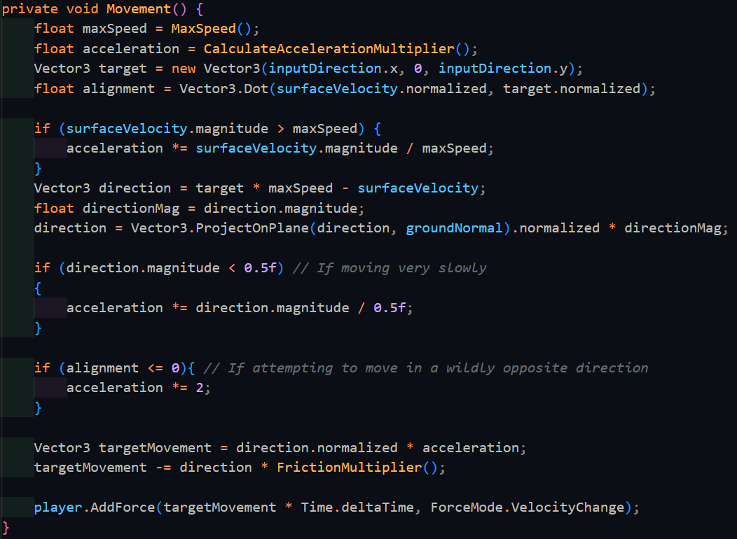

|  |  |  |  |  |  |
| --- | --- | --- | --- | --- | --- |
| Type | What data fits criteria | Justification | Expected | Actual | Comments |
| Valid | Moving the player from rest | This is one of the requirements of what the stakeholder recently requested and hence needs to be checked appropriately | The player will accelerate faster than before | Passed |  |
| Valid | Moving the player in a completely opposing direction than they are currently moving | This is another requirement that the stakeholder recently requested | The player should change to the opposing direction much faster than before | Passed |  |
| Erroneous | No change in the current movement | It is important to check that the system has not changed how it performs | The player will continue moving in the same way | Passed |  |

Next, I decided it would be better to make the game more performant by utilising the built in Physics system to tell the player controller when it is grounded or not. When a collider collides with something, Unity automatically calls OnCollisionEnter() and OnCollisionStay() on all scripts that the object has attached. When this collider stops colliding with an object, Unity automatically calls OnCollisionExit() in the same way. All these functions have a list of the collision points relative to the centre of the player passed in as a parameter. We can simply go through each of these and figure out if the contact’s normal is far shallow enough to be a floor.

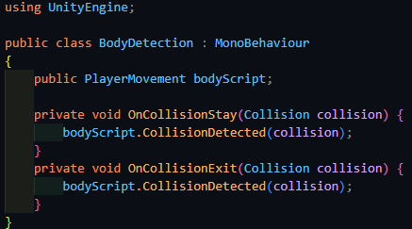

(This script is attached to the body directly ^)

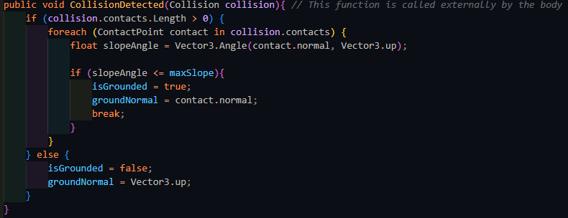

If there are no contacts, then player is in midair, and hence not grounded at all. To test this, the player will jump.

|  |  |  |  |  |  |
| --- | --- | --- | --- | --- | --- |
| Type | What data fits criteria | Justification | Expected | Actual | Comments |
| Valid | Pressing the jump key | When the player jumps they are no longer in the air, and I can check the state of isGrounded | isGrounded will be false. | Passed |  |
| Boundary | Standing on the ground next to a wall | One of the contacts will be on the ground, while another is on a wall, and the game may get confused with this | isGrounded will be true | Passed |  |
| Erroneous | Pressing another key (e.g. M) | This should keep the player on the ground | isGrounded will be true | Passed |  |

With this, I have made sure that game is running much more efficiently, and now I can add a further feature of crouching. Crouching is an action where the player will both move at a slower speed, and while also shrink in height. To shrink the player’s height, we can manually change the player collider’s height to a smaller size that is more appropriate.

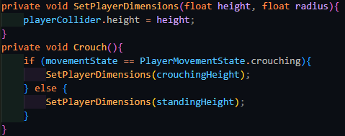

|  |  |  |  |  |  |
| --- | --- | --- | --- | --- | --- |
| Type | What data fits criteria | Justification | Expected | Actual | Comments |
| Valid | Pressing the crouch key | This is input that the player will use, and hence needs to be tested appropriately | The player’s height will be shrunk | Partial: the player did decrease in height, but in mid air | The player shrunk around their centre instead of their base |
| Erroneous | Pressing another key (e.g. M) | An input not related to the test should not affect the test | The player will remain at their standing height | Passed |  |

Upon crouching, the player does indeed shrink in size, but unfortunately, they shrink in midair and end up falling to the ground. This can be solved by finding the distance required to move the player down after the shrink, or back up after they stop crouching, and then taking this away from the player’s current y-position. This value needs to be halved since I only need the part of the shrunk height that is downwards from the centre of the player. To do all of this, I also need to store the height before the change

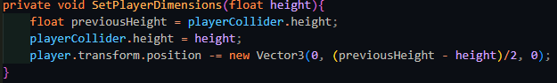

|  |  |  |  |  |  |
| --- | --- | --- | --- | --- | --- |
| Type | What data fits criteria | Justification | Expected | Actual | Comments |
| Valid | Pressing the crouch key | This is input that the player will use, and hence needs to be tested appropriately | The player’s height will be shrunk | Passed |  |

Next, I can implement the ability to crouch with either a toggle crouch or with a crouch key that must be held. Following the algorithm that was designed earlier and testing as such:

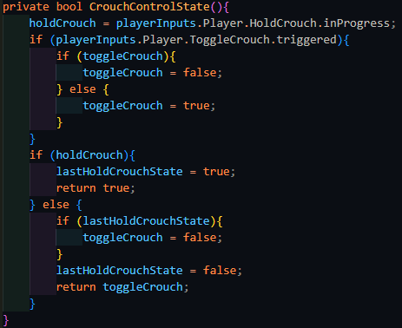

|  |  |  |  |  |  |
| --- | --- | --- | --- | --- | --- |
| Type | What data fits criteria | Justification | Expected | Actual | Comments |
| Valid | Pressing the toggle crouch key | Each input must be tested separately to verify that they work | The player will crouch | Passed |  |
| Valid | Holding the hold crouch key | Each input must be tested separately to verify that they work | The player will crouch for the duration that the key is held | Passed |  |
| Boundary | Pressing the toggle crouch key and then the hold crouch key, and then releasing it | As was specified in the first interview, the held crouch must take priority over | The player will crouch and then uncrouch when the hold crouch key is released | Passed |  |
| Erroneous | Pressing another key (e.g. M) | An input not related to the test should not affect the test, and hence checks that the input system is still working as expected | The player will remain at the same height | Passed |  |

However, looking at the code, I realised that the toggleCrouch if statement was simple enough to instead use the C# ternary operator instead, which can compress 1 line if else statements.



Taking a look at the code from this view, however, I realised that it was simpler to invert the current state of toggleCrouch, increasing the efficiency of the algorithm even further.



|  |  |  |  |  |  |
| --- | --- | --- | --- | --- | --- |
| Type | What data fits criteria | Justification | Expected | Actual | Comments |
| Valid | Pressing the toggle crouch key | Each input must be tested separately to verify that they work | The player will crouch | Passed |  |
| Valid | Holding the hold crouch key | Each input must be tested separately to verify that they work | The player will crouch for the duration that the key is held | Passed |  |
| Boundary | Pressing the toggle crouch key and then the hold crouch key, and then releasing it | As was specified in the first interview, the held crouch must take priority over | The player will crouch and then uncrouch when the hold crouch key is released | Passed |  |
| Erroneous | Pressing another key (e.g. M) | An input not related to the test should not affect the test, and hence checks that the input system is still working as expected | The player will remain at the same height | Passed |  |

### Miscellaneous

To measure the performance of the game, I decided to add an on-screen element to measure how many frames are being run per second (FPS). The higher the FPS of the game, the better it is running since less calculations are done per frame, and hence the easier it is to run. The simplest way to do this was to follow this equation $f=\frac{1}{T}$, where the frequency is the FPS, and T (the time period) is how long each frame took to run. This value can be updated every frame.

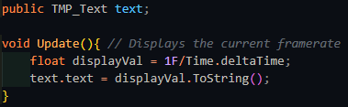



*(The FPS counter in the game)*

However, this noticeably has a problem – the value changes to quickly to get an accurate reading of what it is and as such it might be better to use a method which averages the FPS across the game.

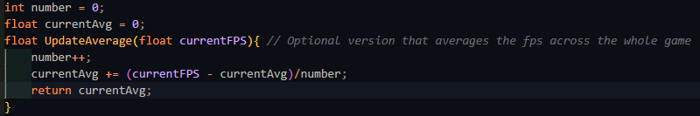

This version instead stores how many frames have gone by, and what the current average is, it can then work out how much the average would change based on the current FPS and then update the average.

While this works well, as the game goes on longer and longer, the average becomes less sensitive to the current FPS as each progressive value has less and less of an impact on the whole. As such, I decided to scrap this version since the player is expected to play the game for periods of time longer than 10 minutes, whereas the average FPS becomes useless at around 30 seconds. Instead, to help with debugging the game, I added an option for the current FPS to be logged to the debug file instead.

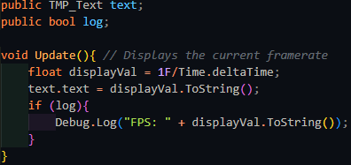

While this works ok, I noticed a noticeable decrease in the FPS when this option was used, and the player’s original framerate was extremely high. This makes sense as writing to a file is quite the intensive operation, and as such this logging facility should be used as sparingly as possible, but exists as a useful option when the game’s FPS is lower, since at FPS lower than 200, the IO operation required to write to the debug file takes less time than the rest of the game by a long margin.

### End of prototype tests

#### Strafing

|  |  |  |  |  |  |
| --- | --- | --- | --- | --- | --- |
| Type | What data fits criteria | Justification | Expected | Actual | Comments |
| Valid | Pressing the W/A/S/D keys alone and in combinations while moving at a wall | These keys allow the player to move in 8 directions once used in the correct combinations and moving at a wall which is required to test the algorithm | The character will accelerate in the direction held until the maximum speed is reached or the direction is released | Passed |  |
| Boundary | Pressing opposing directions – A and D, S and W | This is possible input that a player might momentarily input as they switch directions, but since it is created from both valid inputs, but results in a different output, it should also be tested. | Combining these keys should result in no movement since they lead to movement in opposing directions | Passed |  |
| Erroneous | Pressing another key (e.g. M) | Keys not used for movement should not produce any movement | The player will remain still | Passed |  |

#### Looking

|  |  |  |  |  |  |
| --- | --- | --- | --- | --- | --- |
| Type | What data fits criteria | Justification | Expected | Actual | Comments |
| Valid | Moving the mouse up and down | This is the entire input base that the player should be using for looking around | The character will look around normally | Passed |  |
| Boundary | Moving the mouse really far | This is to check that there is no snapping in the movement and that the system is capable of large movement values | The character will look around really fast | Passed |  |
| Erroneous | No movement | It is important to check that the system does not continue drifting while the player is not moving the mouse | The camera will be still | Passed |  |

#### Boosting

|  |  |  |  |  |  |
| --- | --- | --- | --- | --- | --- |
| Type | What data fits criteria | Justification | Expected | Actual | Comments |
| Valid | Pressing Q | This should be the only key used for boosting, and hence should respond appropriately | The player’s speed increases by a huge amount | Passed |  |
| Erroneous | Pressing another key (e.g. M) | Keys not used for boosting should not activate it | The player will remain at their current speed | Passed |  |

#### Jumping

|  |  |  |  |  |  |
| --- | --- | --- | --- | --- | --- |
| Type | What data fits criteria | Justification | Expected | Actual | Comments |
| Valid | Pressing the jump key | As the only input being used to jump, it is important that it works | The character will move upwards, then move back down | Passed |  |
| Erroneous | Pressing another key (e.g. M) | Since there is only one input, nothing else should cause the player to jump, and if there is, that means something is significantly broken | The player will remain still | Passed |  |

#### Crouching

|  |  |  |  |  |  |
| --- | --- | --- | --- | --- | --- |
| Type | What data fits criteria | Justification | Expected | Actual | Comments |
| Valid | Pressing the crouch key | This is input that the player will use, and hence needs to be tested appropriately | The player’s height will be shrunk | Passed |  |
| Erroneous | Pressing another key (e.g. M) | An input not related to the test should not affect the test | The player will remain at their standing height | Passed |  |

#### Different crouch keys

|  |  |  |  |  |  |
| --- | --- | --- | --- | --- | --- |
| Type | What data fits criteria | Justification | Expected | Actual | Comments |
| Valid | Pressing the toggle crouch key | Each input must be tested separately to verify that they work | The player will crouch | Passed |  |
| Valid | Holding the hold crouch key | Each input must be tested separately to verify that they work | The player will crouch for the duration that the key is held | Passed |  |
| Boundary | Pressing the toggle crouch key and then the hold crouch key, and then releasing it | As was specified in the first interview, the held crouch must take priority over | The player will crouch and then uncrouch when the hold crouch key is released | Passed |  |
| Erroneous | Pressing another key (e.g. M) | An input not related to the test should not affect the test, and hence checks that the input system is still working as expected | The player will remain at the same height | Passed |  |

#### Looking and strafing combined tests

|  |  |  |  |  |  |
| --- | --- | --- | --- | --- | --- |
| Type | What data fits criteria | Justification | Expected | Actual | Comments |
| Valid | Moving the mouse up and down while moving in a circle | This combines all the looking actions with all the movement options and is also covers the most typical of a player’s movement style | The character will look around and the player will move around relative the current looking direction. | Passed |  |
| Boundary | Moving the mouse really far while moving in a circle | This is to check that there is no snapping in the movement and that the system is capable of large movement values, while maintaining movement | The character will look around really fast and will move accordingly | Passed |  |
| Erroneous | No movement | It is important to check that the system does not continue drifting while the player is not moving the mouse | The camera will be still and the player will not move | Passed |  |

### Interview

Me: I’ve finished implementing the basic movement options and I’ve confirmed that there are no errors with them. Should I now move onto the entity system and the player’s ability to damage them?

SillyAustralian: First, let me try the game so far. If everything is ok, then you can move onto those features.

[Henry Masters proceeded to play the prototype in its current state]

SillyAustalian: Ok, everything is fine here. It is ok to move onto the weapon interaction and entity system. As previously discussed, due to the setbacks that have occurred, you do not need to implement anything other than a gun for the weapon system, and u do not need to make the entities communicate with any other entity, including the manager.

Stakeholder Signature:



## Prototype 2

### Interacting with weapons

Weapon interaction will begin with 1 weapon.

To begin interacting with weapons, first I need to make a weapon. Weapon will be an abstract class that contains information that is applicable or can be made applicable to all types of weapon and Fire() which will be used to activate the weapon. The properties that are applicable are:

* The type of the weapon, which will function as an ID
* The total ammunition that the weapon has
* The amount left in the clip if applicable
* The capacity of the weapon’s clip

Weapon is a class that must be made abstract, and hence all the internal properties will be abstract as well. These will have default values, since not every child class will need to overwrite the values.



However, attempting to do this will cause an error since abstract functions (C# properties act as variables that are functions under the surface) can not have anything within them. As such, these need to be defined as virtual instead, which is a special keyword in C# that allows a function to be overridden while containing a base implementation.

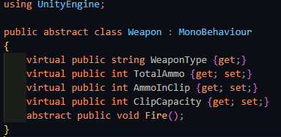

Next, a gun will have a type of bullet that it will fire, that will deal a certain amount of damage, and it will also have a barrel where the bullet is fired from. Importantly, the bullet itself is the thing that will be dealing the damage, not the gun itself. This way, the class can be reused for other weapons which will keep the codebase smaller and easier to maintain, since there will be only 1 bullet that can deal damage to entities.

Bullet is a class that will have 1 purpose: to check whether it will hit an entity, and if it does, to deal damage to it. As such, its contents are relatively simple in comparison:

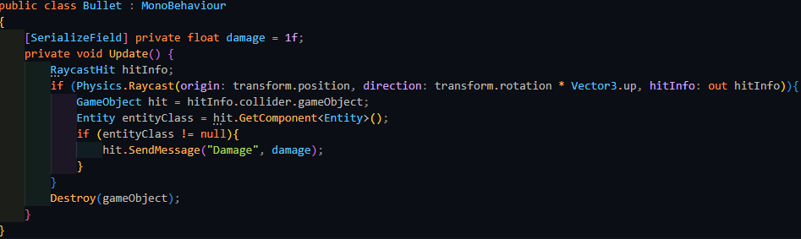

Once the bullet has performed its task, it destroys itself, keeping memory consumption low, and making the game as easy to run as possible. To fire said bullet, the gun will first check there is enough ammunition remaining, and if so, it will instantiate a bullet entity. Afterwards, it will then subtract 1 from both TotalAmmo and AmmoInClip.

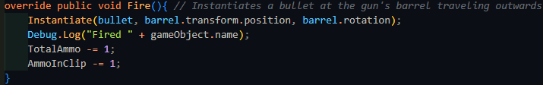

On the other side of the system, the player’s input needs to be read and passed through to the weapon. This is done by subscribing a pass-through method to the correct input action, which upon activation, will call the relevant action on the gun.

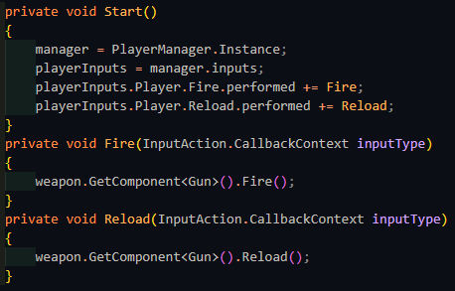

|  |  |  |  |  |  |
| --- | --- | --- | --- | --- | --- |
| Type | What data fits criteria | Justification | Expected | Actual | Comments |
| Valid | Pressing the fire button while there is enough ammunition remaining | This is the most common action the weapon will encounter and therefore is suitable as a valid test | The gun will fire 1 bullet | Passed |  |
| Boundary | Pressing the fire button while there is no ammunition remaining | It is important the system still acts accordingly when there is no ammunition in the clip remaining | The gun will not fire | Passed |  |
| Erroneous | Pressing another key (e.g. M) | Any inputs not related to the system should not affect it | The gun will not fire | Passed |  |

However, once the gun runs out of ammunition, the player needs to reload it. Since the player has limited ammunition, this needs to be taken into account when reloading. The player could also attempt to reload in the middle of a clip, and hence only the excess should be topped up.

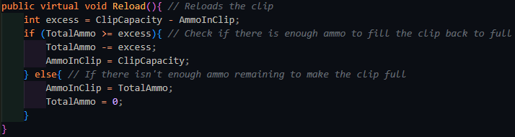

|  |  |  |  |  |  |
| --- | --- | --- | --- | --- | --- |
| Type | What data fits criteria | Justification | Expected | Actual | Comments |
| Valid | Pressing the reload button when there is no ammunition left in the clip, and there is enough ammunition remaining in total | This is the next most common action the weapon will encounter and therefore is suitable as a valid test | The gun will reload back to full | Passed |  |
| Boundary | Pressing the reload button when there is ammunition left in the clip | It is important the system still acts accordingly when the player reloads before they need to | The gun will reload back to full and only take as much ammo as needed | Passed |  |
| Erroneous | Pressing another key (e.g. M) | Any inputs not related to the system should not affect it | The gun will not reload | Passed |  |

Extending this current system to use 4 weapons instead of 1, as was requested can be done by creating 4 weapon slots like below and a tracker of which slot is currently active:

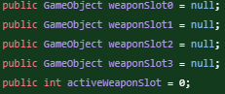

This can then be paired with a switch statement to access each slot.

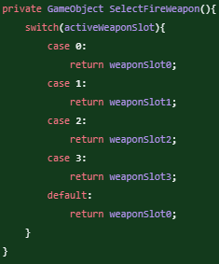

Swapping between slots requires changing activeWeaponSlot and the standard key that is used to do this is the scroll wheel. The scroll wheel returns a float value, although this is only -1.0 and 1.0, indicating the direction the that scroll wheel is moving in. Therefore, this can be casted to an integer with no backlash. The current weapon needs to be deactivated, and then the newly selected weapon needs to be enabled. If the player continues scrolling in the same direction, the value should wrap around to the start.

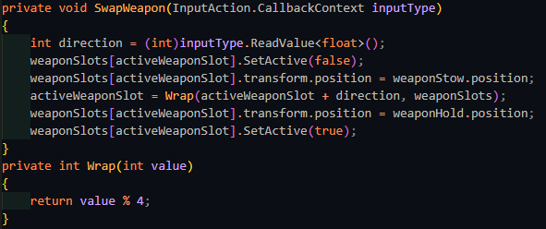

|  |  |  |  |  |  |
| --- | --- | --- | --- | --- | --- |
| Type | What data fits criteria | Justification | Expected | Actual | Comments |
| Valid | Scrolling the scroll wheel in either direction | The player will want to change the current weapon based on the scenario and therefore this is suitable as a valid test | The selected weapon will change relative to the direction the player scrolled in | Failed: When scrolling backwards, the weapon did not change once it reached the first weapon | MOD likely does not work the same when comparing a negative number and a positive one |
| Boundary | Scrolling very fast in either direction | It is important the system still acts accordingly when the player may put it under stress | The currently selected weapon should change accordingly | Failed: Same as the above error |  |
| Boundary | Scrolling when all the weapon slots are not filled | It can occur that all the player’s weapons slots are not filled and as such the scrolling should still respond correctly, even though this is a rare case. | The system should continue wrapping with the remaining weapons and change the weapons accordingly. | Failed: Reached a NullReference Exception when the empty slot was reached and the same error as the above when scrolling in reverse | Nothing is stopping Wrap() from accessing the empty variables |
| Erroneous | Pressing another key (e.g. M) | Any inputs not related to the system should not affect it | The current weapon will remain selected | Passed |  |

The problem caused by scrolling in reverse is caused due to the MOD operator, as -1 MOD 4 does not loop round to 3. To counteract this, you must first add on the number that you are performing MOD with, which in this case, is 4. This offsets the negative number and is cancelled out for the positive numbers by MOD.

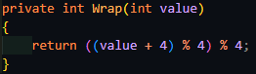

However, this only works when all the player’s weapon slots are filled. If any weapon slot is empty, such as in a tutorial or elsewhere, this throws a NullReferenceException. The next way of creating 4 weapon slots could be done with an array since the maximum number of weapons has already been predetermined.

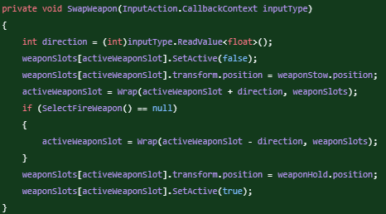

Adding an extra check for if the returned output of SelectFireWeapon() is null (meaning that there is no weapon in that slot) does indeed work for when there is only 2 or 3 weapons in all the slots. However, when there is only 1 or even no weapons equipped, this fails again, and adding an extra exception for when there is only 1 weapon is not the correct approach either. Instead, the best solution is to have weaponSlots be a list, and to stop adding elements to it once it reaches the limit which is 4. This way, Wrap() can be modified to wrap with the current length.

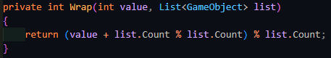

|  |  |  |  |  |  |
| --- | --- | --- | --- | --- | --- |
| Type | What data fits criteria | Justification | Expected | Actual | Comments |
| Valid | Scrolling the scroll wheel in either direction | The player will want to change the current weapon based on the scenario and therefore this is suitable as a valid test | The selected weapon will change relative to the direction the player scrolled in | Passed |  |
| Boundary | Scrolling very fast in either direction | It is important the system still acts accordingly when the player may put it under stress | The currently selected weapon should change accordingly | Passed |  |
| Boundary | Scrolling when all the weapon slots are not filled | It can occur that all the player’s weapons slots are not filled and as such the scrolling should still respond correctly, even though this is a rare case. | The system should continue wrapping with the remaining weapons and change the weapons accordingly. | Passed |  |
| Erroneous | Pressing another key (e.g. M) | Any inputs not related to the system should not affect it | The current weapon will remain selected | Passed |  |

To go hand in hand with this, adding weapons to the current arsenal works very similarly. First a RayCast is performed, and if the hit object has the “Weapon” tag, then that weapon is added to the arsenal. If all the weapon slots are full, then the weapon in the current slot is replaced. On the other hand, if there is space remaining, then activeWeaponSlot is pointed to the next available slot, and the weapon is simply added to the list.

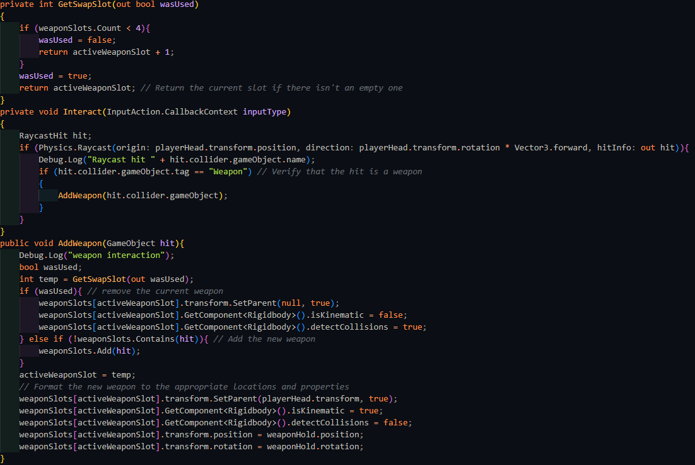

|  |  |  |  |  |  |
| --- | --- | --- | --- | --- | --- |
| Type | What data fits criteria | Justification | Expected | Actual | Comments |
| Valid | Adding a weapon while there is space available | The player will want to change the current weapon based on the scenario and therefore this is suitable as a valid test | The weapon will be added to the list with no other weapon removed, and will swap to that weapon | Passed |  |
| Valid | Adding a weapon while there is no space available | The player will want to change the current weapon based on the scenario, and this is the more common way to acquire a weapon | The weapon will replace the current weapon | Passed |  |
| Erroneous | Pressing another key (e.g. M) | Any inputs not related to the system should not affect it | The current weapon will remain selected | Passed |  |

Finally, as a little artistic touch to make the it more obvious what the player will hit when firing their weapon, the weapon will point towards the point that they will hit. To make it look better and not just snapping, the weapon will rotate towards the target quickly but smoothly. This can be done with Quaternion.Slerp() which spherically interpolates between 2 vectors, which are the current facing direction and the vector from the gun to the aiming location.

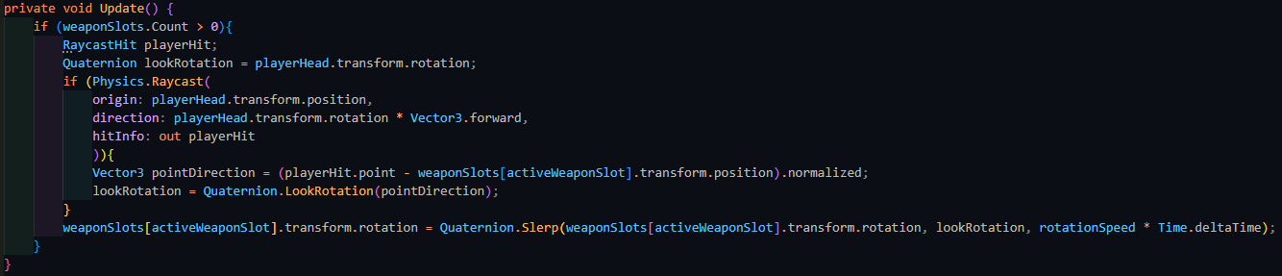

### Entities (Damage)

Start with Entity and basic properties

Add playerEntity

Add spike that deals damage on contact

Add base enemy entity

Add pid controller, show movement with target sphere



Unable to train properly with above setting



Add select target, issue with inaccessible points

Getclosestpoint to solve

Add searching with SetAngles

Added combat

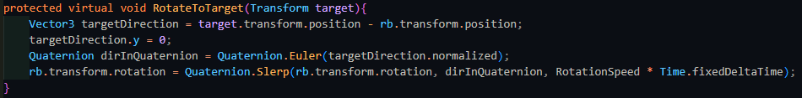

### End of prototype tests

### Interview

Stakeholder: Upon trying out the new system, I think it is a little monotonous and frustrating for the player to have to reload every time they want to fire the weapon. The weapon should instead automatically reload if the player attempts to fire it when there is no ammunition remaining.

Stakeholder Signature:



## Prototype 3

### Automatically Reloading

To fulfil the stakeholder’s request of making the weapon automatically reload, the gun needs to check if there is no ammo remaining when the player requests it to fire, and if so it needs to reload the weapon.

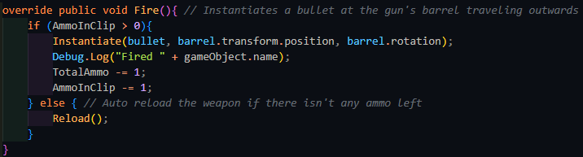

|  |  |  |  |  |  |
| --- | --- | --- | --- | --- | --- |
| Type | What data fits criteria | Justification | Expected | Actual | Comments |
| Valid | Pressing the fire button while there is enough ammunition remaining | This is the most common action the weapon will encounter and therefore is suitable as a valid test | The gun will fire 1 bullet | Passed |  |
| Boundary | Pressing the fire button while there is no ammunition remaining | It is important the system still acts accordingly when there is no ammunition in the clip remaining | The gun will reload | Passed |  |
| Erroneous | Pressing another key (e.g. M) | Any inputs not related to the system should not affect it | The gun will not fire | Passed |  |

Stakeholder: Yes, this is much better. This way the player will be able to play more fluidly and easier. You can move onto the next system.

Stakeholder Signature:



### Saving and Loading System

Add savedata, playerdata, worldflags, level highscores (needs serilizable structs)

Add save, load, saveGame in manager

Add save list

Add setCursorLock

Add lookup

Add slot menu

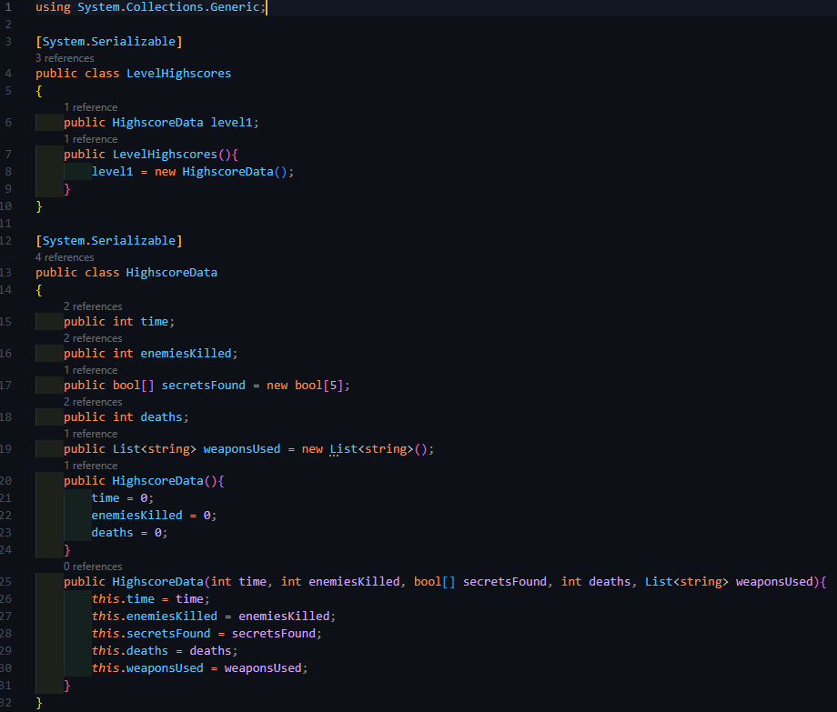

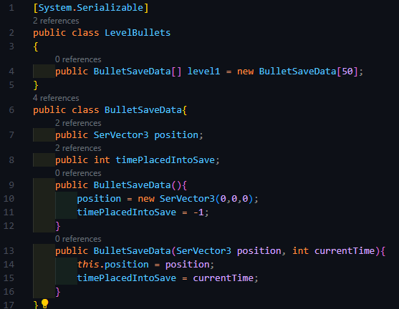

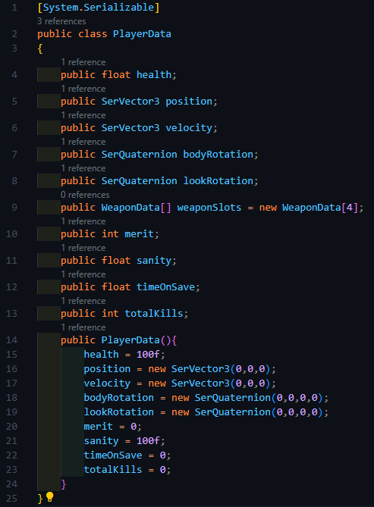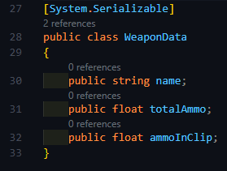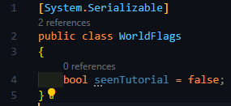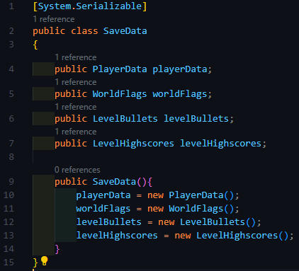

### Menus and level transitions



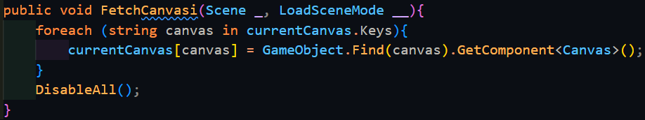

Upon consulting the C# documentation, when the contents of a dictionary change, this operation will fail, since Dictionary.Keys does not return a copy of the keys but is in fact a reference to the actual set of keys. This error is therefore returned as a warning in case the user removed a key from the dictionary. To fix it, we need to force C# to return a copy rather than a reference by using ToList(), which does what we want due to the data structure casting.

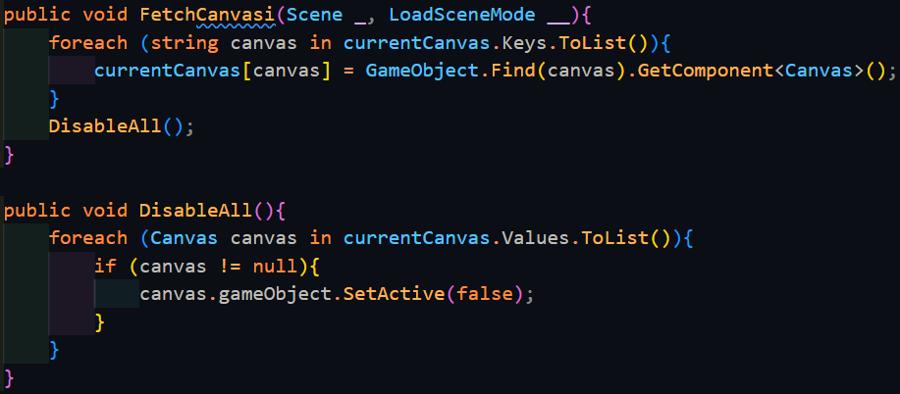

This error would also have shown up in DisableAll() which resets all canvases as a just-in-case for if any canvases where left enabled in between scene changes.

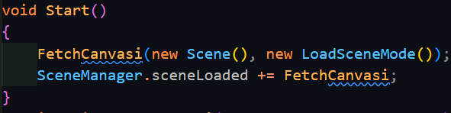

This error seems to be caused by FetchCanvasi() being run in Start(). This might be because Start(), against what I previously thought, is running before the scene actually loads fully. However, upon moving this to Update(), the error still persisted. A Debug.Log() was added to see which Canvas was causing the error, and it turned out to be ‘Slots’, which had been set to be inactive. Consulting the documentation, I discovered that GameObject.Find() will not return an inactive object, and this was causing the error. In fact, there exists no built-in function within Unity that will return inactive objects, and as such I have to make my own function using the object list in the scene data:

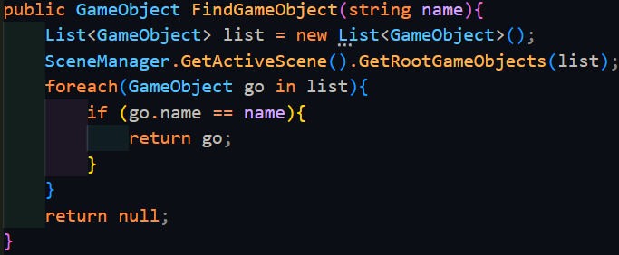

It functions similarly to GameObject.Find(), but is more inefficient as it goes through the scene data. However, nonetheless it should help with the issue.

Indeed, it gets past ‘Slots’, which was previously causing the issue, but then gets stuck again at ‘Pause’. This is because ‘Pause’ is an object that has been marked as DontDestroyOnLoad, meaning that it does not exist in any of the following scene’s data. The typical way to grab references to objects that are marked as DontDestroyOnLoad is to have passed a manual reference in the Unity Inspector, but this is not feasible in this scenario.

Instead, I came up with a better solution, using the CanvasGroup component. This allows you to hide and show objects without disabling it. It also allows you to control whether a canvas is interactable or not, which means the Dictionary would have to be modified to use a tuple as well to store whether a menu should be interactable or not (this is needed because of the player’s HUD).

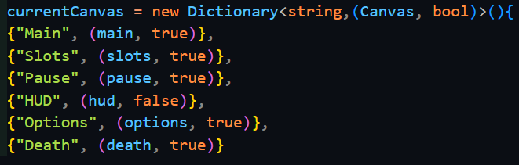

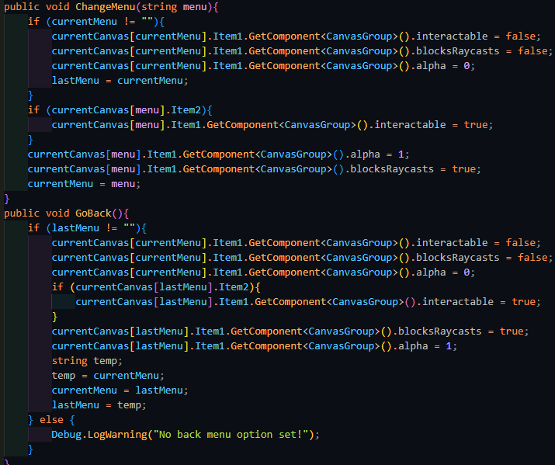

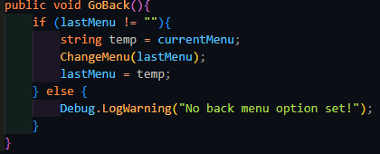





Add level loader

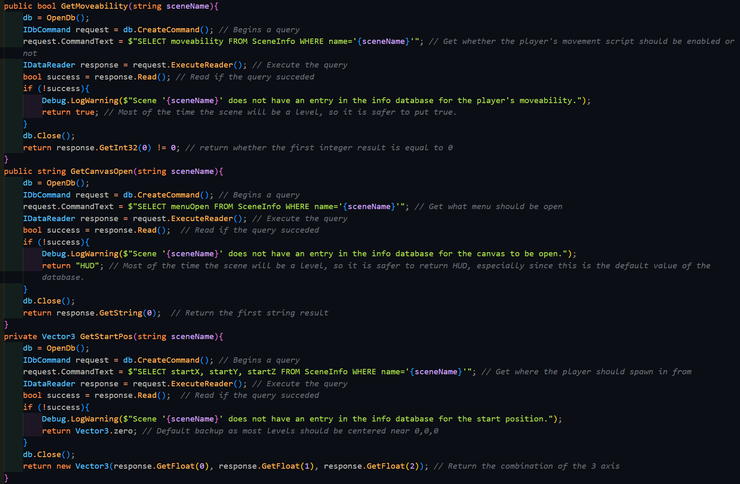

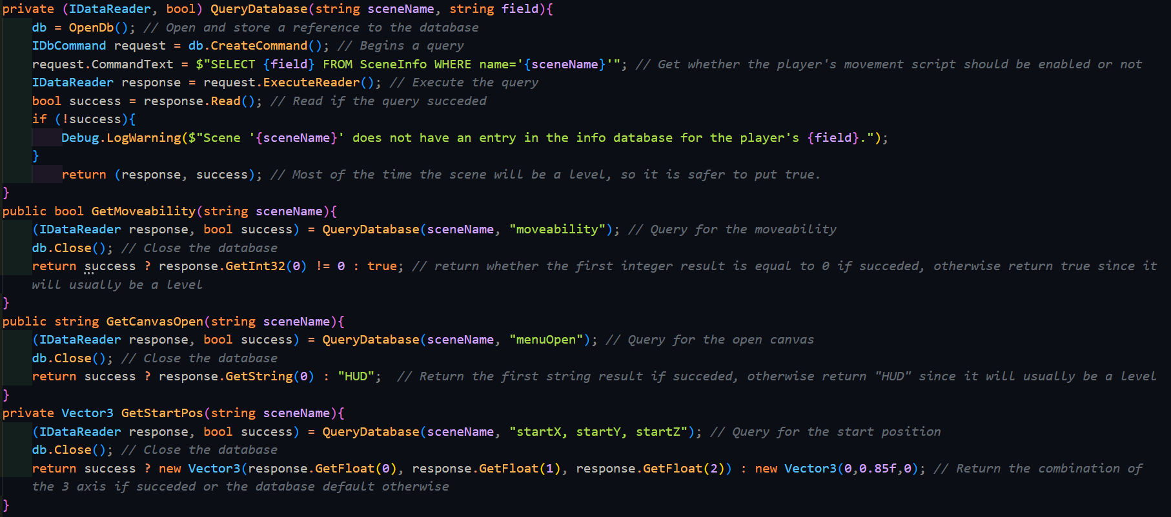

### Miscellaneous

#### Referencing the Game Manager

This is a minor change that was used to further optimise the code. Originally, the game manager was an object that could easily be referenced beforehand in each scene just by dragging the reference in the inspector. However, once multiple scenes were added, the manager was changed to an object that was only created once, then persisted between the scene changes. Because of this, the inspector reference no longer worked, since the object would not exist in most scenes before the scene was loaded. As such, GameObject.Find() was first used as such to find the Game Manager object.

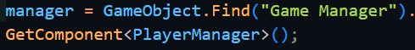

GameObject.Find() is useful, however not every single object required to use it, since some other objects would also be taken along in the scene change, such as the player or certain UI elements. Therefore, you must first check if the manager reference is null, and if it is, fetch the reference.

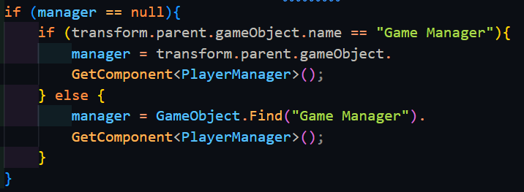

GameObject.Find() is a very simple solution to the problem, but it comes with a few drawbacks, of which the main ones are that it is extremely slow (it uses a linear search to find the object) and it uses a string to reference the name of the object which is susceptible to typos. Therefore, the even better solution to reducing the time spent searching for the Game Manager is to not search for it at all, and make it a static reference. This works since only 1 Game Manager exists in memory at any time and therefore no problems will occur. This method is called a Singleton and is commonly used for manager objects.

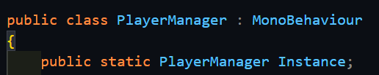

First the public reference is defined within the script, and then any script referencing the manager needs only to reference it like below.



This is the best solution since everything is baked into the code beforehand, which is the most efficient solution.

### End of prototype tests

### Interview

## Prototype 4

### Audio

Add audio manager

Add uihover script

### Movement

Next, I could implement sliding, which first requires checking if the player is moving above the walking speed. If they are, and then they start crouching, then they enter a sliding state, which has lower friction and control. The player also gains a slight boost in the first second of sliding

Then handle preBoostVelocity

Then handle double jump

Then change from player.addforce to movement

Then end with half done wallrun.

### Dialogue

Implementing the dialogue system to fulfil all its requirements was incredibly difficult and arduous. To be able to easily add multiple languages, the best solution to this would be to have every single dialogue line in a database, where the different fields are the different languages. All one would need was the record ID and the related language, and the correct line of dialogue would be loaded.

The interactions will be stored in external files with the extension of .dlg, where the flow of lines will be marked with special syntax, of which will be stored in 2 locations: some within the line data in the database, and others within the .dlg file itself. Within the line itself, the syntax is:

* _ which denotes the text surrounded by them to be in italics
* * which denotes the text surrounded by them to be in bold
* - which denotes a pause
* < and > surround colour information about the text written in hexadecimal (#FFFFFF) like “<#FFFFFF example> where “example” will be in white.
* \ is the escape character, allowing any of the above characters to be displayed, so long as it is preceded by it

For the .dlg file, the syntax varies more, since rather than styling the text, it instead defines the flow of the lines:

* Dialog sections are marked with [], which is how the dialog will be able to jump and change based on variables. Dialog sections won’t naturally progress to each other unless a -> is used to go to the next section, allowing the last section to continue forever.
* Choices for the player are marked with | at the beginning, and the first choice is used as the title of the choice. These set a local ‘choice’ variable to the number of the choice, which can then by checked and jumped to after. After each choice, a comma is there to indicate another choice is there, except for the last one, signifying it is the last choice.
* Variables will be how the dialog will react to external events. To mark a variable-based line, it will be preceded by @. This will prompt the game to check for that relevant value being set in the save file. If the condition is fulfilled then the dialog will go to the dialog section that is labelled after the -> that succeeds the condition. Otherwise, it will go to the next line. Chaining together many of these will allow an if-else-like behaviour. If a variable is on a line by itself, it can be assigned to a value. Variables can also be assigned values similarly, instead using ’=’ to set the value, and no -> will be required after.
* To request each line of dialog, the line is prefaced with an actor ID, followed by :: then the line ID. The actor IDs are labelled with #Ax and the line IDs are labelled with #Lx, where the x in both is the record ID in the database for each of them.

As you might have noticed, this would require me to create a custom parser for all of this, along with managers for the subtitles and databases. To start with, I had to learn how to use SQL in C#. The database did not need to be hosted online, and as such SQLite was a perfectly usable solution of the SQL dialects. It was also an advantage to use this since I had some experience with using this in Python before, and was a somewhat well-used solution in Unity projects. However, the drawback is that SQLite was overall the least-used SQL dialect, as many flock to using MySQL instead. However, the many variations in syntax and its main use as a multi-user access database system is not a capability I require. In fact, SQLite is extremely useful in being lightweight, and its main use is for small applications such as this game.

Having decided on a dialect to use, I searched around for how this was implemented within Unity or C#. Unity contains a plugin within it called Mono.Data.Sqlite and combined with System.Data from C#, I could create database connections using the IDbConnection interface and send commands using the IDbCommand interface. I would need two databases, one for storing the entire list of actors, and another for storing the dialogue lines. Having all the actors in a database would make the parser easier to construct, since it would not need to be aware beforehand of which scene and interaction it was in – it could be easily generalised to handle all situations. A separate manager would be responsible for assigning the actors to the actual characters in the scene, but this would be included in the scene data making this a worthwhile option. I first started off by making a way to create the database and table connection, resulting in the below code:

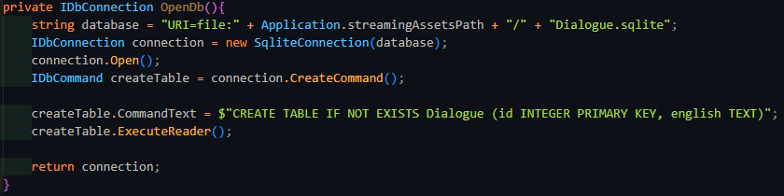

This code makes a reference to the StreamingAssets folder of Unity, which is how developers are able to include files unchanged with the build of their application. Usually when a file is included, it is serialized to make it easier and faster to load into memory. This also means that the format of the file changes, so it may no longer be possible to access it like you may have before. The way around this is StreamingAssets, which is where all the databases and .dlg files will exist. This version of the code does not take into account the different ways that different OS define paths to files, nor does it take into account that multiple different databases exist. To handle the different databases, and the different names for the columns, the function was changed to have two parameters: a string databaseName, and an array of strings that contained the columns. To handle the array, a string had to be made that combined the whole array into 1 string.

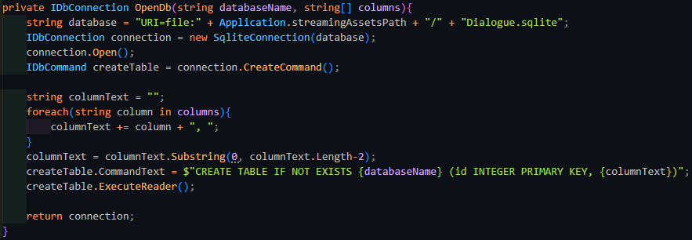

The for loop would iterate over each string in the array, and add it to the already combined total, along with a comma and a space to separate the different fields. The last field does not need a comma after it, so the last 2 characters will be cut off by taking a substring from the start of columnText, to 2 before the end of it.

To then fix the issue of the different OS, instead of concatenating strings together, I could use the Path class from System.IO which has a function that automatically stiches together a path with the appropriate connectors. I also discovered that C# had range slicing for substrings like Python did, and the code was far shorter to use, and as such I would be using the range operator going forward. To simplify the access of opening the actor or dialogue database to external classes, 2 public functions were made to fill in the required data into the OpenDb function.

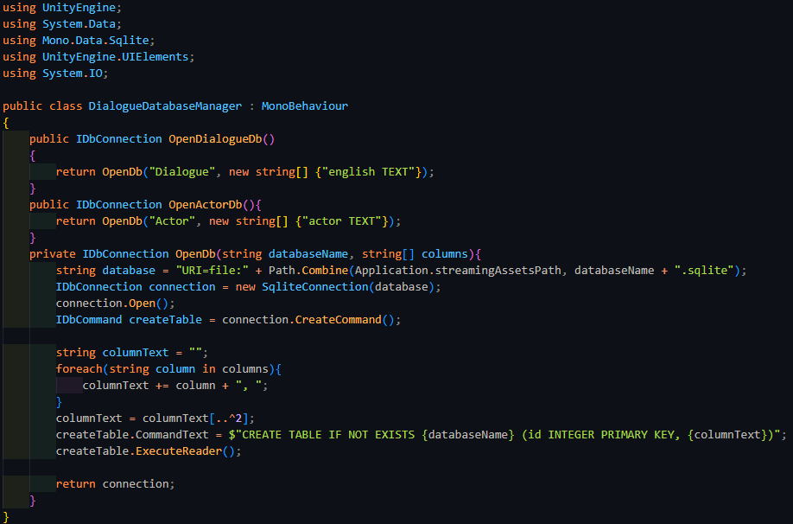

Now that other scripts could easily setup a connection with the dialogue or actor database, it was time to start implementing the .dlg files. When the program had to go through the file, it first needed to preprocess it and find where the dialog sections were on the lines of the file. This also needed me to be able to read the text within the file.

Unity has a built in asset type called TextAsset, and the useful property of it was that the text could easily be extracted from within it with a single property. Writing code to sift through the lines and add it to a list of the line number and dialog section name was not terribly difficult.

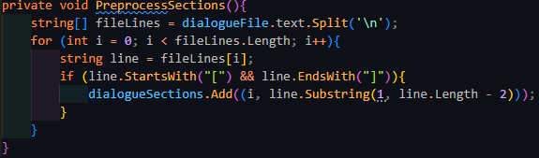

It consists of just a simple for loop, checking whether the end and start of a line had square brackets, the defining feature of dialog section headers. The code was extremely simple, but only if the .dlg file was to be recognised as a TextAsset. Unity unfortunately, was unable to do so, even with many attempts, including attempting to write a ScriptedImporter for the filetype.

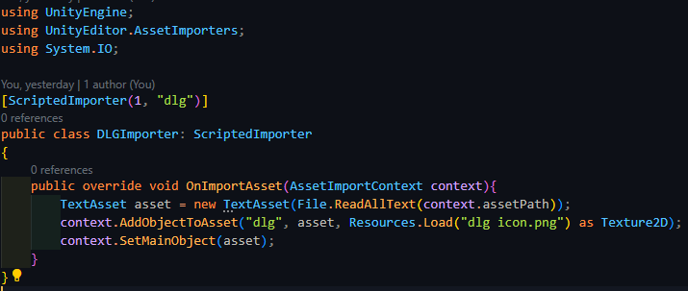

This was standard code to do the following, albeit without the icon (this was added as an easier check to see if the file was imported correctly), but unfortunately it would not work. Even after scouring for a solution to this problem, none were found, and as such I had to go for the less memory-efficient and slightly worse approach of using the C# method to opening and reading file contents – StreamReader. While the File class exists, it turns out to be far slower to StreamReader on its own, and as such I went with the below changed code to accommodate StreamReader.

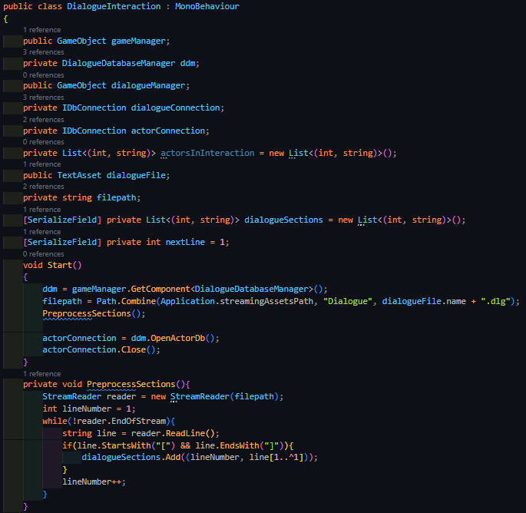

The new code is very similar to the previous, but has a custom counter instead, and reads off a new line using StreamReader.ReadLine(). It stops when the reader detects it has reached the end of the file.

Add line to richtext parser

Add treenode

Add tokenizer, read next/peek, readID then extrapolate for other funcs

Add analysis

Change to manager reflection

Change back, realise no time, add basic line to subtitles for manager

### End of prototype tests

### Interview

# Evaluation

## Evaluative Testing

### Usability Tests

## Success Criteria

## Usability Features

## Limitations

Full dialog system

Grenade and blade

Team sides for enemy

Grappling

## Maintenance

# Bibliography

Anon., 2024. [Online]   
Available at: https://tf2sr.github.io/TF2SR-Wiki/

Anon., n.d. *How to Tune a PID Controller.* [Online]   
Available at: https://pidexplained.com/how-to-tune-a-pid-controller/  
[Accessed 22 November 2024].

Atwood, J. & Spoisky, J., 2008. *Stack Overflow.* [Online]   
Available at: https://stackoverflow.com/  
[Accessed 26 June 2024].

d'Apprentissage, T. d. F. e., n.d. *Orthogonal Unit Differentiation.* [Online]   
Available at: https://tecfa.unige.ch/tecfa/maltt/VIP/Ressources/Articles/Game%20Design%20Patterns/collection/Alphabetical_Patterns/OrthogonalUnitDifferentiation.htm#:~:text=When%20Units%20in%20a%20game,with%20different%20types%20of%20abilities.  
[Accessed 24 July 2024].

Dev, P., 2023. *Collide And Slide - *Actually Decent* Character Collision From Scratch.* [Online]   
Available at: https://www.youtube.com/watch?v=YR6Q7dUz2uk  
[Accessed 25 July 2024].

Electronic Arts Inc.; Respawn Entertainment, 2018. *Titanfall 2.* [Online]   
Available at: https://www.ea.com/en-gb/games/titanfall/titanfall-2

Fadi, E., 2025. *Link to my GitHub.* [Online]   
Available at: https://github.com/RandomEF/Abrupt-Animus

Frei, D., 2022. *Saving Data in Unity using SQLite,* s.l.: s.n.

gskinner, n.d. *RegExr.* [Online]   
Available at: https://regexr.com/  
[Accessed 27 August 2024].

Half Life Fandom, 2007. *Overwatch Soldier.* [Online]   
Available at: https://half-life.fandom.com/wiki/Overwatch_Soldier  
[Accessed 17 September 2024].

Huertas, R., n.d. s.l.: s.n.

id Software, 2016. *DOOM.* [Online]   
Available at: https://bethesda.net/en/game/doom-2016

id Software, 2020. *DOOM Eternal.* [Online]   
Available at: https://mods.bethesda.net/doometernal

Iyer, A., 2018. *Titanfall 2: How Design Informs Speed,* s.l.: s.n.

Leprawel, n.d. *Parkour Controller Script,* s.l.: s.n.

Microsoft, 2024. *C# Language Documentation.* [Online]   
Available at: https://learn.microsoft.com/en-us/dotnet/csharp/  
[Accessed 6 July 2024].

Official, T., 2016. *Titanfall 2: Inside Development,* s.l.: s.n.

OMOCAT LLC., 2020. *Omori.* [Online]   
Available at: https://www.omori-game.com/en

One More Level; Slipgate Ironworks, 2020. *Ghostrunner.* [Online]   
Available at: https://ghostrunnergame.com/

Patala, A. "., 2020. *Ultrakill.* [Online]   
Available at: https://store.steampowered.com/app/1229490/ULTRAKILL/

SFB Games, 2021. *ChipTone.* [Online]   
Available at: https://sfbgames.itch.io/chiptone  
[Accessed 20 February 2025].

Unity Technologies, 2025. *Unity Documentation.* [Online]   
Available at: https://docs.unity3d.com/6000.0/Documentation/ScriptReference/index.html

Valve Corporation, 1998. *Half Life.* [Online]   
Available at: https://www.half-life.com/en/halflife

Valve Corporation, 2024. *Steam Hardware Survey.* [Online]   
Available at: https://store.steampowered.com/hwsurvey/Steam-Hardware-Software-Survey-Welcome-to-Steam  
[Accessed 19 September 2024].

Valve Developer Community, 2005. *Category:AI - Valve Developer Community.* [Online]   
Available at: https://developer.valvesoftware.com/wiki/Category:AI  
[Accessed 18 September 2024].